553/1

BIOLOGY

(Theory)

Paper 1

Oct. / Nov. 2012

2 ½ hours

**UGANDA NATIONAL EXAMINATIONS BOARD**

**Uganda Certificate of Education**

**BIOLOGY**

**(THEORY)**

**Paper 1**

**2 hours 30 minutes**

**INSTRUCTIONS TO CANDIDATES**

*This paper consists of sections A, B and C.*

*Answer all questions in sections A and B, plus two questions in Section C.*

*Write the answers to section A in the boxes provided, answers to section B in the spaces provided, and answers to section C in the answer booklets provided.*

|  |  |  |
| --- | --- | --- |
| **FOR EXAMINERS’ USE ONLY** | | |
| **Section** | **Marks** | **Examiner’s Signature & No.** |
| A: |  |  |
| B: No. 31  No. 32  No. 33 |  |  |
|  |  |
|  |  |
| C: No.  No. |  |  |
|  |  |
| **Total** |  |  |

**SECTION A: (30 MARKS)**

*Answer all questions in this section. Write the letter representing the most correct answer to each question in the box provided.*

1. Which one of the following pairs of parts of the human eye refracts light?
2. Cornea and choroid
3. Aqueous and vitreous humours
4. Cornea and Iris
5. Iris and Ciliary body
6. An advantage that a lizard has over a cat is that it
7. Has a constant metabolic rate
8. Has a lower food consumption per unit body mass
9. Can live in any environment
10. Is active throughout the day
11. Which one of the following methods of controlling malaria does not harm the environment?
12. Draining ponds
13. Use of insecticide such as DDT
14. Spraying oil on top of water ponds.
15. Introducing fish into ponds
16. Part of a section of a leaf showed irregularly shaped cells which were loosely packed and had few chloroplasts. The part of the leaf is most likely to be that of the
17. Spongy mesophyll layer
18. Palisade mesophyll layer
19. Upper epidermis
20. Lower epidermis
21. A soil sample characterized by good aeration, high drainage, low capillarity and loose particles is
22. Clay
23. Loam
24. Sand
25. Laterite
26. The following is a dichotomous key of invertebrates:
27. (a) Has 8 legs ………………………………………… W

(b) Has 6 legs ………………………………………… 2

1. (a) Has long antennae ……………………………. X

(b) Has short antennae …………………………… 3

1. (a) Has proboscis …………………………………… Y

(b) Has mandibles ………………………………….. Z

Which one of the organisms is a fly?

1. W
2. X
3. Y
4. Z
5. Which of the following are likely blood groups of children from parents of blood groups A and B?
6. O only
7. AB only
8. O and AB only
9. O, A, B and AB
10. Which one of the following is difference between nervous and endocrine coordination?

**Nervous Endocrine**

1. Messages are transmitted slowly Messages are rapidly transmitted
2. Effects are localized Effects are widespread
3. Produce long lasting effects Produce short lived effects
4. Message is chemical Message is electrical
5. Figure 1 is a diagram of a seedling.

L

M

N

O

The region that elongates most rapidly during epigeal germination is indicated by letter

1. L
2. M
3. N
4. O
5. Four test tubes, each with contents as indicated in the following table, were incubated at a temperature of 370C for some time.

|  |  |
| --- | --- |
| **Test tube** | **Contents** |
| **1** | Albumen + Pepsin |
| **2** | Albumen + dilute hydrochloric acid |
| **3** | Albumen + pepsin + dilute hydrochloric acid |
| **4** | Albumen + boiled pepsin + dilute hydrochloric acid |

In which test tube did the contents become clear?

1. 4
2. 3
3. 2
4. 1
5. Which one of the following occurs during the stage of anaphase of mitosis?
6. Chromatids separate and move to opposite poles
7. Chromosomes uncoil
8. Chromosomes line at the equator
9. Chromatids collect together at the opposite ends.
10. Which of the following organisms reproduce by budding?
11. Bacteria
12. Spirogyra
13. Amoeba
14. Fungi
15. The hormones that stimulate the growth of pubic hair in humans are
16. Oestrogen and testosterone
17. Progesterone and luteinizing hormone
18. Luteinizing hormone and thyroxine
19. Follicle stimulating hormone and progesterone
20. Which one of the following constituents of blood is not found in the glomerular filtrate?
21. Urea
22. Proteins
23. Water
24. Glucose
25. Figure 2 is an experimental set up to demonstrate anaerobic respiration in yeast.

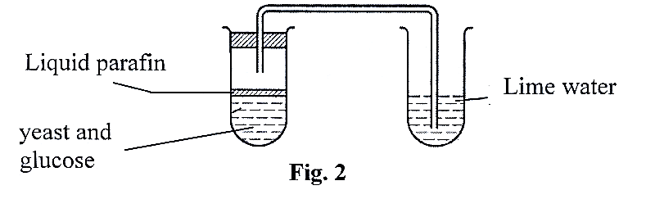

The importance of liquid paraffin in the experiment is to

1. React with yeast and glucose
2. Speed up the reaction between yeast and glucose
3. Exclude atmospheric oxygen from the yeast – glucose mixture
4. Expel all the oxygen in the solution
5. Which one of the following describes the change from plant protein to ammonium compounds?
6. Fermentation
7. Denitrification
8. Putrefaction
9. Nitrification
10. A gene which does not express itself unless in a homozygous state is
11. Dominant
12. Sex linked
13. Codominant
14. Recessive
15. Which one of the following groups of organisms in a food chain contains the least amount of energy?
16. Tertiary consumers
17. Secondary consumers
18. Primary consumers
19. Producers
20. A characteristic feature of a thoracic vertebra is the presence of
21. Short transverse processes
22. Vertebraterial canals
23. A large centrum
24. A long neural spine
25. In a mammalian heart, the left ventricle is more muscular than the right because it
26. Pumps a lot of blood to the lungs
27. Pumps blood to all parts of the body
28. Receives blood from all parts of the body
29. Receives more blood
30. Which one the following organisms does not transport oxygen by the blood?
31. Cockroach
32. Frog
33. Bird
34. Fish
35. Figure 3 shows the results of an experiment to determine the amount of water lost by a potential plant due to transpiration under different environmental conditions

Time (Minutes)

Weight of the plant

A

B

C

Fig. 3

The most likely conditions under which the experiment was conducted between points A and B were in

1. A darkroom and the plant covered with a wet polythene bag
2. An open place, in bright sunlight
3. A cold and humid place
4. A humid and shady place
5. An athlete breathes 500cm3 of air at each breath. His breathing rate is 40 breaths per minute. If the atmospheric air contains 15% oxygen by volume, what is his oxygen intake per minute?
6. 3000 cm3
7. 2000 cm3
8. 600 cm3
9. 300 cm3
10. Bile salts help in the digestion of fats by
11. Neutralizing excess stomach acids
12. Converting fats into simpler substances
13. Breaking fats into smaller particles
14. Separating fatty acids from glycerol
15. The growth of a plant shoot towards light is induced by
16. Lack of auxins on the dark side
17. A higher distribution of auxins on the light side
18. A high concentration of auxins at the tip of the shoot
19. A higher distribution of auxins on the dark side
20. The type of pollination that the flower in figure 4 is adapted for is

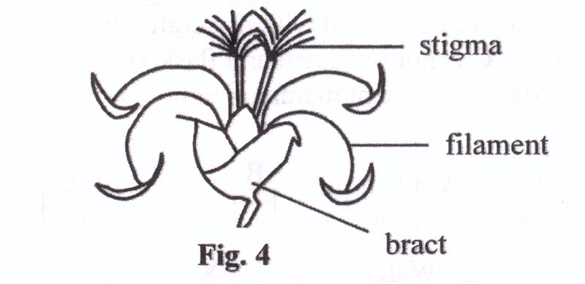

1. Cross pollination
2. Self-pollination
3. Wind pollination
4. Insect pollination
5. Removal of a ring of bark from a tree trunk interferes with the movement of
6. Water to the leaves
7. Mineral salts to the leaves
8. Food to the leaves
9. Food to the roots
10. Some plants produce large quantities of pollen grains because
11. Some of the pollen grains do not mature
12. Much of the pollen grains never reach the stigma
13. The pollen is needed by bees
14. The pollen gives a nice scent to the plant
15. Vasodilation is likely to occur together with
16. Vasoconstriction
17. Shivering
18. Sweating
19. Increased metabolism
20. The most likely habitat of a plant with many stomata on the upper surface of its leaves is
21. Water
22. Salty marsh
23. High altitude
24. Desert

**SECTION B: (40 MARKS)**

*Answer all questions in this section. Answers must be written in the spaces provided.*

1. Figure 5 shows four flasks A, B, C, D each filled with hot water at 700C and left to cool. Flask A is insulated with dry cotton wool, flask B with wet cotton wool, flask C is not insulated and flask D is smaller in size and not insulated. The flasks represent mammalian bodies.

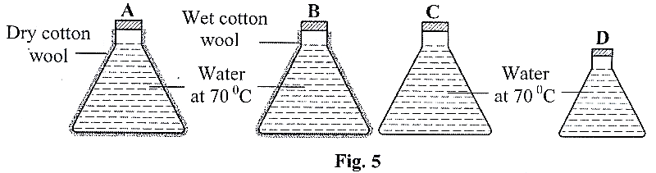

The table below shows the temperature in each flask in figure 5, recorded at 10 minute intervals for 30 minutes.

|  |  |  |  |  |
| --- | --- | --- | --- | --- |
|  | **(Temperature (0C) at 10 minute intervals)** | | | |
| 0(min) | 10(min) | 20(min) | 30(min) |
| A | 70 | 66 | 62 | 60 |
| B | 70 | 50 | 38 | 30 |
| C | 70 | 60 | 53 | 48 |
| D | 70 | 53 | 40 | 38 |

Study the information and answer the questions that follow:

1. For each flask draw a graph to show the changes in temperature with time in the space on next page. Use the same X and Y axes for all the graphs. (06 marks)

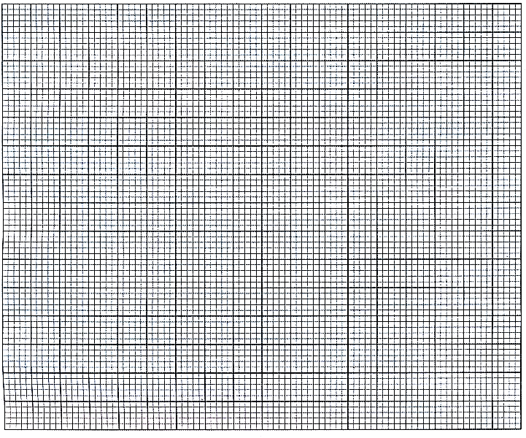

1. Calculate the average rate of cooling in each flask. *(04 marks)*

……………………………………………………………………………………………………….

……………………………………………………………………………………………………….

……………………………………………………………………………………………………….

……………………………………………………………………………………………………….

……………………………………………………………………………………………………….

……………………………………………………………………………………………………….

……………………………………………………………………………………………………….

……………………………………………………………………………………………………….

……………………………………………………………………………………………………….

……………………………………………………………………………………………………….

1. Explain the rate of cooling in
2. Flask A (02 marks)

……………………………………………………………………………………………………….

……………………………………………………………………………………………………….

……………………………………………………………………………………………………….

……………………………………………………………………………………………………….

1. Flask B (03 marks)

……………………………………………………………………………………………………….

……………………………………………………………………………………………………….

……………………………………………………………………………………………………….

……………………………………………………………………………………………………….

1. Flask C (02 marks)

……………………………………………………………………………………………………….

……………………………………………………………………………………………………….

……………………………………………………………………………………………………….

……………………………………………………………………………………………………….

1. Flask D (02 marks)

……………………………………………………………………………………………………….

……………………………………………………………………………………………………….

……………………………………………………………………………………………………….

……………………………………………………………………………………………………….

1. From the information, state two factors that affect the rate of cooling from a body. (01 mark)

……………………………………………………………………………………………………….

…………………………………………………………………………………………………

1. Figure 6 is an experimental set up to investigate a process in plants.

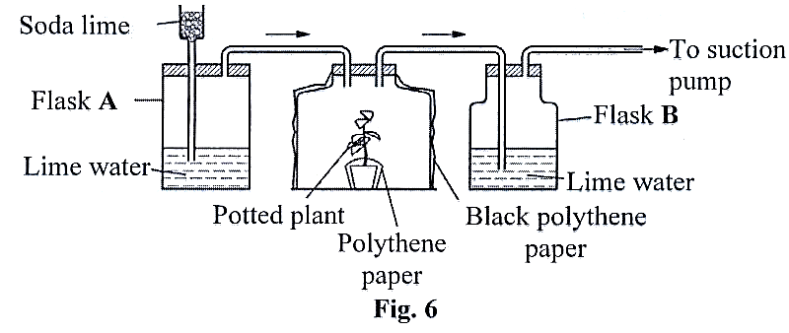

1. Name the process being investigated. (01 mark)

……………………………………………………………………………………………………….

……………………………………………………………………………………………………….

1. Explain why
2. The bell jar was covered with black polythene paper. (01 mark)

……………………………………………………………………………………………………….

……………………………………………………………………………………………………….

……………………………………………………………………………………………………….

……………………………………………………………………………………………………….

1. Part of the plant was covered with polythene paper. (01 mark)

……………………………………………………………………………………………………….

……………………………………………………………………………………………………….

……………………………………………………………………………………………………….

……………………………………………………………………………………………………….

1. Soda lime was used in the experiment. (01 mark)

……………………………………………………………………………………………………….

……………………………………………………………………………………………………….

……………………………………………………………………………………………………….

……………………………………………………………………………………………………….

1. State what would be observed in flasks A and B at the end of the investigation. (02 marks)
2. Flask A

……………………………………………………………………………………………………….

……………………………………………………………………………………………………….

……………………………………………………………………………………………………….

1. Flask B

……………………………………………………………………………………………………….

……………………………………………………………………………………………………….

1. Explain the results stated in c (i) and (ii).

……………………………………………………………………………………………………….

……………………………………………………………………………………………………….

……………………………………………………………………………………………………….

……………………………………………………………………………………………………….

1. (i) State what would be observed in flasks A and B if the set-up was placed in a dark room. (01 mark)

……………………………………………………………………………………………………….

……………………………………………………………………………………………………….

(ii) Explain your answer in d (i). (01 mark)

……………………………………………………………………………………………………….

……………………………………………………………………………………………………….

1. (a) State the organ in the human body that secretes insulin hormone.

(01 mark)

……………………………………………………………………………………………………….

……………………………………………………………………………………………………….

(b) Explain why a person suffering from diabetes

(i) has to be given regular doses of insulin (03 marks)

……………………………………………………………………………………………………….

……………………………………………………………………………………………………….

……………………………………………………………………………………………………….

……………………………………………………………………………………………………….

……………………………………………………………………………………………………….

……………………………………………………………………………………………………….

(ii) has to eat more frequently (02 marks)

……………………………………………………………………………………………………….

……………………………………………………………………………………………………….

……………………………………………………………………………………………………….

……………………………………………………………………………………………………….

(c) Glucose and not sucrose is recommended to be given to an athlete after a race. Explain this observation. (04 marks)

……………………………………………………………………………………………………….

……………………………………………………………………………………………………….

……………………………………………………………………………………………………….

……………………………………………………………………………………………………….

……………………………………………………………………………………………………….

……………………………………………………………………………………………………….

……………………………………………………………………………………………………….

……………………………………………………………………………………………………….

……………………………………………………………………………………………………….

……………………………………………………………………………………………………….

……………………………………………………………………………………………………….

……………………………………………………………………………………………………….

……………………………………………………………………………………………………….

……………………………………………………………………………………………………….

……………………………………………………………………………………………………….

……………………………………………………………………………………………………….

……………………………………………………………………………………………………….

**SECTION C: (30 MARKS)**

*Answer any two questions from this section. Additional questions answered will not be marked. Answers to this section are to be written in the answer booklets provided.*

1. (a) With the help of diagrams, describe sexual reproduction in a Rhizopus (10 marks)

(b) Outline different ways in which fungi are important. (05 marks)

1. (a) Describe the structure of the different types of skeleton in mammals, giving an example in each case. (09 marks)

(b) Explain how the vertebral column in mammals is adapted to its functions. (06 marks)

1. (a) Explain how the action of muscles causes carbon dioxide to pass from the lungs into the atmosphere. (05 marks)

(b) How does oxygen move from the air in the alveoli into body tissues? (07 marks)

(c) How are respiratory surfaces adapted to their functions? (03 marks)

1. (a) Describe two ways in which the white blood cells defend the body. (02 marks)

(b) Explain how red blood cells are adapted to their function. (10 marks)

(c) Describe the changes that occur in an individual’s blood if the person moves from a lowland and goes to live on a highland. Explain you answer. (03 marks)

**2011**

Answer all questions in this section.

1. In plants, efficient gaseous exchange due to large surface to volume ratio is achieved by
2. Many stomata on leaves
3. Flatness of leaves
4. Large sized lenticels
5. Numerous root hairs
6. Which of the following would happen if a torch was shown directly into a person’s eye?
7. Iris muscles would contract, narrowing the pupil
8. Lens would bulge, allowing less light to enter
9. Iris muscles would relax, narrowing the pupil
10. Lens would flatten, diverging light rays.
11. The following are results of an experiment to determine percentage of water within a sample of soil.

Mass of crucible = 15 g

Mass of crucible + soil = 30 g

Mass of crucible + soil after drying = 25 g

The percentage of water in the soil is

1. 18.7
2. 20.0
3. 33.3
4. 66.7
5. In peas, yellow seed colour is dominant over green seed color. What would be the phenotype of the offspring if a true breeding yellow-seeded plant is crossed with a green-seeded plant?
6. 2 yellow : 2 green
7. 3 yellow : 1 green
8. 3 green : 1 yellow
9. All yellow
10. The relationship between fungi and algae in lichen is best described as
11. Mutualistic
12. Parasitic
13. Predatory
14. Symbolic
15. Which one of the following contains a set of characteristics which are all for wind – dispersed fruits and seeds?
16. Parachute-like, hooked and light
17. Dry, curled inwards and spiked
18. Parachute-like, winged and light
19. Succulent, buoyant and light
20. Which one of the following contains a set of cells which are all haploid?
21. Pollen grains, ovules and root hair cells
22. Sperms, pollen grains and ova
23. Sperms, ovules and brain cells
24. Cells of the epididymis, ovules and ova
25. Which one of the following sets, consists of bones of the fore limb?
26. Femur, tibia, humerus
27. Radius, ulna, femur
28. Tibia, fibula, ulna
29. Humerus, radius, ulna
30. Which one of the following organs is supplied and drained by a vein?
31. Stomach
32. Liver
33. Kidney
34. Pancreas
35. In the Biuret test, the colour which indicates a positive result is
36. Purple
37. Blue
38. Pink
39. Red brown
40. Which one of the following is not a correct statement about flower parts?
41. Sepals and petals together form perianth
42. Sepals form calyx
43. Carpels form androecium
44. Petals form corolla.
45. Which one of the following occurs to urine as it leaves the kidney to the bladder?
46. Glucose is removed
47. Urea is added
48. Its composition remains unchanged
49. Water is removed
50. Under which one of the following conditions will air enter the mammalian lungs? When the
51. Pressure of the thorax is increased
52. Ribs are lowered
53. Diaphragm is raised
54. Volume of the thorax is increased
55. Which one of the following is a modified tap root?
56. Onion bulb
57. Carrot tuber
58. Cassava tuber
59. Irish potato
60. Which one of the following activities generates heat in the human body?
61. Shivering of the body
62. Constriction of peripheral blood vessels
63. Contraction of the erector pili muscle
64. Dilation of the peripheral blood vessels.
65. Plants lack special excretory organs because
66. Their waste products are less toxic and are sometimes reused.
67. They do not produce waste products
68. They lack vessels to transport the products
69. Waste products produced are gaseous
70. Which one of the following groups of bacteria converts soul nitrates to free nitrogen?
71. Nitrifying bacteria
72. Nitrogen fixing bacteria
73. Denitrifying bacteria
74. Putrefying bacteria
75. An albino offspring is likely to result from a cross between
76. An albino father and a normal mother
77. Both parents who are carriers for albinism
78. A carrier mother for albinism and a normal father
79. Both parents who are normal
80. Asexual reproduction in a *Rhizopus* results into
81. Zygospores
82. Buds
83. Fragments
84. Spores
85. Figure 1 is a pyramid of numbers in an ecosystem.

Large fish

Small fish

Mosquito Larvae

Microscopic algae

Which one of the following changes would reduce the number of mosquito larvae?

1. Increase in number of large fish
2. Increase in number of small fish
3. Decrease the number of small fish
4. Increase in number of microscopic algae
5. Which one of the following is the route a red blood cell takes from the liver to the lungs?
6. Hepatic portal vein, vena cava, pulmonary artery
7. Hepatic vein, pulmonary vein, pulmonary artery
8. Hepatic artery, aorta, pulmonary artery
9. Hepatic vein, vena cava, pulmonary artery
10. In a photometer, the rate of movement of an air bubble corresponds to the rate of
11. Water uptake
12. Osmosis
13. Air movement around the plant
14. Water loss from the reservoir
15. To estimate the population of *Tilapia* using a capture-recapture method, 60 fish were captured, marked and released. In the second capture, out of 72 fish, 10 had been marked. The estimated population of *Tilapia* was
16. 672
17. 780
18. 432
19. 4310
20. To which one of the following groups of plants do mosses belong?
21. Pteridophytes
22. Bryophytes
23. Angiosperms
24. Conifers
25. Which one of the following human activities is likely to increase the level of carbon dioxide in the atmosphere?
26. Cutting down trees
27. Using artificial fertilizers
28. Discharging waste in water bodies
29. Using pesticides
30. A radical of a seedling grows downwards because the concentration of auxin is
31. Higher on its lower side, promoting growth on that side
32. Lower on its lower side, promoting growth on that side
33. Higher on its upper side, promoting growth on that side
34. Lower on its upper side, promoting growth on that side
35. Which one of the following activities results into upstroke during flight in birds?
36. Movement of the humerus downwards
37. Contraction of large flight muscles and relaxation of small flight muscles
38. Contraction of small flight muscles and relaxation of large flight muscles
39. Faster air movement on upper surface than lower surface
40. Which of the following are characteristics of wind-pollinated flowers?
41. Feathery stigmas and smooth pollen grains
42. Stigmas growing much higher than stamens.
43. Free stamens growing higher than the stigma
44. Large pollen grains on firm anthers.
45. Identical twins result from
46. One ovum being fertilized by one sperm
47. An ovum splitting into two before fertilization
48. Two ova being fertilized by one sperm
49. Two ova being fertilized by two sperms
50. Which one of the following statements describes hypogeal germination?
51. Hypocotyl elongates, leaving cotyledons below the ground.
52. Epicotyl elongates, leaving cotyledons below the ground
53. Hypocotyl elongates, bringing cotyledons above the ground
54. Epicotyl elongates, bringing cotyledons above the ground.

**SECTION B (40 MARKS)**

*Answer all questions to this section. Write the answers in the spaces provided.*

1. Figure 2 (i), (ii) and (iii) show the rate of photosynthesis under different conditions.

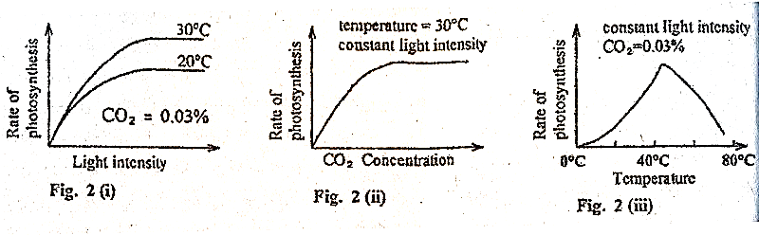

1. State what each figure shows.

Figure 2(i) (02 marks)

………………………………………………………………………………………………………………

………………………………………………………………………………………………………………

………………………………………………………………………………………………………………

………………………………………………………………………………………………………………

Figure 2(ii) (02 marks)

………………………………………………………………………………………………………………

………………………………………………………………………………………………………………

………………………………………………………………………………………………………………

………………………………………………………………………………………………………………

Figure 2(iii) (02 marks)

………………………………………………………………………………………………………………

………………………………………………………………………………………………………………

………………………………………………………………………………………………………………

………………………………………………………………………………………………………………

………………………………………………………………………………………………………………

1. Describe what happens in each figure

Figure 2(i) (03 marks)

………………………………………………………………………………………………………………

………………………………………………………………………………………………………………

………………………………………………………………………………………………………………

………………………………………………………………………………………………………………

Figure 2(ii) (03 marks)

………………………………………………………………………………………………………………

………………………………………………………………………………………………………………

………………………………………………………………………………………………………………

………………………………………………………………………………………………………………

………………………………………………………………………………………………………………

………………………………………………………………………………………………………………

………………………………………………………………………………………………………………

Figure 2(iii) (03 marks)

………………………………………………………………………………………………………………

………………………………………………………………………………………………………………

………………………………………………………………………………………………………………

………………………………………………………………………………………………………………

………………………………………………………………………………………………………………

………………………………………………………………………………………………………………

………………………………………………………………………………………………………………

1. Explain the shape of figure 2 (iii). (02 marks)

………………………………………………………………………………………………………………

………………………………………………………………………………………………………………

………………………………………………………………………………………………………………

………………………………………………………………………………………………………………

………………………………………………………………………………………………………………

1. From figures 2(i), 2(ii) and 2(iii), state the factors that affect the rate of photosynthesis. (03 marks)

………………………………………………………………………………………………………………

………………………………………………………………………………………………………………

………………………………………………………………………………………………………………

………………………………………………………………………………………………………………

1. Figure 3 shows a structure in the mammalian lung, study the figure and answer the questions that follow:

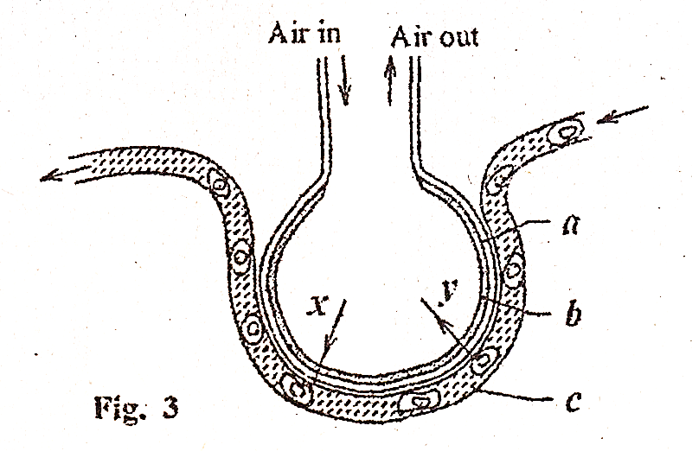

1. Name the
2. Parts labelled a, b, c (1 ½ marks)
3. ……………………………………………………………………………………………….
4. ……………………………………………………………………………………………….
5. ……………………………………………………………………………………………….
6. Gases indicated by arrows x and y. (01 mark)

x. …………………………………………………………………………………………………….

y. …………………………………………………………………………………………………….

1. Explain how the features shown in the figure, enable the structure to function efficiently. (5 ½ marks)

………………………………………………………………………………………………………………

………………………………………………………………………………………………………………

………………………………………………………………………………………………………………

………………………………………………………………………………………………………………

………………………………………………………………………………………………………………

………………………………………………………………………………………………………………

………………………………………………………………………………………………………………

………………………………………………………………………………………………………………

………………………………………………………………………………………………………………

………………………………………………………………………………………………………………

………………………………………………………………………………………………………………

………………………………………………………………………………………………………………

1. State four differences between the air that goes into the structure and that which goes out of the structure. (02 marks)

………………………………………………………………………………………………………………

………………………………………………………………………………………………………………

………………………………………………………………………………………………………………

………………………………………………………………………………………………………………

………………………………………………………………………………………………………………

………………………………………………………………………………………………………………

………………………………………………………………………………………………………………

………………………………………………………………………………………………………………

………………………………………………………………………………………………………………

1. Rats are herbivores that usually live in human dwellings which are filthy. Bacteria of the species *Pasteurella pestis,* live in and feed on the blood of the them to humans when the fleas bite humans. The bacteria feed on human blood too; and this sometimes results into humans developing bubonic plague.
2. In the space below, draw a food web to show the feeding relationships described. (02 marks)
3. Which organisms are
4. Parasites (01 mark)

………………………………………………………………………………………………………………

………………………………………………………………………………………………………………

1. Vectors (01 mark)

………………………………………………………………………………………………………………

………………………………………………………………………………………………………………

1. Suggest the name of the producer for the food web and explain how it would enter the food web. (02 marks)

………………………………………………………………………………………………………………

………………………………………………………………………………………………………………

………………………………………………………………………………………………………………

………………………………………………………………………………………………………………

………………………………………………………………………………………………………………

………………………………………………………………………………………………………………

1. From the information given,
2. State the trophic levels in the food web and give one organism in each level. (02 marks)

………………………………………………………………………………………………………………

………………………………………………………………………………………………………………

………………………………………………………………………………………………………………

………………………………………………………………………………………………………………

1. Describe what would happen if rats were removed from the food web. (02 marks)

………………………………………………………………………………………………………………

………………………………………………………………………………………………………………

………………………………………………………………………………………………………………

………………………………………………………………………………………………………………

**SECTION C (30 MARKS)**

*Answer two questions from this section. Answers are to be written in the answer booklets provided.*

1. (a) Explain how a plant benefits from transpiration. (04 marks)

(b) Describe how plants in arid areas control excessive loss of water. (11 marks)

1. Describe the processes that occur after pollination in a flowering plant leading to the formation of a fruit. (15 marks)
2. (a) Explain the advantages of ectothermy and endothermy. (09 marks)

(b) A shrew is the smallest mammal in Africa. It eats a lot of food which is mainly insects, rich in fats. Explain why the shrew eats

(i) a lot of food (03 marks)

(ii) mainly insects rich in fats (03 marks)

1. (a) What is accommodation? (02 marks)

(b) Suppose a boy was sitting in a dimly lit room reading a book, then he suddenly stepped out of the room into bright sunshine to look at an aeroplane in the sky. Describe the sequence of events which would occur in his eyes to enable him see the aeroplane clearly. (09 marks)

(c) Explain why many old people use glasses to read. (04 marks)

**2010**

**2009**

**SECTION A**

1. Which one of the following control measures against mosquitoes is least harmful to the environment?
2. Draining of swamps
3. Spraying with insecticide.
4. Covering surfaces of stagnant water with oil
5. Introducing fish in ponds
6. The magnitude of a biological drawing is given as × 0.5. This means that the drawing is
7. Five times larger than the specimen
8. Half the natural size of the specimen
9. Twice the natural size of the specimen
10. Five times smaller than the specimen
11. A diet most suitable for strengthening of teeth and bones should be rich in
12. Iodine and vitamin K
13. Calcium and vitamin D
14. Magnesium and vitamin C
15. Iron and vitamin B
16. Which one of the following digestive processes is catalyzed by salivary amylase?
17. Maltose to glucose
18. Sucrose to glucose and fructose
19. Starch to maltose
20. Lactose to galactose and glucose
21. Figure 1 shows the effect of relative humidity on transpiration rate.

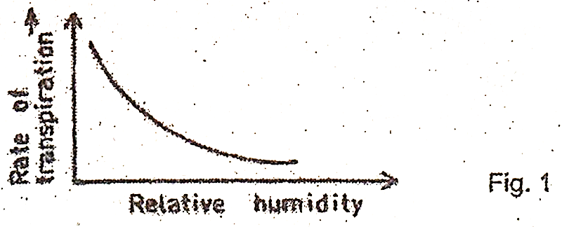

From the figure, transpiration rate

1. Increases with decreased relative humidity
2. Increase with increased relative humidity
3. Decreases with decreased relative humidity
4. Remains constant with increased relative humidity
5. Which one of the following classes has the highest number of species?
6. Crustacea
7. Arachnida
8. Insect
9. Myriapoda
10. Which of the following substances is not contained in the glomerular filtrate in the mammalian kidney?
11. Urea
12. Plasma proteins
13. Glucose
14. Mineral salts
15. Which one of the following is an adaptation of the leaf for transportation of manufactured food?
16. Numerous chloroplasts
17. Numerous stomata
18. Branching network of veins
19. Large airspaces in the spongy mesophyll
20. Slow rate of repair of the uterine wall after menstruation in a mammal may be due to a deficiency in
21. Oestrogen
22. Luteinizing hormone
23. Progesterone
24. Follicle stimulating hormone
25. Which of the following vertebrae provide points of attachment to the ribs?
26. Cervical
27. Thoracic
28. Lumbar
29. Sacral
30. Which of the following allow smooth movement of bones at a joint?
31. Synovial fluid
32. Tendons
33. Ligaments
34. Synovial membrane
35. Clay soil has a high water retention capacity because it
36. Has small air spaces
37. Contains little amount of humus
38. Is sticky when wet
39. Has good capillary attraction
40. Which of the following is the correct order of cell organization?
41. Cell $⟶$ organ $⟶$ tissue $⟶$ system
42. Tissue $⟶$ cell $⟶$ organ $⟶$ system
43. Organ $⟶$ cell $⟶$ tissue $⟶$ system
44. Cell $⟶$ tissue $⟶$ organ $⟶$ system
45. Figure 2 shows changes in the body temperature with environmental temperature in an animal.

Environmental temperature

Body temperature

Fig. 2

Which one of the following could be the animal represented?

1. Bird
2. Dog
3. Human
4. Frog
5. Which of the following groups of organisms usually colonise bare rock first?
6. Herbs
7. Mosses
8. Lichens
9. Grasses
10. Which of the following features differentiate a housefly from a spider?
11. Segmented body
12. Jointed limbs
13. Number of body parts
14. Possession of exoskeleton
15. Which one of the following relationships is an example of mutualism?
16. Tapeworm living in a human gut
17. Bacteria living in the gut of a cow
18. Ticks living on the skin of a dog
19. Plasmodium living in human blood
20. Which one of the following plant organs can be used in vegetative reproduction?
21. Stem tuber of Irish potato
22. Root tuber of cassava
23. Tap root of a carrot
24. Leaves in metabolic rate
25. The following are responses to cold conditions in mammals:
26. Vasoconstriction
27. Hair standing up
28. Shivering
29. Increase in metabolic rate

Which of these, both reduce heat loss?

1. 1 and 2
2. 1 and 4
3. 2 and 3
4. 3 and 4
5. Which of the following are not respiratory surfaces in animals?
6. Spiracles
7. Tracheoles
8. Gill filaments
9. Alveoli
10. A man of blood group AB marries a woman of blood group O. What would be the possible blood groups of their children?
11. O and AB
12. A only
13. AB
14. A and B
15. Which one of the following types of fruits is a pineapple?
16. Drupe
17. Multiple fruit
18. Indehiscent fruit
19. Berry
20. Strips W, X, Y and Z of same size and shape were cut fro, a raw pawpaw, whose sap had a sugar concentration of 28%. The strips were then placed in sugar solution of different concentrations as shown in table 1.

Table 1

|  |  |
| --- | --- |
| Strip | Sugar concentration  Of solution (%) |
| W | 15 |
| X | 25 |
| Y | 28.5 |
| Z | 48 |

Which strip would be longest after 4 hours?

1. X
2. W
3. Y
4. Z
5. What is likely to happen if a maize coleoptile whose tip has been removed, is illuminated from only one side? The coleoptile would
6. Curve towards the direction of light
7. Curve away from the direction of light
8. Not show any further growth
9. Grow upright
10. Which of the following sets of joints consists of only the hinge type?
11. Hip, wrist and elbow
12. Neck, shoulder and elbow
13. Elbow, knee and finger joints
14. Knee, wrist and ankle
15. Which one of the following is the least important reason why plants need to ensure efficient dispersal of seeds in nature?
16. Increasing chances of finding a better habitat for multiplication
17. Escape being eaten by animals in its original habitat
18. Reducing competition for food
19. Ensuring better colonization of different places.
20. Under which of the following sets of conditions indicated in table 2 will bean seeds germinate?

Table 2

|  |  |  |  |  |
| --- | --- | --- | --- | --- |
|  | Temperature | Light | Water | Oxygen |
| A | 200C | Absent | Present | Present |
| B | 200C | Present | Absent | Present |
| C | 00C | Present | Present | Present |
| D | 200C | Present | Present | Absent |

1. In plants, large surface area to volume ratio for gaseous exchange is achieved by
2. Presence of numerous stomata on leaves
3. Flatness of leaves
4. Presence of air spaces in the mesophyll
5. Presence of lenticels
6. In the mammalian heart, the thick muscular walls of the left ventricle are vital for
7. Resisting pressure of the blood coming into the ventricles.
8. Maintaining the shape of the heart
9. Producing enough pressure to pump blood to all parts of the body
10. Resisting back flow of blood from the aorta

**SECTION B (40 MARKS)**

*Answer all questions in this section.*

1. Table 3 shows the change in mass of starch and protein in a typical pea seed during the first 20 days of germination.

Table 3

|  |  |  |  |  |  |  |
| --- | --- | --- | --- | --- | --- | --- |
| Food  Substanc.es in the seed | Days of germination | | | | | |
| 0 | 4 | 8 | 12 | 16 | 20 |
| Starch (mg) | 60 | 56 | 32 | 8 | 5 | 4 |
| Protein (mg) | 28 | 21 | 11 | 5 | 3 | 2 |

1. Using the same axes, draw two graphs to show the change in mass of starch and protein during the first 20 days of germination of the seed in the space provided. (08 marks)



1. How are the changes in mass of starch and protein
2. Similar? (02 marks)

………………………………………………………………………………………………………………..

………………………………………………………………………………………………………………..

………………………………………………………………………………………………………………..

………………………………………………………………………………………………………………..

1. Different? (02 marks)

………………………………………………………………………………………………………………..

………………………………………………………………………………………………………………..

………………………………………………………………………………………………………………..

………………………………………………………………………………………………………………..

1. Explain why the mass of starch and proteins change in the germinating seed, in each case state the reactions that result into the changes. (04 marks)

………………………………………………………………………………………………………………..

………………………………………………………………………………………………………………..

………………………………………………………………………………………………………………..

………………………………………………………………………………………………………………..

………………………………………………………………………………………………………………..

………………………………………………………………………………………………………………..

1. Suggest two ways in which the products from each starch and proteins may be used in the germinating seed.
2. Starch (02 marks)

………………………………………………………………………………………………………………..

………………………………………………………………………………………………………………..

………………………………………………………………………………………………………………..

………………………………………………………………………………………………………………..

1. Proteins (02 marks)

………………………………………………………………………………………………………………..

………………………………………………………………………………………………………………..

………………………………………………………………………………………………………………..

………………………………………………………………………………………………………………..

1. In a food chain, when energy is transferred from one trophic level to another some of it is lost. Figure 3 shows such a transfer of energy in an out of a cow in a year.

Green plants

Cow

5757 units lost energy

6060 units of energy in food

Eaten

Figure 3

1. Name the trophic levels shown in the figure. (02 marks)

………………………………………………………………………………………………………………..

………………………………………………………………………………………………………………..

1. State two ways in which energy is lost from the cow. (01 mark)

………………………………………………………………………………………………………………..

………………………………………………………………………………………………………………..

1. Calculate the percentage of energy taken in during the year, which is retained by the cow. (02 marks)

………………………………………………………………………………………………………………..

………………………………………………………………………………………………………………..

………………………………………………………………………………………………………………..

………………………………………………………………………………………………………………..

1. In proportion to its body, a calf uses more energy to maintain its body temperature than a cow. Explain why this is so. (03 marks)

………………………………………………………………………………………………………………..

………………………………………………………………………………………………………………..

………………………………………………………………………………………………………………..

………………………………………………………………………………………………………………..

………………………………………………………………………………………………………………..

………………………………………………………………………………………………………………..

………………………………………………………………………………………………………………..

1. In the recycling of materials, how can the energy within the cow be made available to plants? (02 marks)

………………………………………………………………………………………………………………..

………………………………………………………………………………………………………………..

………………………………………………………………………………………………………………..

………………………………………………………………………………………………………………..

1. Figure 4 shows part of a section of a human eye.

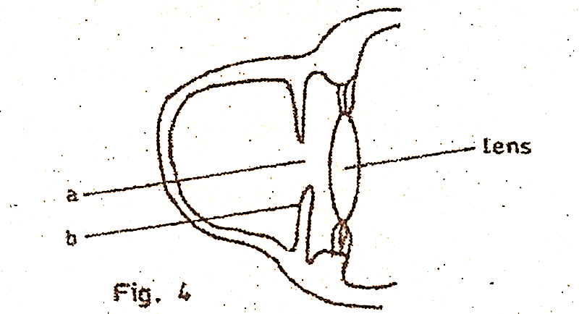

1. Name the parts labelled a and b. (01 mark)
   1. ………………………………………………………………………………………….
   2. ………………………………………………………………………………………….
2. What is the function of structure b in the eye? (02 marks)

………………………………………………………………………………………………………………..

………………………………………………………………………………………………………………..

………………………………………………………………………………………………………………..

………………………………………………………………………………………………………………..

1. If a person entered a room with bright light, state the changes that would occur in each of parts a and b of the eye.
2. a …………………………………………………………………………………… (01 mark)
3. b …………………………………………………………………………………………………………………………………………………………………………………………………………………………………………………………………………………… (02 marks)
4. In the space below, draw the shape of the lens only, when the eye is focusing on a near and distant object respectively. (02 marks)

When focusing on a near object when focusing on a distant object

1. Describe how the shape of the lens is brought about when the eye is focusing on a near object.

(02 marks)

**SECTION C (30 MARKS)**

*Answer any two questions.*

1. (a) Describe the breathing mechanism in a bony fish. (11 marks)

(b) How are gills in a bony fish adapted to their functions? (04 marks)

1. (a) Outline the internal structural differences between monocotyledonous and dicotyledonous plants in the following parts:
2. Stems (03 marks)
3. Roots (02 marks)

(b) Describe how leaves of green plants are suited for photosynthesis. (10 marks)

1. (a) Explain how the small size of soil particles in a soil type affect the soil’s suitability for plant growth. (08 marks)

(b) Describe an experiment to compare the rate of drainage of two soil samples. (07 marks)

1. (a) What is meant by pollution? (02 marks)

(b) Explain how the continued use of polythene paper may harm the environment. (10 marks)

(c) Suggest ways of preventing the effects suggested in (b). (03 marks)

**2008**

*Answer all questions in this section.*

1. Which one of the following sets of events occurs in a person when feeling cold?

A. Blood capillaries constrict, hair rises and metabolic rate increases

B. Hair lowers, blood capillaries dilate and metabolic rate decreases.

C. metabolic rate increases, blood capillaries dilate and hair lowers

D. Metabolic rate decreases, blood capillaries constrict and hair rises.

1. Which one of the following word equations summarizes the process of fermentation?

A. Glucose $⟶$ Ethanol + carbon dioxide + water

B. Glucose $⟶$ Lactic acid + energy + water

C. Glucose $⟶$ Ethanol + carbon dioxide + energy

D. Glucose $⟶$ Lactic acid + water + carbon dioxide

1. The type of roots labeled Y in figure 1 are called

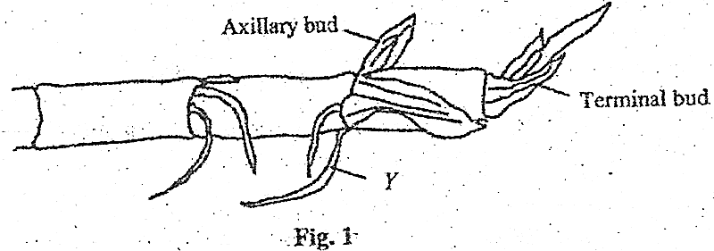

A. prop roots

B. lateral roots

C. clasping roots

D. adventitious roots

1. What are the chances of parents who are carriers of a gene for albinism, producing an albino child?

A. 25%

B. 50%

C. 75%

D. 100%

1. Which one of the following is the correct route taken by an impulse after it has left a relay neurone?

A. synapse $⟶$ sensory neurone $⟶$ effector

B. sensory neurone $⟶$ synapse $⟶$ effector

C. synapse $⟶$ motor neurone $⟶$ effector

D. sensory neurone $⟶$ motor neurone $⟶$ effector

1. Which one of the following is the mode of feeding of a mould?

A. Holozoic

B. Saprophytic

C. Autotrophic

D. Parasitic

1. Which one of the following is a characteristic of sandy soils?

A. High retention

B. High capillarity

C. Low drainage

D. High porosity

1. Which one of the following plant organs has a scattered arrangement of vascular bundles?

A. Root of a monocotyledonous plant

B. Stem of a monocotyledonous plant

C. Stem of a dicotyledonous plant

D. Root of a dicotyledonous plant

1. In the colonization of a bare rock, the next most likely group of plants after lichens are the

A. grasses

B. mosses

C. shrubs

D. trees

1. Which one of the following includes all the possible blood groups that can be possessed by the children from a marriage between a mother heterozygous for blood group A and a father heterozygous for blood group B?

A. A and B

B. AB and O

C. A, B and O

D. A, B, AB and O

1. Which one of the following is a correct route taken by carbondioxide from the body cells of an insect to the atmosphere?

A. Trachea $–$ Tracheoles – spiracles

B. Spiracles – trachea – Tracheoles

C. Tracheoles – trachea – spiracles

D. Spiracles – Tracheoles – trachea

1. In an experiment to find the proportion of air in soil, the following results were obtained.

Volume of soil = x cm3

Volume of water added to soil = 200 cm3

Volume of soil plus water after stirring = y cm3

Which one of the following expressions gives the volume of air in the soil samples?

A. y – x cm3

B. (x + 200) – y cm3

C. y – 200 cm3

D. y – (x + 200) cm3

1. Which one of the following enzymes acts best at low pH?

A. Pepsin

B. Peptidase

C. Trypsin

D. Lipase

1. Figure 2 shows the changes in the lactic acid concentration in the blood during and after exercise.

Time (min)

Lactic

Concentration mg/100mg. blood

A

B

Fig. 2

The correct explanation for what is occurring between points A and B is that

A. breathing rate has increased

B. blood flow to the muscles has increased

C. oxygen supply to the muscles is less than the demand

D. oxygen supply to the muscles is in excess

1. Which of the following are characteristics of insect pollinated flowers?

A. feathery stigmas, light pollen grains

B. sticky stigmas, heavy pollen grains

C. light pollen grain, dull coloured

D. long filaments, much pollen

1. The part of the microscope used to make the image clear is the

A. objective lens

B. eye piece

C. coarse adjustment

D. fine adjustment

1. Which one of the following glands become most active when a person is frightened?

A. Thyroid gland

B. Adrenal gland

C. gonads

D. Pancreas

1. Figure 3 shows a joint in a mammalian skeleton.

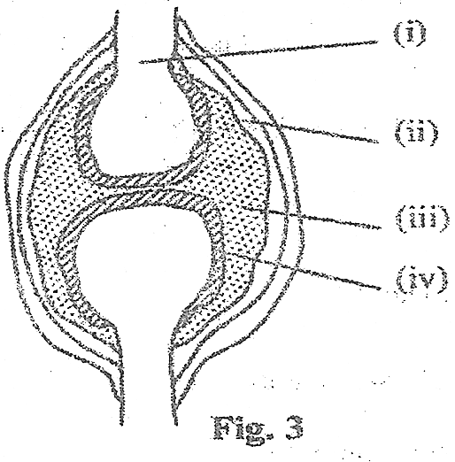

Which one of the following pairs consists of parts which reduce friction during movement in the joint?

A. I and II

B. I and III

C. II and III

D. III and IV

1. Which one of the following correctly describes population density? The number of organisms

A. in a specified area

B. of a particular species in a specified area.

C. living either on land or water

D. one which can interbreed and produce viable offspring

1. Which one of the following is a form of sexual reproduction?

A. binary, fission

B. fragmentation

C. conjugation

D. spore formation

1. Figure 4 is an experimental set up to demonstrate photosynthesis.

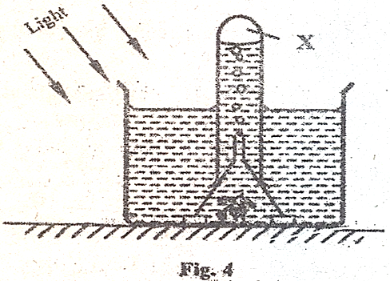

Gas X produced in the experiment is tested by the use of

A. lighted splint

B. lime water

C. litmus paper

D. sodium bicarbonate

1. The main function of buttress roots is to

A. provide additional support

B. store food for the plant

C. enable the plant clasp firmly onto others

D. store water for the plant

1. The bacteria which convert ammonia into nitrates are called

A. putrefying bacteria

B. nitrifying bacteria

C. denitrifying bacteria

D. nitrogen fixing bacteria

1. Which one of the following is likely to occur if the osmotic pressure of the cell sap of the root hair is lower than that of the surrounding?

A. plant wilts

B. cells of root hairs become turgid

C. rate of transpiration

D. more water is absorbed

1. Which one of the following foods is rich in iron?

A. Milk

B. Cheese

C. Liver

D. Butter

1. Which one of the following features of arthropods would be least important when constructing an identification key?

A. presence or absence of antennae

B. Number of body divisions

C. Body colour

1. Which one of the following conditions would lead to the highest transpiration rate?

A. high light intensity and low temperature

B. low light intensity and high temperatures

C. low humidity and high temperatures

D. high humidity and low temperatures

1. Which one of the following parts of the kidney carries out the excretory function?

A. Cortex

B. Pelvis

C. Medulla

D. Nephron

1. Which of the following events result into the formation of identical twins?

A. One egg released, fertilized and splits into two

B. Two eggs released and each fertilized by a separate sperm

C. One egg released and fertilized by two sperms

D. One egg released, splits and fertilized by separate sperms

1. Which one of the following diseases is not prevented by washing of hands and covering of food?

A. Cholera

B. Typhoid

C. Tapeworm infection

D. Dysentery

**SECTION B (40 MARKS)**

*Answer all questions in this section. Answers must be written in spaces provided.*

1. A student carried out an experiment using the set up in figure 5. In set R, bean seeds soaked in water were used. In S, boiled bean seeds sprinkled with a preservative were used, while in T, boiled bean seeds without the preservative were used.

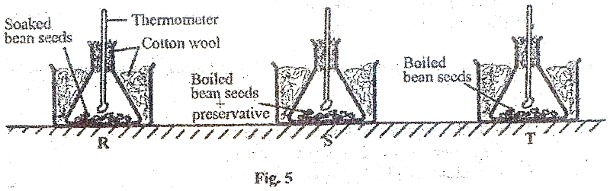

The temperature in each set was recorded for a week. The results obtained are shown in figure 6.

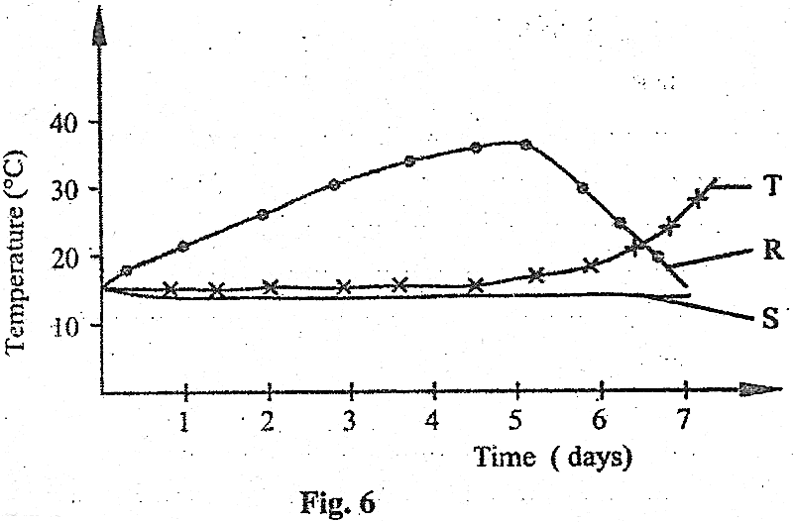

1. State the aim of the experiment? (02 marks)

…………………………………………………………………………………………………………...

…………………………………………………………………………………………………………...

1. Using the information provided, explain the changes in temperature in set R and T,
2. From day 0 to day 5.

In R

…………………………………………………………………………………………………………...

…………………………………………………………………………………………………………...

…………………………………………………………………………………………………………...

…………………………………………………………………………………………………………...

…………………………………………………………………………………………………………...

In T

…………………………………………………………………………………………………………...

…………………………………………………………………………………………………………...

…………………………………………………………………………………………………………...

…………………………………………………………………………………………………………...

…………………………………………………………………………………………………………...

1. After day 5

In R

…………………………………………………………………………………………………………...

…………………………………………………………………………………………………………...

…………………………………………………………………………………………………………...

…………………………………………………………………………………………………………...

…………………………………………………………………………………………………………...

In T

…………………………………………………………………………………………………………...

…………………………………………………………………………………………………………...

…………………………………………………………………………………………………………...

…………………………………………………………………………………………………………...

…………………………………………………………………………………………………………...

1. Explain why there was no significant change in temperature in S for the whole week. (02 marks)

…………………………………………………………………………………………………………...

…………………………………………………………………………………………………………...

…………………………………………………………………………………………………………...

…………………………………………………………………………………………………………...

1. Suggest one way the above set-up could be improved for better results. Give a reason for the suggested improvement. (02 marks)

…………………………………………………………………………………………………………...

…………………………………………………………………………………………………………...

…………………………………………………………………………………………………………...

…………………………………………………………………………………………………………...

1. What other changes would occur in the composition of air in set up R and T during the experiment? (04 marks)

In R

…………………………………………………………………………………………………………...

…………………………………………………………………………………………………………...

…………………………………………………………………………………………………………...

…………………………………………………………………………………………………………...

…………………………………………………………………………………………………………...

In T

…………………………………………………………………………………………………………...

…………………………………………………………………………………………………………...

…………………………………………………………………………………………………………...

…………………………………………………………………………………………………………...

…………………………………………………………………………………………………………...

1. In a breeding experiment, when plants with red flowers were crossed, a total of 898 plants were produced out of which 325 had white flowers.
2. What was the recessive character? Give two reasons. (03 marks)

…………………………………………………………………………………………………………...

…………………………………………………………………………………………………………...

…………………………………………………………………………………………………………...

…………………………………………………………………………………………………………...

…………………………………………………………………………………………………………...

…………………………………………………………………………………………………………...

1. What was the genotype of the parents? (01 mark)

…………………………………………………………………………………………………………...

…………………………………………………………………………………………………………...

…………………………………………………………………………………………………………...

1. Using suitable symbols show the expected phenotype and genotype ratios in the experiment. (04 marks)

…………………………………………………………………………………………………………...

…………………………………………………………………………………………………………...

…………………………………………………………………………………………………………...

…………………………………………………………………………………………………………...

…………………………………………………………………………………………………………...

…………………………………………………………………………………………………………...

…………………………………………………………………………………………………………...

1. Were the observed results in agreement with the laws of monohybrid inheritance? Show your working. (02 marks)

…………………………………………………………………………………………………………...

…………………………………………………………………………………………………………...

…………………………………………………………………………………………………………...

…………………………………………………………………………………………………………...

1. The following organisms live in a national part in Uganda: Bush rat, guinea fowl, hawk, grasshopper, Uganda kob and grass.
2. Show the feeding relationship that exists between these organisms. (03 marks)

…………………………………………………………………………………………………………...

…………………………………………………………………………………………………………...

…………………………………………………………………………………………………………...

…………………………………………………………………………………………………………...

…………………………………………………………………………………………………………...

…………………………………………………………………………………………………………...

1. What name is given to the feeding relationship in (a)? (01 mark)

…………………………………………………………………………………………………………...

…………………………………………………………………………………………………………...

1. Which organisms in the relationship are
2. Primary producers? (01 mark)

…………………………………………………………………………………………………………...

1. Primary consumers? (01 mark)

…………………………………………………………………………………………………………...

1. Secondary consumers? (01 mark)

………………………………………………………………………………………………………….

1. Suggest what would happen in the relationship if Uganda kobs were removed from the park. (03 marks)

…………………………………………………………………………………………………………...

…………………………………………………………………………………………………………...

…………………………………………………………………………………………………………...

…………………………………………………………………………………………………………...

…………………………………………………………………………………………………………...

**SECTION C: (30 MARKS)**

*Answer any two questions.*

1. (a) What is a balanced diet? (01 mark)

(b) In which way is the ileum adapted for its function? (08 marks)

(c) Outline the fate of food after absorption. (06 marks)

1. (a) In what ways is nitrogen added and removed from the soil? (10 marks)

(b) Give the importance of organic matter in the soil. (05 marks)

1. (a) Describe how light, humidity and air movement affect the rate of transpiration in plants. (09 marks)

(b) Describe an experiment to show that more transpiration occurs in the lower epidermis than the upper epidermis of a plant leaf. (06 marks)

1. (a) Describe how the human body controls temperature. (12 marks)

(b) What is the importance of having a constant body temperature? (03 marks)

**2007**

**SECTION A (30 MARKS)**

*Answer all questions in this section.*

1. Which type of fruit is shown in the cross section of figure 1?

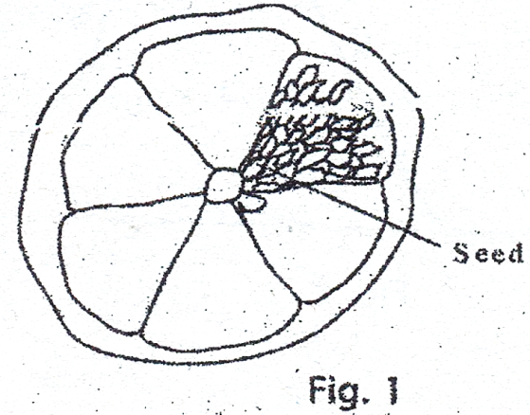

1. Berry
2. Drupe
3. Caryopsis
4. Achene
5. Which one of the following sets of bones make the axial skeleton?

A. Ribs, femur, sternum

B. Sternum, ribs, vertebrae

C. Hind limbs, skull, limb girdle

D. Skull, vertebrae, humerus

1. Which one of the following pairs of insects undergoes incomplete metamorphosis?

A. housefly and mosquito

B. butterfly and cockroach

C. honey bee and moth

D. cockroach and grasshopper

1. Which one of the following occurs in a flower after fertilization?

A. petals, stigma and style persist

B. ovary, petals and sepals dry and fall off

C. ovary, develops into seed coat.

D. ovules develop into seeds.

1. Figure 2 shows the concentration of lactic acid in the blood of an athlete during and after a race. During which period on the graph does the athlete not experience both aerobic and anaerobic respiration?

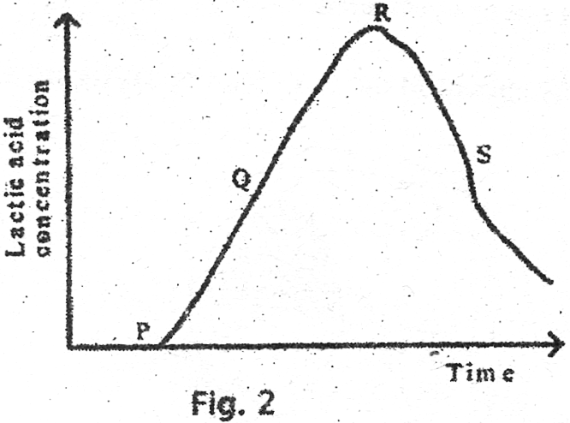

A. P – Q

B. Q – R

C. R – S

D. P – R

1. Which one of the following is not a reproductive and storage organ of a plant?

A. Yam tuber

B. Ginger rhizome

C. Cassava tuber

D. Irish potato tuber

1. Which one of the following secretions does not play a digestive role in the alimentary canal?

A. Pepsin

B. Rennin

C. Trypsin

D. Lipase

1. Which of the following are not social insects?

A. Ants

B. Bees

C. Termites

D. Butterflies

1. Which one of the following does not contribute to the efficiency of a housefly as a vector?

A. Ability to fly

B. feeding on liquid food

C. feeding in dirty places

D. possession of hairs on the body

1. Figure 3 is a transverse section through a dicotyledonous stem.

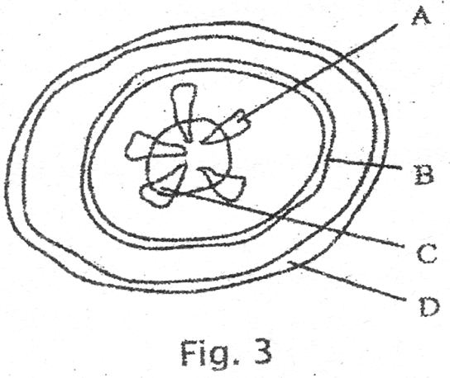

Which one of the parts labelled is used to transport food substances?

1. Which one of the following is the correct order in the level of organization of an organism?

A. cells $⟶$ organs $⟶$ tissues $⟶$ systems

B. tissue $⟶$ organs $⟶$ systems $⟶$ cells

C. cells $⟶$ tissues $⟶$ organs $⟶$ systems

D. organs $⟶$ tissues $⟶$ systems $⟶$ cells

1. Which one of the following modes of reproduction is sexual?

A. spore formation

B. budding

C. fragmentation

D. conjugation

1. Which one of the following blood vessels has the highest level of nutrients?

A. Mesenteric artery

B. Hepatic portal vein

C. Renal Artery

D. Hepatic vein

1. Which one of the following farming practices does not promote soil fertility?

A. strip cropping

B. crop rotation

C. monoculture

D. Mulching

1. The following are characteristics of animals.
2. Jointed appendages
3. Possession of exoskeleton
4. Three body parts
5. Three pairs of limbs

Which set of characteristics is possessed by all arthropods?

1. (i) and (ii)
2. (ii) and (iii)
3. (iii) and (iv)
4. (ii) and (iv)
5. A health worker advised people to do the following

- wash hands before eating

- cover all food

- burn or bury rubbish

- use toilets

Which one of the following disease out breaks was the health worker mainly preventing?

1. Tapeworm
2. Cholera
3. Trachoma
4. Tuberculosis
5. Which one of the following organisms has the largest surface area to volume ratio?
6. Dog
7. Frog
8. Cockroach
9. Amoeba
10. In a certain, offspring of crosses between round – seeded and long – seeded plants were found always to be oval – seeded.

Which one of the following results would be most likely to occur if oval – seeded plants were self-pollinated?

1. 100% oval – seeded
2. 25% oval – seeded, 50% long – seeded, 25% round – seeded
3. 67% oval – seeded, 33% long – seeded
4. 25% long – seeded, 50% oval – seeded, 25% round – seeded
5. Which one of the following parts of the ear, regulates air pressure?
6. Ear drum
7. Oval window
8. Round window
9. Eustachian tube
10. Which one of the following structures of a dicotyledonous seed is correctly matched with its function?

**Structure Function**

1. Micropyle protection
2. Radicle develops into shoot
3. Testa allows in air
4. Cotyledons store food
5. The lead in figure 4 is modified for

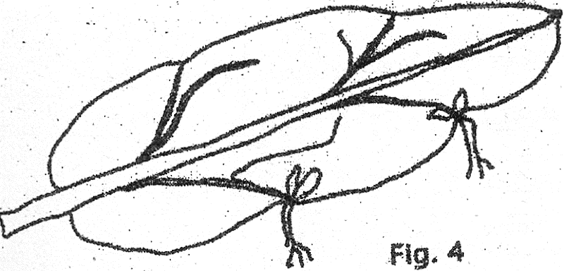

A. absorption of nutrients

B. reproduction

C. photosynthesis

D. water storage

1. Which of the following parts are essential for fertilization?
   * + 1. Filament, style and petal
       2. Petal, receptacle and sepals
       3. Ovary, anther and stigma
       4. Filament, sepal and receptacle
2. Which one of the following enzymes acts in the duodenum and ileum?
3. Lipase
4. Maltase
5. Peptidase
6. Sucrose
7. Which one of the following is a nastic response?
8. Bending of a plant shoot towards light
9. Folding of plant leaflets when touched
10. Growing of plant roots towards water
11. Bending of plant root towards gravity
12. Under activity of the thyroid gland in a child may result into
13. Overweight and sluggishness
14. Thinness and over-activity
15. Stunted growth and mental retardation
16. Increased metabolic rate and restlessness
17. Which one of the following organs excretes urea?
18. Bladder
19. Skin
20. Liver
21. Lungs
22. Which one of the following is not an adaptation of a leaf for absorption of carbon dioxide?
23. Its exposure in the air
24. Presence of airspaces in the mesophyll layer
25. Its being thin
26. Presence of chloroplasts
27. The hormone which causes ovulation is called
28. Follicle stimulating hormone
29. Progesterone
30. Luteinizing hormone
31. Oestrogen
32. Which one of the following would not contribute to the accuracy of the capture-recapture method of estimating population size?
33. Using a stable population
34. Capturing animals selectively
35. Use of very small marks
36. Allowing time before the recapture
37. Which one of the following stores carbon dioxide for a long term, in the carbon cycle?
38. Living animals
39. Dead plants
40. Fossils
41. Living plants

**SECTION B (40 MARKS)**

*Answer all questions in this section.*

1. Table 1 shows the body surface area to volume of two land mammals A and B. Table 2 shows the rate of metabolism in arbitrary units, of the two animals at varying environmental temperatures.

Table 1

|  |  |  |
| --- | --- | --- |
| Mammal | Surface area (m2) | Volume (m3) |
| A | 1.2 | 0.92 |
| B | 0.6 | 0.18 |

Table 2

|  |  |  |
| --- | --- | --- |
|  | Metabolic rate (arbitrary units) | |
| Mammal A | Mammal B |
| 16 | 10.5 | 12.9 |
| 18 | 8.9 | 10.9 |
| 20 | 7.5 | 9.2 |
| 22 | 6.4 | 7.8 |
| 24 | 5.6 | 6.7 |
| 26 | 5.0 | 5.8 |

1. From table 1
2. Work out the surface area: volume ratio of each mammal. (02 marks)

………………………………………………………………………………………………………………..

………………………………………………………………………………………………………………..

………………………………………………………………………………………………………………..

………………………………………………………………………………………………………………..

1. State the structural difference between mammal A and B. (02 marks)

………………………………………………………………………………………………………………..

………………………………………………………………………………………………………………..

………………………………………………………………………………………………………………..

………………………………………………………………………………………………………………..

1. Using the space provided, plot on the same graph the metabolic rate of the two animals against environmental temperature. (07 marks)

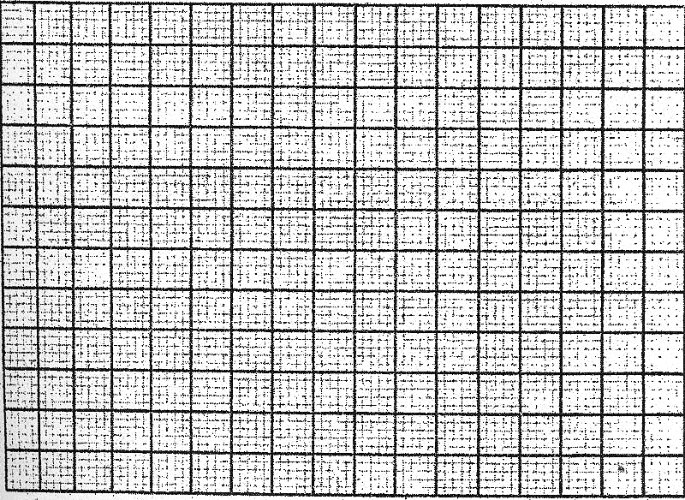

1. From your graph, determine the metabolic rate of each mammal at environmental temperature of 250C. (02 marks)

………………………………………………………………………………………………………………..

………………………………………………………………………………………………………………..

………………………………………………………………………………………………………………..

1. (i) How does environmental temperature affect the metabolic rate of the mammals? (02 marks)

………………………………………………………………………………………………………………..

………………………………………………………………………………………………………………..

………………………………………………………………………………………………………………..

………………………………………………………………………………………………………………..

1. From the information provided explain why at any environmental temperature, the metabolic rate of mammal B is higher than that of mammal A. (03 marks)

………………………………………………………………………………………………………………..

………………………………………………………………………………………………………………..

………………………………………………………………………………………………………………..

………………………………………………………………………………………………………………..

………………………………………………………………………………………………………………..

………………………………………………………………………………………………………………..

1. Withdraw of a hand from a hot object and bending of a plant shoot towards light are examples of sensitivity of living organisms.
2. What is the importance of sensitivity to living organisms? (03 marks)

………………………………………………………………………………………………………………..

………………………………………………………………………………………………………………..

………………………………………………………………………………………………………………..

………………………………………………………………………………………………………………..

………………………………………………………………………………………………………………..

1. State three ways in which the two actions described above differ. (03 marks)

………………………………………………………………………………………………………………..

………………………………………………………………………………………………………………..

………………………………………………………………………………………………………………..

………………………………………………………………………………………………………………..

………………………………………………………………………………………………………………..

………………………………………………………………………………………………………………..

………………………………………………………………………………………………………………..

………………………………………………………………………………………………………………..

1. Suggest the cause of the following defects in humans.
2. Production of large amounts of dilute urine. (01 mark)

………………………………………………………………………………………………………………..

………………………………………………………………………………………………………………..

1. Overweight and sluggishness in an adult individual. (01 mark)

………………………………………………………………………………………………………………..

………………………………………………………………………………………………………………..

1. How does auxin concentration affect the growth of plant roots? (02 marks)

………………………………………………………………………………………………………………..

………………………………………………………………………………………………………………..

………………………………………………………………………………………………………………..

………………………………………………………………………………………………………………..

1. (a) State how flowering plants obtain nitrogen from the soil. (02 marks)

………………………………………………………………………………………………………………..

………………………………………………………………………………………………………………..

………………………………………………………………………………………………………………..

(b) How is nitrogen utilized by plants? (02 marks)

………………………………………………………………………………………………………………..

………………………………………………………………………………………………………………..

………………………………………………………………………………………………………………..

………………………………………………………………………………………………………………..

………………………………………………………………………………………………………………..

(c) Outline the possible sources from which plants obtain nitrates. (04 marks)

………………………………………………………………………………………………………………..

………………………………………………………………………………………………………………..

………………………………………………………………………………………………………………..

………………………………………………………………………………………………………………..

………………………………………………………………………………………………………………..

………………………………………………………………………………………………………………..

………………………………………………………………………………………………………………..

………………………………………………………………………………………………………………..

………………………………………………………………………………………………………………..

………………………………………………………………………………………………………………..

………………………………………………………………………………………………………………..

………………………………………………………………………………………………………………..

(d) Explain why water-logged soils are usually deficient in nitrates. (02 marks)

………………………………………………………………………………………………………………..

………………………………………………………………………………………………………………..

………………………………………………………………………………………………………………..

………………………………………………………………………………………………………………..

**SECTION C (30 MARKS)**

***Answer any two questions***

1. (a) What is meant by **tropism**? (02 marks)

(b) Describe the importance of the difference types of tropisms in plants. (13 marks)

1. (a) Outline the causes of water pollution. (05 marks)

(b) What are the effects of water pollution? (06 marks)

(c) Suggest ways of controlling water pollution. (04 marks)

1. Describe how sound produced externally is heard by the human ear. (15 marks)
2. (a) Outline the importance of wild life conservation. (08 marks)

(b) What are the likely problems to be faced in wildlife conservation? (07 marks)

**2006**

**SECTION A (30 MARKS)**

*Attempt all questions in this section.*

1. Muscles are attached to bones by
2. Cartilages
3. Tendons
4. Muscle fibres
5. Ligaments
6. Which one of the following blood vessels contains blood with the highest amount of oxygen?
7. Venacava
8. Hepatic vein
9. Pulmonary vein
10. Hepatic portal vein
11. A distinguishing feature on the thoracic vertebrae is a
12. Long neural spine
13. Big centrum
14. Small neural canal
15. Pair of large transverse processes
16. When testing for starch in a leaf, it is boiled in alcohol in order to
17. Kill the protoplasm
18. Make it permeable to iodine
19. Remove the chlorophyll
20. Make it soft
21. An insect’s respiratory system consists of
22. Trachea, Tracheoles and bronchioles
23. Spiracles, trachea and Tracheoles
24. Spiracles, trachea and bronchioles
25. Trachea, bronchioles and Tracheoles
26. Which one of the following cell structures is possessed by both animal and plant cells?
27. Chloroplast
28. Cell wall
29. Flagellum
30. Cell membrane
31. Beans are usually included in crop rotation cycle because they
32. Act as cover crops
33. Improve water retention of the soil
34. Increase humus content in the soil
35. Restore nitrogen in the soil
36. In a parasitic association between two organisms,
37. Both members benefit
38. Only one member benefits
39. Both members suffer harm
40. Neither member is harmed
41. Which one of the following pairs of activities consists of correct responses to cold in a mammal?
42. Vasoconstriction, hairs standing
43. Increased metabolism, hairs lying flat
44. Increased sweating, hairs standing
45. Increased blood flow to the skin surface, hairs lying flat.
46. Which one of the following is true of vegetative reproduction?
47. Involves spores
48. Maintains varieties
49. Gametes are transported by water
50. Does not lead to overcrowding
51. Which of the following are end products from digestion of cane sugar?
52. Sucrose and maltose
53. Glucose and fructose
54. Maltose and galactose
55. Fructose and galactose
56. Which one of the following is a characteristic of the class insecta?
57. Cutaneous outer skeleton
58. Jointed limbs
59. Two pairs of wings
60. Three body parts
61. A pure breeding red-flowered plant was crossed with a pure breeding white flowered plant and all the resulting F1 generation had pink flowers.

What percentage of the F2 plants would have red flowers if the F­1 plants were self-pollinated?

1. 100%
2. 50%
3. 33%
4. 25%
5. In grasses, the anthers hang out below the flower and the stigma is held out above the anthers. The importance of this arrangement is to
6. Improve the chances of pollination
7. Encourage cross pollination
8. Minimize waste of pollen grains
9. Encourage self-pollination
10. Which one of the following is correct about nutrition in a *Rhizopus?*
11. Digestion of food occurs outside the organism
12. It makes its own food
13. Digestion of food is intracellular
14. It does not produce enzymes
15. Which one of the following tissues brings about an increase in width of a stem in a flowering plant?
16. Xylem
17. Phloem
18. Cambium
19. Cortex
20. Figure 1 represents a setup of experiments to show the effect of unilateral lighting on plant shoots.

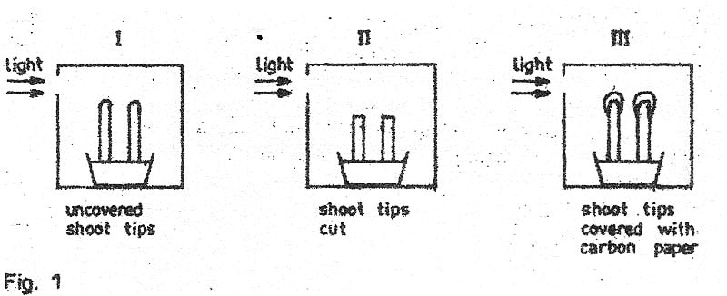

In which experiment(s) would the shoots grow straight?

1. I and II
2. I and III
3. II and III
4. III only
5. The best way to ensure that yeast added to sugar produces ethanol is by
6. Supplying a lot of oxygen to the mixture
7. Placing the mixture in warm conditions
8. Excluding air from the mixture
9. Using a lot of sugar in the mixture
10. Which of the following diseases are all transmitted by mosquitoes?
11. Elephantiasis, river blindness and yellow fever
12. Malaria, elephantiasis and river blindness
13. Yellow fever, river blindness and malaria
14. Yellow fever, malaria and elephantiasis
15. Which one of the following organisms can reproduce both sexually and asexually?
16. Amoeba
17. Spirogyra
18. Bacteria
19. Yeast
20. Which of the following is affected when the cerebrum is damaged?
21. Breathing and heart beat
22. Memory and voluntary actions
23. Body balance and osmoregulation
24. Osmoregulation and temperature control
25. Which one of the following characteristics of an organism is most important in constructing a dichotomous key?
26. Body structure
27. Body colour
28. Body size
29. Age of organism
30. When 80 cm3 of water was added to 100 cm3 of soil, the volume of the mixture was 140 cm3. What was the percentage of air in the soil sample?
31. 20%
32. 40%
33. 60%
34. 80%
35. Cutting of fallopian tubes in a woman prevents conception because
36. Ovaries stop producing eggs
37. Implantation does not occur
38. Sperms do no reach the egg
39. Sperms are destroyed
40. Which one of the following sets of characteristics of leaves enables them to absorb maximum light?
41. Broad lamina, tightly packed palisade cells
42. Being thin, possession of numerous stomata
43. Possession of numerous stomata, waxy cuticle
44. Being thin, large intercellular spaces
45. Figure 2 is a transverse section of a dicotyledonous root.

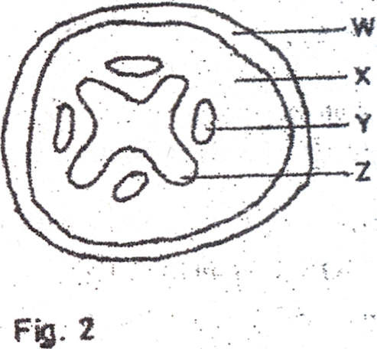

Which one of the parts labelled, is responsible for the conduction of mineral salts and water?

1. W
2. X
3. Y
4. Z
5. Which one of the following characteristics of insects enable them to live in dry habitats?
6. Spiracles
7. Hairy bodies
8. Waxy cuticle
9. Wings
10. Controlled feeding on food rich vitamin A may improve
11. Calcium deposition
12. Number of red blood cells
13. Night vision
14. Healing of wounds
15. Which one of the following sets consists of hormones produced by mammalian reproductive organs?
16. Follicle stimulating hormone and testosterone
17. Progesterone and testosterone
18. Oestrogen and testosterone
19. Follicle stimulating hormone and Oestrogen
20. Lichens are usually the first plants to colonise a rocky surface because they
21. Possess strong roots
22. Require little water
23. Are resistant to desiccation
24. Are able to photosynthesis

**SECTION B (40 MARKS)**

*Answer all questions in this section. Answers must be written in the spaces provided.*

1. Three equal sized shoots X, Y and Z bearing the same number of leaves from similar herbaceous plants were treated as follows:

X – had the upper epidermis of all its leaves covered with petroleum jelly

Y – had the lower epidermis of all its leaves covered with petroleum jelly

Z – all its leaves were left uncovered

The three shots were cut under water and each placed in one of the three identical photometers. All the photometers were then left under a shade. After 5 minutes, the photometer bearing shoot Z was transferred to a sunny place. The movement of the air bubble in each photometer was recorded every time for 10 minutes. The results are shown in figure 3.

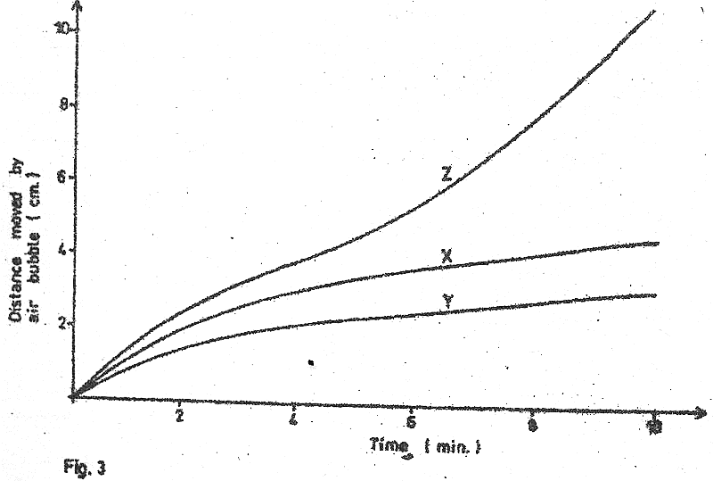

1. Describe the pattern of movement of the air bubble in each of the three photometers during the time of the experiment.
2. X (02 marks)

……………………………………………………………………………………………………….

……………………………………………………………………………………………………….

……………………………………………………………………………………………………….

1. Y (02 marks)

……………………………………………………………………………………………………….

……………………………………………………………………………………………………….

……………………………………………………………………………………………………….

1. Z (04 marks)

……………………………………………………………………………………………………….

……………………………………………………………………………………………………….

……………………………………………………………………………………………………….

……………………………………………………………………………………………………….

1. Explain the pattern of movement of the air bubble in each photometer.
2. X (02 marks)

……………………………………………………………………………………………………….

……………………………………………………………………………………………………….

……………………………………………………………………………………………………….

……………………………………………………………………………………………………….

……………………………………………………………………………………………………….

1. Y (02 marks)

……………………………………………………………………………………………………….

……………………………………………………………………………………………………….

……………………………………………………………………………………………………….

……………………………………………………………………………………………………….

……………………………………………………………………………………………………….

1. Z (05 marks)

……………………………………………………………………………………………………….

……………………………………………………………………………………………………….

……………………………………………………………………………………………………….

……………………………………………………………………………………………………….

……………………………………………………………………………………………………….

……………………………………………………………………………………………………….

1. Why were similar shoots and photometers used and all the three photometers placed under a shade? (01 mark)

……………………………………………………………………………………………………….

……………………………………………………………………………………………………….

……………………………………………………………………………………………………….

1. The movement of the air bubble in the photometer is a measure of water uptake rather than water loss. Why is this so? (02 marks)

……………………………………………………………………………………………………….

……………………………………………………………………………………………………….

……………………………………………………………………………………………………….

……………………………………………………………………………………………………….

……………………………………………………………………………………………………….

……………………………………………………………………………………………………….

………………………………………………………………………………………………………

1. Figure 4 represents the carbon cycle.

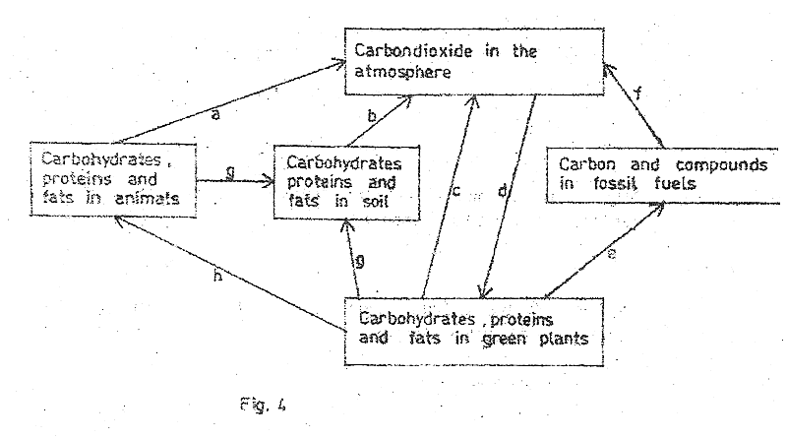

1. Name the processes labeled a, c, f and g (02 marks)
2. ………………………………………………………………………………………………

c. ……………………………………………………………………………………………..

1. ………………………………………………………………………………………………
2. ………………………………………………………………………………………………
3. State one physical factor that promotes process b. (01 mark)

……………………………………………………………………………………………………….

1. Give two uses of process d to animals. (02 marks)

……………………………………………………………………………………………………….

……………………………………………………………………………………………………….

……………………………………………………………………………………………………….

……………………………………………………………………………………………………….

1. Describe one way in which process e may be harmful. (02 marks)

……………………………………………………………………………………………………….

……………………………………………………………………………………………………….

……………………………………………………………………………………………………….

……………………………………………………………………………………………………….

1. (i) Suggest one human activity that tends to lower the level of carbon dioxide in the atmosphere. (01 mark)

……………………………………………………………………………………………………….

……………………………………………………………………………………………………….

(ii) Explain how the activity suggested in (e)(i) lowers the level of carbon dioxide in the atmosphere. (02 marks)

……………………………………………………………………………………………………….

……………………………………………………………………………………………………….

……………………………………………………………………………………………………….

……………………………………………………………………………………………………….

1. Figure 5 represents a section through a mammalian eye.

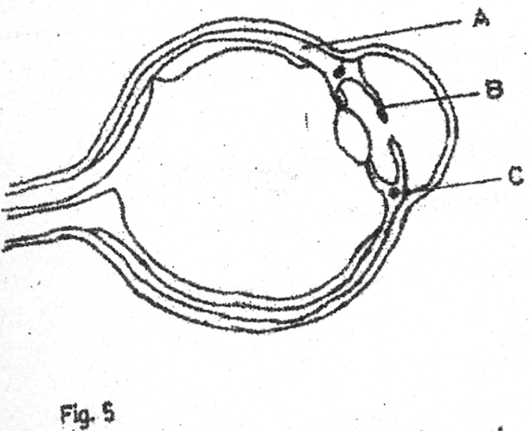

1. Give two functions of structure A to the eye. (02 marks)

……………………………………………………………………………………………………….

……………………………………………………………………………………………………….

……………………………………………………………………………………………………….

……………………………………………………………………………………………………….

1. (i) What stimulus does structure B respond to? (01 mark)

……………………………………………………………………………………………………….

(ii) How does structure B respond to the stimulus stated in (b)(i)? (03 marks)

……………………………………………………………………………………………………….

……………………………………………………………………………………………………….

……………………………………………………………………………………………………….

……………………………………………………………………………………………………….

……………………………………………………………………………………………………….

1. How is part C involved in the change of focus of the eye from a distant object to a near object? (04 marks)

……………………………………………………………………………………………………….

……………………………………………………………………………………………………….

……………………………………………………………………………………………………….

……………………………………………………………………………………………………….

……………………………………………………………………………………………………….

……………………………………………………………………………………………………….

……………………………………………………………………………………………………….

**SECTION C: (30 MARKS)**

*Answer any* ***two*** *questions.*

1. (a) What is the importance of bile in digestion? (02 marks)

(b) How does the body

(i) regulate the level of glucose in the blood? (07 marks)

(ii) deal with amino acids? (06 marks)

1. (a) Explain how flowers are adapted to wind pollination. (10 marks)

(b) What are the benefits of sexual reproduction in plants? (05 marks)

1. (a) (i) What is meant by mitosis? (02 marks)

(ii) What is the importance of mitosis to living things? (08 marks)

(b) Give differences between mitosis and meiosis? (05 marks)

1. (a) How are birds adapted to flight? (05 marks)

(b) With the aid of diagrams, describe how wings are moved up and down during flight in a bird. (10 marks)

**2005**

**SECTION A (30 MARKS)**

1. Which one of the following organisms improves secretion and drainage of soil?
2. Fungi
3. Snails
4. Bacteria
5. Termites
6. Which one of the following groups contains the largest number of organisms?
7. Order
8. Species
9. Class
10. Phylum
11. People living at high altitudes have more red blood cells than those at lower altitudes in order to
12. Breathe more quickly
13. Keep the body warm
14. Pump more blood
15. Absorb enough oxygen
16. Which one of the following best describes the effect of one – sided illumination on the distribution of auxins in a shoot tip?
17. The auxins are evenly distributed around tip
18. The light inhibits movement of auxins down the tip
19. There is a reduction of auxins on the illuminated side of the tip
20. The auxins increase on the illuminated side of the tip
21. The group of organs performing excretory functions is
22. Kidneys, lungs and skin
23. Liver, kidneys and pancreas
24. Skin, kidneys and pancreas
25. Lungs, spleen and gall bladder
26. A cuticle may be regarded as a disadvantage to insects mainly because
27. It does not allow rapid locomotion
28. It limits the size of insects
29. Does not prevent water loss
30. Does not allow gaseous exchange
31. The best description of the leaf in fig. 1 is

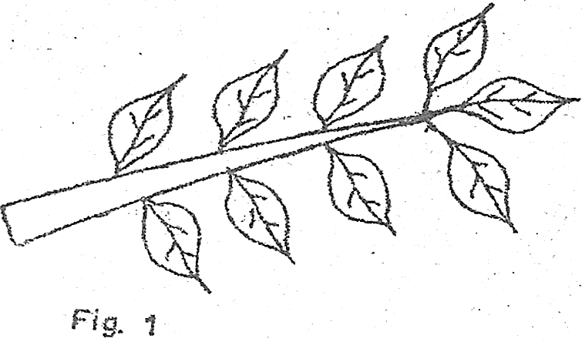

1. Pinnate and parallel veined
2. Palmate and net veined
3. Pinnate and net – veined
4. Bi pinnate and parallel veined
5. Which one of the following structures of the ear equalizes pressure on both sides of the ear drum?
6. Oral window
7. Eustachian tube
8. Semi – circular canal
9. Round window
10. Which one of the following shows the correct path followed by the sperms when ejaculated?
11. Seminiferous tubules $⟶$ epididymis $⟶$ sperm ducts $⟶$ uretha
12. Epididymis $⟶$ seminiferous tubules $⟶$ urethra $⟶$ sperm ducts
13. Sperm ducts $⟶$ seminiferous tubules $⟶$ epididymis $⟶$ uretha
14. Seminiferous tubules $⟶$ urethra $⟶$ sperm ducts $⟶$ epididymis
15. Stunted growth and mental retardation in children may be due to
16. Under production of pituitary hormone
17. Under production of insulin
18. Deficiency of thyroxine hormone
19. Deficiency in adrenaline hormone
20. Which of the following monosacharides make up sucrose?
21. Galactose and fructose
22. Galactose and glucose
23. Fructose and glucose
24. Two glucose molecules
25. Which of the following parts of a microscope are adjusted in order to bring the specimen into focus?
26. Eyepiece and coarse adjustment
27. Coarse and fine adjustment
28. Eyepiece and fine adjustment
29. Mirror and fine adjustment
30. P, Q, R and S are characteristics of insects

P – undergo complete metamorphosis

Q – possess wings

R – have three pairs of legs

S – divided into three body parts

Which of them are common to all insects?

1. P and Q
2. R and S
3. Q and S
4. P and R
5. Which of the following is not a characteristic of a respiratory surface?
6. Thin walls
7. Moist surface
8. Densely supplied with capillaries
9. Smooth surface
10. Green plants give less carbon dioxide during day than at night because during day
11. The rate of photosynthesis is low
12. Transpiration interferes with escape of carbon dioxide
13. Most stomata close
14. Some of the carbon dioxide produced is used for photosynthesis
15. In comparison with the blood flowing through the vena cava, the blood flowing through the aorta has
16. Less carbon dioxide, more oxygen and higher pressure
17. More oxygen, more carbon dioxide and lower pressure
18. Less carbon dioxide, less oxygen and lower pressure
19. More carbon dioxide, less oxygen and higher pressure
20. Which of the following organs contain glands which are part of the endocrine system?
21. Liver, pancreas, heart
22. Brain, pancreas, ovary
23. Brain, testes, heart
24. Kidney, heart, liver
25. Oxygen debt occurs during active physical exercise in mammals because
26. Alcohol accumulates in the body
27. Of anaerobic respiration that occurs
28. Of high rate of breathing during exercise
29. Carbon dioxide produced accumulates during the exercise
30. Which one of the following explains why a rat loses heat more rapid to the surroundings than an elephant?
31. A rat has smaller ears than an elephant
32. A rat has a higher metabolic rate than an elephant
33. Surface area : volume ratio of a rat is higher than that of an elephant
34. A rat has fewer hairs than an elephant
35. Which one of the following is responsible for a decrease in dry weight of a seed during germination?
36. The seed loses more water than it absorbs
37. Soluble food materials are converted to starch
38. Stored food is used up
39. Soluble food materials are lost into the soil
40. Which one the following is not affected by environmental factors?
41. Height
42. Skin colour
43. Albinism
44. Intelligence
45. Which one of the following would occur if the number of predatory bugs was increased in the food chain below?

Plants $⟶$ caterpillars $⟶$ Predatory bugs $⟶$ birds

1. Decrease in number of birds
2. Increase in number of plants
3. Increase in number of plants
4. Decrease in number of plants
5. Which one of the following structures of a flower develops into a seed coat after fertilization?
6. Embryo sac
7. Integuments
8. Receptacle
9. Ovary
10. Which one of the following would happen to plasmolysed cells of a plant tissue that has been placed in water for some time?
11. Their cell vacuoles would shrink
12. They would not experience any change in size
13. They would increase in volume
14. They would become shorter
15. Which one of the following is part of the axial skeleton?
16. Humerus
17. Femur
18. Thoracic vertebra
19. Ulna
20. When homozygous red-flowered plants were crossed with homozygous white-flowered plants, all the plants produced had pink flowers. What would be the phenotype ratio of plants resulting from a cross of pink-flowered plants?
21. 3 red-flowered: 1 white-flowered
22. 1 red-flowered: 3 white-flowered
23. 1 red-flowered: 2 pink-flowered plant, 1 white-flowered
24. 2 red-flowered: 1 pink-flowered, 1 white-flowered
25. When milk is the main food in the diet of a child, it should be supplemented with food rich in
26. Iron
27. Calcium
28. Sugar
29. Vitamin D
30. In which of the following are the largest amounts of nitrogenous wastes excreted?
31. Urine
32. Sweat
33. Breath
34. Feaces
35. Which of the following describes internal respiration?
36. Breathing in and releasing of oxygen into the tissues.
37. Getting rid of carbon dioxide accumulated in the tissue
38. Building up of complex substances
39. Oxidation of food substances to release energy
40. Which one of the following is the least important function of humus in the soil?
41. Improving soil aeration
42. Prevention of soil erosion
43. Water retention
44. Increasing soil fertility

**SECTION B: (40 MAKRS)**

*Answer all questions in this section. Answers must be written in the spaces provided.*

1. Six identical potato cylinders measuring 2.0 cm in length were each placed in a different concentration of sugar solution. After two hours, the potato cylinders were removed from the solutions and re measured. The table below shows the results.

|  |  |  |
| --- | --- | --- |
| **Concentrations of sugar**  **Solutions mol *l*-1** | **Length of potato cylinders**  **After 2 hours (cm)** | **Difference in length**  **Of potato cylinders**  **After 2 hrs (cm)** |
| 0.1  0.2  0.3  0.4  0.5  0.6 | 2.40  2.25  2.15  2.05  1.98  1.02 |  |

1. Complete the table by filling in the difference in length of each potato cylinder after two hours (i.e length after 2 hours subtract initial length) (03 marks)
2. In the space provided plot a graph of the difference in length after 2 hours against concentration of sugar solutions. (05 marks)

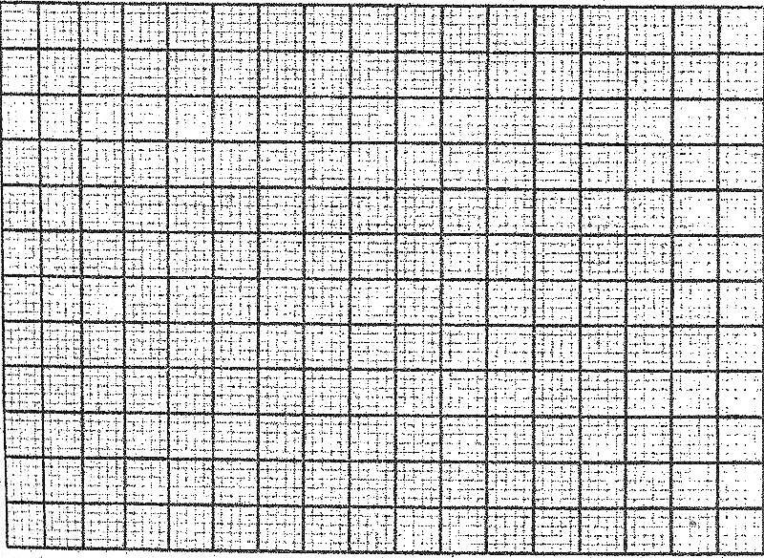

1. (i) What was the effect of the concentration of the sugar solutions on the length of the potato cylinders? (04 marks)

………………………………………………………………………………………………………

………………………………………………………………………………………………………

………………………………………………………………………………………………………

………………………………………………………………………………………………………

………………………………………………………………………………………………………

(ii) Explain why the concentration of the sugar solutions affected the length of the potato cylinders as stated in (c)(i). (03 marks)

………………………………………………………………………………………………………

………………………………………………………………………………………………………

………………………………………………………………………………………………………

………………………………………………………………………………………………………

………………………………………………………………………………………………………

………………………………………………………………………………………………………

1. (i) From your graph, determine the concentration of the sugar solution that would give no difference in length of a potato cylinder. (01 mark)

………………………………………………………………………………………………………

(ii) Explain what happens in a potato cylinder when no change in length occurs. (02 marks)

………………………………………………………………………………………………………

………………………………………………………………………………………………………

………………………………………………………………………………………………………

1. Suggest one other observation other than change in size that would be made on the potato cylinders.

………………………………………………………………………………………………………

………………………………………………………………………………………………………

………………………………………………………………………………………………………

………………………………………………………………………………………………………

………………………………………………………………………………………………………

………………………………………………………………………………………………………

……………………………………………………………………………………………………….

1. Fig. 2 shows the relationship between blood supply of the embryo, placenta and uterus.

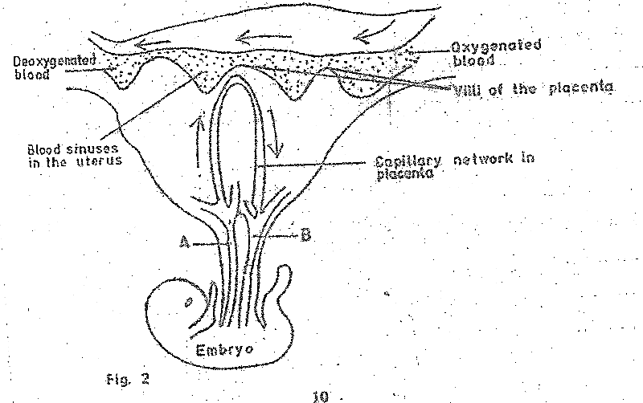

1. State the functions of the;
2. Placenta to the embryo (04 marks)

……………………………………………………………………………………………………….

……………………………………………………………………………………………………….

……………………………………………………………………………………………………….

……………………………………………………………………………………………………….

……………………………………………………………………………………………………….

1. Villi on the placenta (02 marks)

……………………………………………………………………………………………………….

……………………………………………………………………………………………………….

……………………………………………………………………………………………………….

……………………………………………………………………………………………………….

1. Give two reasons why the mother’s blood does not mix with that of the embryo. (02 marks)

……………………………………………………………………………………………………….

……………………………………………………………………………………………………….

……………………………………………………………………………………………………….

……………………………………………………………………………………………………….

1. Give two differences in the composition between the blood in vessels A and B. (02 marks)

……………………………………………………………………………………………………….

……………………………………………………………………………………………………….

……………………………………………………………………………………………………….

1. (a) What is meant by genotype? (01 mark)

……………………………………………………………………………………………………….

……………………………………………………………………………………………………….

(b) A man of blood group A married a woman homozygous for blood group B and they produced a son of blood group B.

(i) Work out the genotypes of the father and of the son. (04 marks)

……………………………………………………………………………………………………….

……………………………………………………………………………………………………….

……………………………………………………………………………………………………….

……………………………………………………………………………………………………….

……………………………………………………………………………………………………….

……………………………………………………………………………………………………….

……………………………………………………………………………………………………….

(ii) The son married a wife of blood group O. showing your working, give the percentages of the possible phenotypes of their offspring. (03 marks)

……………………………………………………………………………………………………….

……………………………………………………………………………………………………….

……………………………………………………………………………………………………….

……………………………………………………………………………………………………….

……………………………………………………………………………………………………….

……………………………………………………………………………………………………….

……………………………………………………………………………………………………….

(c) Blood groups in humans, show discontinuous variation. Explain what you understand by this statement. (02 marks)

……………………………………………………………………………………………………….

……………………………………………………………………………………………………….

……………………………………………………………………………………………………….

……………………………………………………………………………………………………….

**SECTION C: (30 MARKS)**

*Answer any two questions.*

1. (a) What are the constituents of fertile soil? (03 marks)

(b) In what ways may human activities:

(i) improve soil? (06 marks)

(ii) degrade soil? (06 marks)

1. (a) Describe the structure of the different types of a bird’s feathers, stating the function of each type. (06 marks)

(b) What factors contribute to the bird’s ability to fly? (09 marks)

1. (a) Draw and label a transverse section of a stem of a herbaceous dicotyledonous plant. (03 marks)

(b) State the function of five of the parts that can be identified in the section. (05 marks)

(c) Describe how stems are modified to perform other functions other than conducting materials within the plant. (07 marks)

1. (a) What is meant by excretion? (02 marks)

(b) Describe how carbon dioxide is removed from the mammalian body tissue into the atmosphere. (13 marks)

**2004**

**SECTION A (30 MARKS)**

*Attempt all questions in this section.*

1. Which of the following are structural adaptations to flight in birds?
2. Light bones and webbed feet
3. Webbed feet and light feathers
4. Streamlined body and light bones
5. Smooth body and light feathers
6. In which of the following associations do both organisms benefit?
7. Malarial parasite and human
8. Tapeworm and human
9. A fungal parasite and plant
10. Nitrogen fixing bacteria and leguminous plant
11. Which one of the following methods would be best for estimating the population density of rats in a bush?
12. Direct counting
13. Quadrant counting
14. Line transect
15. Capture-recapture method
16. Addition of humus to a sandy soil would
17. Decrease the capillarity of the soil
18. Increase the aeration of the soil
19. Decrease mineral content of the soil
20. Improve the water retention capacity of the soil
21. At which of the following levels of classification can organisms interbreed and produce fertile offspring?
22. Class
23. Species
24. Phylum
25. Kingdom
26. By which one of the following processes does carbon dioxide leave the blood capillaries into the alveoli?
27. Osmosis
28. Active transport
29. Diffusion
30. Capillarity
31. Which one of the following parts of the mammalian ear is concerned with balance?
32. Cochlea
33. Semi – circular canal
34. Eustachian tube
35. Oval window
36. The main reason why birds sit on their eggs during the incubation period is to ensure that
37. Hatching occurs quickly
38. Rain does not destroy eggs
39. Eggs are kept at a constant temperature
40. All eggs develop chicks at the same time
41. Which one of the following would be a correct sequence of plant succession on an abandoned tarmac road?
42. Mosses $⟶$ herbs $⟶$ shrubs $⟶$ trees
43. Herbs $⟶$ mosses $⟶$ shrubs $⟶$ trees
44. Shrubs $⟶$ herbs $⟶$ trees $⟶$ mosses
45. Mosses $⟶$ herbs $⟶$ trees $⟶$ shrubs
46. Which one of the following is likely to cause pollution in water bodies?
47. Over fishing
48. Boat racing
49. Use of fertilisers
50. Use of farmyard manure
51. When a growing shoot is placed horizontally, it bends upwards after sometime. Which of the following;
52. High auxin concentration on the upper side inhibits growth on the upper side
53. High auxin concentration on the lower side makes the lower side grow faster.
54. Lack of auxin on the upper side inhibits growth on the upper side.
55. Low auxin concentration on the lower side makes the lower side grow faster
56. Which one of following is an advantage of vegetative propagation?
57. Competition between parent and offspring is minimal
58. Colonization of new habitats is fast
59. Variation among offspring occurs
60. Maintenance of parental characteristics in offspring
61. Which one of the following excretory products are removed from the body by the kidney?
62. Urea, excess water and excess salts
63. Urea, excess water and carbon dioxide
64. Carbon dioxide, excess water and excess salts
65. Carbon dioxide, urea and excess salts
66. Which one of the following pairs of organs is important in the digestion of fats?
67. Stomach and liver
68. Pancreas and stomach
69. Liver and pancreas
70. Stomach and mouth
71. Which of the following describes the carrying capacity of a population?
72. Maximum number of organisms that can reproduce freely in a habitat
73. Area occupied by organisms of different species
74. Maximum number of organisms that can be supported by a specific area.
75. Maximum number of plants that can support animals in a given area
76. Fig. 1 shows how the body temperature of animals A and B vary with environmental temperature.

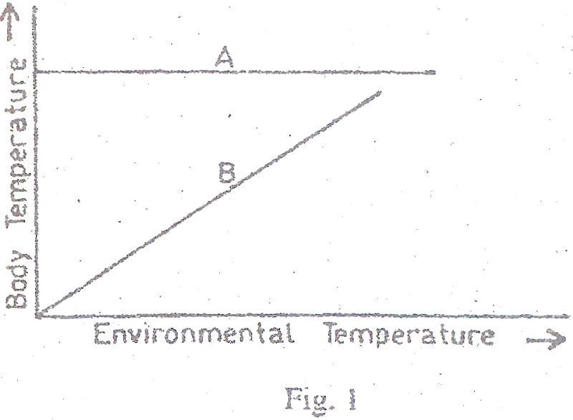

Which one of the following is demonstrated in the figure?

1. Body temperature of A is dependent on environmental temperature
2. Body temperature of B is dependent on environmental temperature
3. A has a higher body temperature than B
4. B loses more heat than A
5. Which of the following features show continuous variation?
6. A, B and O blood groups
7. Sickle cells
8. Heamophilia
9. Height
10. Which of the following is a likely effect of a decrease in the number of platelets in the blood?
11. The blood may not be able to carry enough oxygen
12. There may be prolonged bleeding in case of an injury
13. The body may not be able to fight disease
14. The body may not be able to distribute heat efficiently
15. Which one of the following characteristics may be used to determine whether leaves are compound?
16. Nature of margin
17. Number of leaflets
18. Type of venation
19. Presence of leaflets
20. The following events occur during germination of a bean seed.
21. Development of lateral crops
22. Growth of radicle out of the testa
23. Hypocotyl pulls cotyledons out of soil
24. Growth of root hairs

Which one of the following gives the correct sequence of the events?

1. (i), (ii), (iii) and (iv)
2. (ii), (iii), (iv) and (iii)
3. (ii), (iv), (i) and (iii)
4. (ii), (i), (iii) and (iv)
5. Which one of the following stimulates the reabsorption of water in the kidneys?
6. Adrenalin
7. Antidiuretic hormone
8. Thyroxine
9. Insulin
10. The best explanation for panting of an athlete immediately after a race is to
11. Allow fast blood flow to the lungs
12. Restore the used up energy
13. Take in more oxygen
14. Allow fast blood flow from the muscles
15. During pregnancy in humans, the substances that pass from the mother to the embryo are
16. Oxygen, nitrogenous wastes and glucose
17. Glucose, amino acids and oxygen
18. Carbon dioxide, mineral salts and nitrogenous wastes
19. Carbon dioxide, amino acids and mineral salts
20. An endosperm is formed in plants when the second male nucleus fuses with the
21. Egg nucleus
22. Polar nuclei
23. Antipodal nuclei
24. Embryo sac
25. In a pea plants, tallness is dominant over shortness. If a heterozygous tall plant is crossed with a short plant, the proportion of the offspring will be
26. 50% tall, 50% short
27. 100% tall
28. 25% tall, 75% short
29. 75% tall, 25% short
30. A farmer grew beans and noticed that the leaves turned yellow but the veins remained green. The minerals likely to be deficient in the soil are
31. Magnesium and iron
32. Potassium and manganese
33. Calcium and potassium
34. Zinc and calcium
35. Which of the following conditions increase the rate of transpiration?
36. High temperature windy conditions and high humidity
37. Low temperatures, windy conditions and high humidity
38. High temperatures, low windy humidity and windy conditions
39. Low temperatures, low humidity and still air
40. Which of the following parts of a microscope magnify the object?
41. Eyepiece and mirror
42. Objective lens and mirror
43. Eyepiece and objective lens
44. Eyepiece and fine adjustment
45. Which one of the following shows the correct order of cell organization?
46. Organism $⟶$ system $⟶$ organ
47. Tissue $⟶$ organ $⟶$ organism
48. Organ $⟶$ tissue $⟶$ organism
49. Tissue $⟶$ organ $⟶$ system
50. Which one of the following is a long term adaptation of mammals to low temperature environment?
51. Raising of hair
52. Increase in metabolic rate
53. Deposition of fats under the skin
54. Reduction of blood flow to the skin

**SECTION B (40 MARKS)**

*Answer all questions in this section.*

1. The table below shows the percentage composition of inhaled and exhaled air, in a human being at rest and also the composition of exhaled air, during exercise. Use the information in the table to answer the questions that follow.

|  |  |  |  |  |
| --- | --- | --- | --- | --- |
| Inhaled air at rest | Water Vapour | Nitrogen | Carbon dioxide | Oxygen |
| Variable | 79% | 0.03% | 20.96% |
| Exhaled air at rest | 0.8% | 79% | 4.1% | 16.2% |
| Exhaled air during exercise | 0.92% | 79% | 4.5% | 15.58% |

1. State the differences in composition between inhaled and exhaled air at rest. (03 marks)

…………………………………………………………………………………………………………...

…………………………………………………………………………………………………………...

…………………………………………………………………………………………………………...

…………………………………………………………………………………………………………...

…………………………………………………………………………………………………………...

…………………………………………………………………………………………………………...

1. Give a reason for each difference stated in (a). (06 marks)

…………………………………………………………………………………………………………...

…………………………………………………………………………………………………………...

…………………………………………………………………………………………………………...

…………………………………………………………………………………………………………...

…………………………………………………………………………………………………………...

…………………………………………………………………………………………………………...

…………………………………………………………………………………………………………...

…………………………………………………………………………………………………………...

…………………………………………………………………………………………………………...

…………………………………………………………………………………………………………...

1. State the changes that occur in the composition of exhaled air in a human being who is previously at rest, then takes an exercise. (03 marks)

…………………………………………………………………………………………………………...

…………………………………………………………………………………………………………...

…………………………………………………………………………………………………………...

…………………………………………………………………………………………………………...

…………………………………………………………………………………………………………...

1. Give a reason why each stated in (c) occurs. (03 marks)

…………………………………………………………………………………………………………...

…………………………………………………………………………………………………………...

…………………………………………………………………………………………………………...

…………………………………………………………………………………………………………...

…………………………………………………………………………………………………………...

…………………………………………………………………………………………………………...

1. During exercise, the breathing rate increases. From the information provided, suggest why this happens. (03 marks)

…………………………………………………………………………………………………………...

…………………………………………………………………………………………………………...

…………………………………………………………………………………………………………...

…………………………………………………………………………………………………………...

…………………………………………………………………………………………………………...

…………………………………………………………………………………………………………...

…………………………………………………………………………………………………………...

1. Why is the percentage of nitrogen constant in inhaled and exhaled air? (02 marks)

…………………………………………………………………………………………………………...

…………………………………………………………………………………………………………...

…………………………………………………………………………………………………………...

…………………………………………………………………………………………………………...

…………………………………………………………………………………………………………...

1. To investigate the effect of carbon dioxide on photosynthesis, a green plant was destarched by leaving it in darkness for 24 hours. After destarching, immediately tested for starch. The set up was then left in light for 12 hours after which leaves A and C were tested for starch.

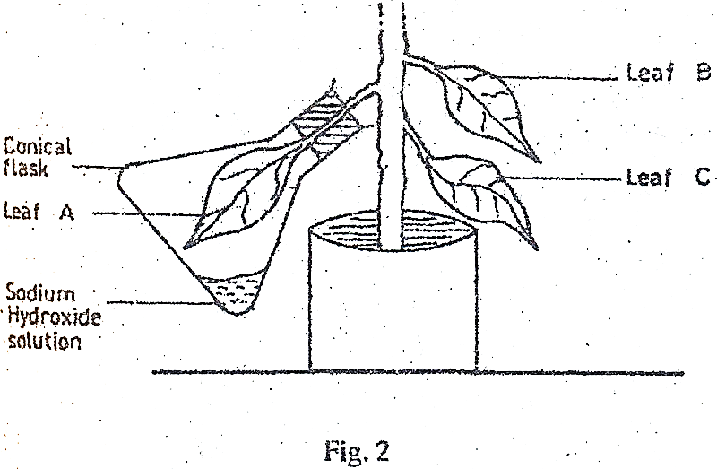

1. Why was sodium hydroxide used in the experiment? (01 mark)

………………………………………………………………………………………………………

………………………………………………………………………………………………………

1. State two reasons why when the plant was placed in darkness f0r 24 hours it became destarched.

………………………………………………………………………………………………………

………………………………………………………………………………………………………

………………………………………………………………………………………………………

1. State the purpose of including each of leaves B and C in the experiment. (02 marks)
2. Leaf B

………………………………………………………………………………………………………

………………………………………………………………………………………………………

1. Leaf C

………………………………………………………………………………………………………

………………………………………………………………………………………………………

1. What was observed when each leaves A, B and C were tested for starch? (03 marks)
2. Leaf A

………………………………………………………………………………………………………

………………………………………………………………………………………………………

1. Leaf B

………………………………………………………………………………………………………

………………………………………………………………………………………………………

1. Leaf C

………………………………………………………………………………………………………

………………………………………………………………………………………………………

1. Give reasons why each of the following is carried out while testing a leaf for starch.
2. Put a leaf in boiling water. (02 marks)

………………………………………………………………………………………………………

………………………………………………………………………………………………………

1. Put a leaf in hot ethanol (02 marks)

………………………………………………………………………………………………………

………………………………………………………………………………………………………

1. (a) What do you understand by a recessive gene? (02 mark)

………………………………………………………………………………………………………

………………………………………………………………………………………………………

……………………………………………………………………………………………………….

(b) A man who is a carrier for albinism married a normal woman. Using suitable symbols, work out the proportions of the possible genotypes and phenotypes of their children. (06 marks)

………………………………………………………………………………………………………

………………………………………………………………………………………………………

………………………………………………………………………………………………………

………………………………………………………………………………………………………

………………………………………………………………………………………………………

………………………………………………………………………………………………………

(c) Give two benefits of studying human genetics. (02 marks)

………………………………………………………………………………………………………

………………………………………………………………………………………………………

………………………………………………………………………………………………………

………………………………………………………………………………………………………

………………………………………………………………………………………………………

**SECTION C (30 MARKS)**

*Answer any two questions*

1. (a) Explain the value of earthworm in maintaining the soil in a condition suitable for crop growth? (07 marks)

(b) How does clay affect the fertility of soil? (08 marks)

1. (a) What are the functions of a skeleton in mammals? (04 marks)

(b) With the aid of a labelled diagram, describe how movement is caused in a named hinge joint in a mammal. (11 marks)

1. (a) What factors are necessary for germination in seeds? (1 ½ marks)

(b) Using labelled diagrams, describe experiments to show the necessity of each factor for germination. (13 ½ marks)

1. In humans, the blood circulatory and lymphatic systems transport body fluids.
2. Outline the functions of the lymphatic system. (04 marks)
3. Explain the changes that occur in the composition of blood as it passes through the capillaries of the following parts of the body.
4. Lungs (03 marks)
5. Liver (05 marks)
6. Kidneys (03 marks)

**2003**

**SECTION A (30 MARKS)**

1. The following are conditions necessary for germination except
2. Oxygen
3. Moisture
4. Moderate temperature
5. Carbon dioxide
6. The main value of panting in a dog is that
7. Excess water is removed from the body
8. Latent heat of vaporization of water cools the body
9. Excess mineral salts are removed from the body
10. The dog relaxes from exhaustion
11. Which one of the following is true about a person of blood group O?
12. Receives blood from people of all other blood groups
13. Donates blood to people of all other blood groups
14. Receives blood from only people of blood groups AB and O
15. Donates blood to only people of blood group AB
16. The main value of sweating in man is that during the process
17. Excess water is lost
18. Excess salts are got rid of
19. The body is cooled
20. Excess nitrogenous waste is got rid of
21. Sexual reproduction in spirogyra is described as
22. Fragmentation
23. Conjugation
24. Binary fission
25. Budding
26. Lack of a nucleus in a red blood cell is advantageous in that it
27. Enables the cell to pass through thin epithelium ]
28. Allows the cell to fight disease-causing organisms.
29. Allows the cell to carry a lot of oxygen
30. Enables the cell to carry much dissolved food
31. Which of the following parts of a flower is not essential for reproduction?
32. Corolla
33. Stigma
34. Style
35. Anther
36. Mitosis is different from malaria in that mitosis results into
37. Four daughter cells with equal matter
38. Two daughter cells with equal genetic matter
39. Four daughter cells with half the genetic matter
40. Two daughter cells with half the genetic matter
41. The role of rennin in children during digestion is
42. Breaking down milk protein into peptides
43. Mixing the milk protein with digestive enzyme
44. Activating pepsin to digest the milk protein
45. Coagulating milk protein
46. Which one of the following is a reaction to over – cooling by a mammalian body?
47. Dilation of blood vessels
48. Sweating
49. Decrease in metabolic rate
50. Shivering
51. A good mammalian respiratory surface should be
52. Dry with large surface area
53. Moist with reduced surface area
54. Dry with many blood vessels
55. Moist with many blood vessels
56. Which of the following parts of a plant cell provides shape and rigidity?
57. Protoplasm
58. Nucleus
59. Cell wall
60. Cell membrane
61. Which one of the following is not a function of the liver?
62. Regulation of blood sugar
63. Production of insulin
64. Formation of bile
65. Storage of iron
66. Which of the following biological processes describes a fungus growing on the leaves of a living potato plant?
67. Predation
68. Parasitism
69. Competition
70. Saprophytism
71. In cattle, white bull is mated with a red cow, the offspring is roan. This indicates that the gene for white is
72. Dominant to that for red
73. Recessive to that for red
74. Codominant with that for red
75. Mutated to show roan
76. What would be the ratio of the phenotypes if a roan bull and roan cow from the offspring referred to in question 15 were mated?
77. 1 red : 2 roan : 1 white
78. 2 red : 1 roan : 1 white
79. 1 red : 1 roan : 2 white
80. 1 red : 1 white
81. Which one of the following is true about insect pollinated flowers?
82. Produce small and smooth pollen
83. Have small greenish bracts
84. Stigma and pollen grains are often sticky
85. Filaments are flexible and anthers loosely attached.
86. While analyzing a soil sample, the following results were obtained:

Sand = 200 cm3

Water = 300 cm3

Water and sand after stirring = 450 cm3

What was the percentage of air in the sand?

1. 10%
2. 20%
3. 25%
4. 30%
5. Which of the following features of an amphibian are suited for aquatic life?
6. Possession of wings
7. Muscular hind limbs
8. Moist skin without scales
9. Webbed toes
10. Which part of Irish potato plant is used in its vegetative reproduction?
11. Stem
12. Root
13. Leaf
14. Flower
15. In which two parts of the alimentary canal is starch digested?
16. Small intestines and mouth
17. Mouth and duodenum
18. Duodenum and stomach
19. Mouth and stomach
20. Lack of iodine in the human diet causes
21. Anaemia
22. Scurvy
23. Goiter
24. Rickets
25. Which of the following farming practices would control soil erosion?
26. Application of artificial fertilizers
27. Addition of compost manure
28. Terracing
29. Mixed farming
30. Which one of the following maintains a transpiration stream in flowering plants?
31. Capillarity
32. Osmosis
33. Diffusion
34. Active transport
35. Which one of the following layers of the human skin helps the body to retain water?
36. Granular layer
37. Malpighian layer
38. Subcutaneous layer
39. Cornified layer
40. Which one of the following is not caused by Oestrogen?
41. Healing of the uterine wall.
42. Growth of the uterine wall
43. Inhibiting further secretions of follicle stimulating hormone
44. Causing ovulation
45. Which one of the following increases the amount of nitrogen in the atmosphere?
46. Excretion
47. Action of fungi on dead organic matter
48. Action of nitrifying bacteria
49. Action of denitrifying bacteria
50. The following are structures of a cell
51. Cell wall
52. Cell membrane
53. Nucleus
54. Chloroplast

Which of them are found in both plant and animal cells?

1. (i),(ii) and (iv)
2. (i),(iii) and (iv)
3. (ii) and (iii)
4. (ii) and (iv)
5. Which one of the following parts of a tooth contains living tissue?
6. Cement
7. Pulp cavity
8. Enamel
9. Dentine
10. Which one of the following occurs during exhalation in a mammal?
11. The diaphragm relaxes
12. The inter-costal muscles contract
13. The volume of the chest cavity increases
14. The ribs move upwards and outwards

**SECTION B (40 MARKS)**

*Answer all questions in this section.*

1. (a) What is transpiration? (02 marks)

……………………………………………………………………………………………………….......

……………………………………………………………………………………………………….......

……………………………………………………………………………………………………….......

(b) Figure 1(a) and (b) show how temperature and humidity affect the rate of transpiration.

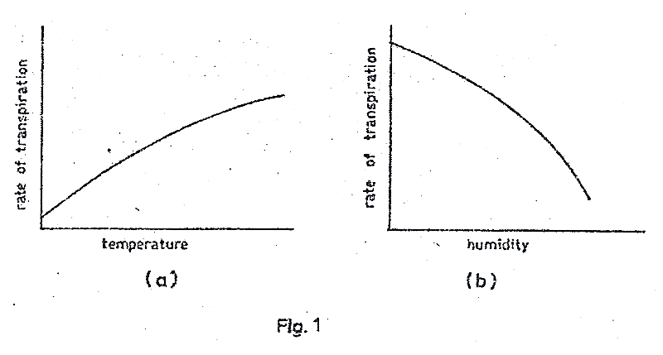

1. From fig. 1 (a), describe how the rate of transpiration changes with temperature. (01 mark)

…………………………………………………………………………………………………………...

…………………………………………………………………………………………………………...

1. From fig. 1(b), describe how the rate of transpiration changes with humidity. (01 mark)

…………………………………………………………………………………………………………...

…………………………………………………………………………………………………………...

1. Explain why:
2. Temperature affects the rate of transpiration as shown in figure 1(a).

…………………………………………………………………………………………………………...

…………………………………………………………………………………………………………...

…………………………………………………………………………………………………………...

…………………………………………………………………………………………………………...

…………………………………………………………………………………………………………...

…………………………………………………………………………………………………………...

…………………………………………………………………………………………………………...

(02 marks)

1. Humidity affects the rate of transpiration as shown in the figure 1(b). (02 marks)

…………………………………………………………………………………………………………...

…………………………………………………………………………………………………………...

…………………………………………………………………………………………………………...

…………………………………………………………………………………………………………...

…………………………………………………………………………………………………………...

1. State the importance of transpiration in plants. (02 marks)

…………………………………………………………………………………………………………...

…………………………………………………………………………………………………………...

…………………………………………………………………………………………………………...

…………………………………………………………………………………………………………...

1. How does each of the following characteristics of a respiratory surface aid diffusion of gases at the surface?
2. Thin epithelium (02 marks)

………………………………………………………………………………………………………

………………………………………………………………………………………………………

1. Dense network of capillaries (03 marks)

………………………………………………………………………………………………………

………………………………………………………………………………………………………

1. Moist Surface (03 marks)

……………………………………………………………………………………………….

………………………………………………………………………………………………………

1. Large surface area (02 marks)

………………………………………………………………………………………………………

………………………………………………………………………………………………………

1. Figure 2 shows an internal structure of a leaf.

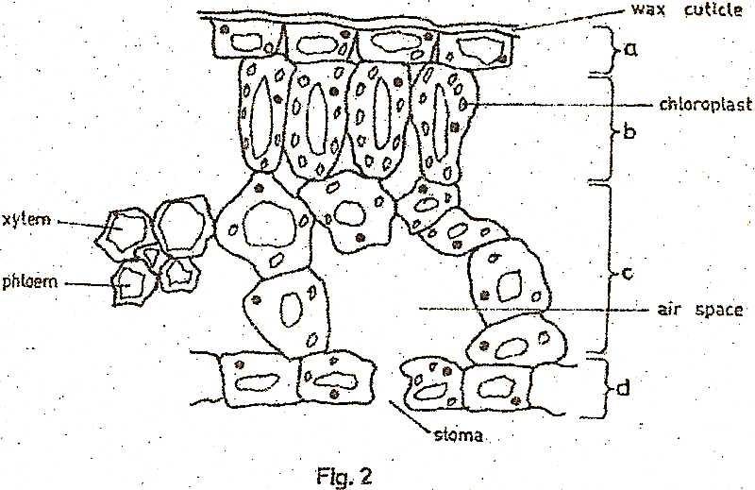

1. Label the layers marked a, b, c and d on the diagram. (02 marks)
2. Give three differences between layers b and c. (03 marks)

|  |  |
| --- | --- |
| Layer b | Layer c |
| 1. ……………………………………………..   ……………………………………………………..   1. …………………………………................   ……………………………………………………   1. …………………………………………..   ……………………………………………………. | ……………………………………...  ………………………………….......  ……………………………………...  ……………………………………..  ……………………………………  ……………………………………. |

1. Using evidence from the diagram, describe how the structure of a leaf is suited for photosynthesis. (04 marks)

………………………………………………………………………………………………………

………………………………………………………………………………………………………

………………………………………………………………………………………………………

………………………………………………………………………………………………………

………………………………………………………………………………………………………

………………………………………………………………………………………………………

………………………………………………………………………………………………………

………………………………………………………………………………………………………

………………………………………………………………………………………………………

………………………………………………………………………………………………………

1. What is the importance of wax on layer (a)? (01 mark)

………………………………………………………………………………………………………

………………………………………………………………………………………………………

1. (a) What is long-sightedness? (02 marks)

………………………………………………………………………………………………………

………………………………………………………………………………………………………

(b) State two causes of long-sightedness. (02 marks)

(i) ………………………………………………………………………………………………………

………………………………………………………………………………………………………

(ii)

………………………………………………………………………………………………………

………………………………………………………………………………………………………

(c) In the space below, draw light rays from an object into the eye to show long-sightedness. (03 marks)

(d) What is the effect of each of the following movements of the different parts of the eye?

(i) Contraction of the iris (01 mark)

………………………………………………………………………………………………………

………………………………………………………………………………………………………

(ii) Relaxation of the Ciliary muscle (01 mark)

………………………………………………………………………………………………………

………………………………………………………………………………………………………

(iii) Shortening and thickening of the lens (01 mark)

………………………………………………………………………………………………………

………………………………………………………………………………………………………

**SECTION C (30 MARKS)**

*Answer any two questions*

1. (a) Distinguish between dominance and codominance in genetics. (02 marks)

(b) When all pea plants were crossed with short pea plants, all the plants in F1 generation were tall. When two plants of the F1 generation were crossed, both tall and short plants were produced in the F2 generation.

(i) Why were all plants tall in the F1generation? (02 marks)

(ii) Using suitable symbols, show the crosses to produce the F1 and F2 generations. (07 ½ marks)

(c) In rose plants, when a red flowered plant is crossed with a white flowered plant, all plants produced bear pink flowers. Using suitable symbols show the result of crossing a pink flowered plant and a white flowered plant. (03 ½ marks)

1. (a) What do you understand by environmental degradation? (01 mark)

(b) Describe how man’s activities lead to the degradation of soil. (14 marks)

1. (a) List the substances transported by the blood circulatory system. (04 marks)

(b) Give the importance of transporting each one of the substances named in (a) above. (11 marks)

1. (a) What is excretion? (02 marks)

(b) With the aid of a labelled diagram describe the functioning of the kidney in excretion. (13 marks)

**2002**

**SECTION A**

*Answer all questions in this section.*

1. Which of the following are characteristics of surfaces for gaseous exchange?
2. Large surface area, thinness and moistness
3. Thinness, moistness and presence of fine blood vessels.
4. Large surface area thinness and presence of arteries and veins
5. Thinness, moistness and presence of arteries and veins
6. Stunted plant growth, creamy yellow leaves and poor fruit development is caused by deficiency of
7. Nitrogen and potassium
8. Nitrogen and phosphorous
9. Potassium and iron
10. Nitrogen and iron
11. Which one of the following dental formulae is that of a sheep?
12. I $0/2$ C $0/0$ Pm $3/3$ M $3/3$
13. I $2/2$ Pm $2/2$ M $3/3$
14. I $3/3$ C $0/0$ Pm $3/3$ M $2/2$
15. I $2/2$ C $1/1$ Pm $2/2$ M $3/3$
16. Enzymes differ from catalysts because enzymes
17. Are required in small amounts
18. Respond to temperature changes
19. Are protein in nature
20. Speed up reactions
21. When preparing to test for starch in a leaf, the leaf is boiled in alcohol in order to
22. Burst chloroplasts
23. Remove coloured materials in the leaf
24. Quicken the reaction of starch with iodine
25. Soften the leaf
26. In which of the following animals does expired air take a different route from that of inspired air?
27. Birds
28. Reptiles
29. Bony fish
30. Mammals
31. Which one of the following does not aid flight in birds?
32. Pectoral muscles
33. Hollow muscles
34. Down feathers
35. Quill feathers
36. Which one of the following sets of organisms belong to the same group?
37. Butterfly, beetles and starfish
38. Crab, tape worm and liver fluke
39. Scorpion, mite and spider
40. Jelly fish
41. Which one of the following explains the accumulation of lactic acid in muscles during vigorous activity?
42. Carbohydrates is completely broken down
43. The oxygen supply to the muscles may not be enough
44. Much of the stored glycogen is converted into glucose
45. The blood vessels leading from the muscles are constricted
46. Bacteria that often live in their hosts where both partners cannot survive without the other are called
47. Parasites
48. Symbionts
49. Commensals
50. Saprophytes
51. In a plant tissue, water moved from cell A to cell B. this indicates that
52. Cell A and cell B had the same osmotic potential
53. Cell A had a higher osmotic potential than cell B
54. Cell A had a lower osmotic potential than cell B
55. Cell A was older than cell B
56. Which of the following are the end products of lactose?
57. Glucose and sucrose
58. Glucose and galactose
59. Glucose and fructose
60. Fructose and galactose
61. Which one of the following sets contains only characteristics of continuous variation?
62. Tongue rolling, blood group, skin colour
63. Height, body weight, intelligence
64. Sex, Heamophilia, height
65. Finger prints, intelligence, albinism
66. The following are sizes of different soil particles in millimetres

P = 2.0 – 0.02

Q = 0.2 – 0.02

R = 0.02 – 0.002

S = less than 0.002

In which of the following soil particles would you expect the rise of water by capillarity to be highest?

1. P
2. Q
3. R
4. S
5. Which one of the following methods can be used to estimate the population of butterflies in a flower garden?
6. Direct count
7. Quadrant
8. Line transect
9. Capture-recapture
10. Where in the mammalian skin is the melanin pigment found?
11. Malphigian layer
12. Granular layer
13. Cornfield layer
14. Subcutaneous layer
15. Which one of the following organisms reproduce by budding?
16. Yeast
17. Amoeba
18. Spirogyra
19. Mucor
20. What would happen to a plant tissue placed in a strong sugar solution? It
21. Becomes longer and soft
22. Maintains the original length and texture
23. Becomes shorter and soft
24. Becomes shorter and hard
25. Figure 1 shows a leaf type

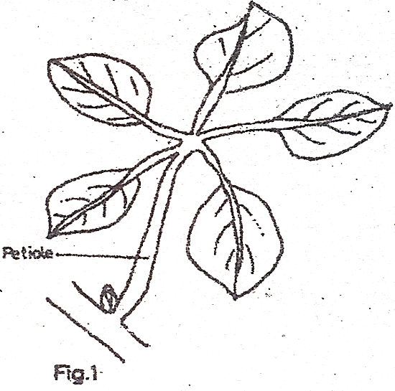

Which type of leaf is shown in the figure shown?

1. Compound bipinnate
2. Compound trifoliate
3. Compound pinnate
4. Compound palmate
5. Which one of the following is not a function of blood?
6. Regulation of sugar level in the body
7. Healing of damaged parts of the body
8. Regulation of body temperature
9. Transportation of wastes
10. Figure 2 is a cross section of part of a plant.

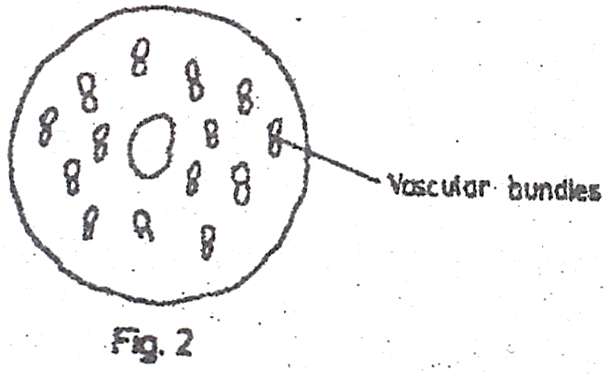

From which one of the following was the section obtained?

1. Root of dicotyledonous plant
2. Stem of monocotyledonous plant
3. Root of monocotyledonous plant
4. Stem of dicotyledonous plant
5. What effect does light have on the distribution of auxins at the tip of a plant shoot?
6. Causes equal distribution of auxins at the shoot tip
7. Has no effect on the distribution of auxins at the shoot tip
8. Concentration more auxins on the dark side of the shoot tip
9. Causes auxins to concentrate more on the illuminated side of the shoot tip.
10. Which one of the following is a modified root?
11. Irish potato tuber
12. Cassava tuber
13. Rhizome
14. Corm
15. Which one of the following organs is responsible for removing excess amino acids from blood?
16. Gall bladder
17. Kidney
18. Liver
19. Spleen
20. Which one of the following is the most common air pollutant
21. Dust
22. Fungicides
23. Herbicides
24. Smoke
25. In which part of the kidney nephron does reabsorption of glucose occur?
26. Proximal convoluted tubule
27. Distal convoluted tubule
28. Descending loop of Henle
29. Ascending loop of Henle

**SECTION B**

*Answer all questions in this section.*

1. (a) What is an artery?

……………………………………………………………………………………………………….......

……………………………………………………………………………………………………….......

(01 mark) (b)

1. Figure 3 shows the effect of unidirectional light on the growth of plant shoots. Study the figure and answer the questions that follow.

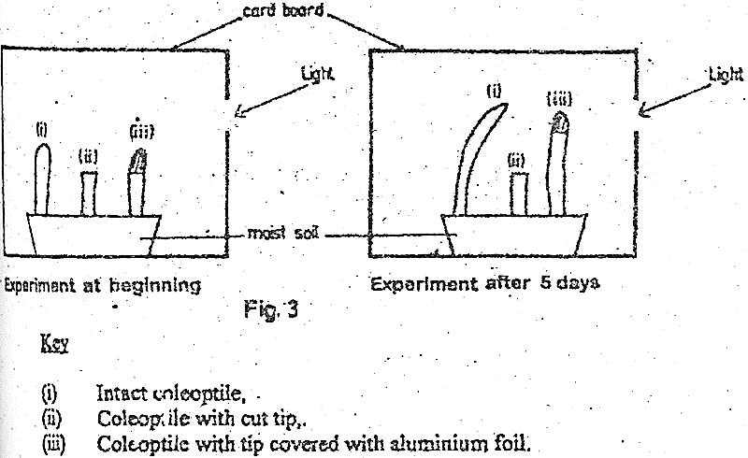

1. Explain why each coleoptile appears as shown after 5 days.

……………………………………………………………………………………………………….......

……………………………………………………………………………………………………….......

……………………………………………………………………………………………………….......

……………………………………………………………………………………………………….......

(ii)

……………………………………………………………………………………………………….......

……………………………………………………………………………………………………….......

……………………………………………………………………………………………………….......

……………………………………………………………………………………………………….......

(iii)

……………………………………………………………………………………………………….......

……………………………………………………………………………………………………….......

……………………………………………………………………………………………………….......

………………………………………………………………………………………………………....... (07 marks)

1. What is importance of the response shown in the diagram, to plants?

……………………………………………………………………………………………………….......

……………………………………………………………………………………………………….......

……………………………………………………………………………………………………….......

……………………………………………………………………………………………………….......

(03 marks)

1. (a) (i) Which chromosomes are responsible for determining sex in humans?

……………………………………………………………………………………………………….......

(ii) Using appropriate symbols show how sex is determined in humans.

……………………………………………………………………………………………………….......

……………………………………………………………………………………………………….......

……………………………………………………………………………………………………….......

……………………………………………………………………………………………………….......

……………………………………………………………………………………………………….......

……………………………………………………………………………………………………….......

……………………………………………………………………………………………………….......

……………………………………………………………………………………………………….......

(b) Red-green colour blindness is a defect caused by a recessive gene carried on the X chromosome. What would be the phenotype of the offspring when a normal woman carries a colour blind man?

Show your working.

……………………………………………………………………………………………………….......

……………………………………………………………………………………………………….......

……………………………………………………………………………………………………….......

……………………………………………………………………………………………………….......

……………………………………………………………………………………………………….......

……………………………………………………………………………………………………….......

……………………………………………………………………………………………………….......

……………………………………………………………………………………………………….......

……………………………………………………………………………………………………….......

……………………………………………………………………………………………………….......

……………………………………………………………………………………………………….......

……………………………………………………………………………………………………….......

……………………………………………………………………………………………………….......

(06 marks)

1. (a) State four ways in which a leaf is suited for photosynthesis.

……………………………………………………………………………………………………….......

……………………………………………………………………………………………………….......

……………………………………………………………………………………………………….......

……………………………………………………………………………………………………….......

……………………………………………………………………………………………………….......

……………………………………………………………………………………………………….......

……………………………………………………………………………………………………….......

……………………………………………………………………………………………………….......

……………………………………………………………………………………………………….......

……………………………………………………………………………………………………….......

……………………………………………………………………………………………………….......

……………………………………………………………………………………………………….......

(08 marks)

(b) State two ways in which food transported to growing regions is utilized by the plant.

(i)

……………………………………………………………………………………………………….......

……………………………………………………………………………………………………….......

(ii)

……………………………………………………………………………………………………….......

……………………………………………………………………………………………………….......

(02 marks)

**SECTION C**

*Answer any two questions.*

1. Using named examples, describe the methods of fruit and seed dispersal. (15 marks)
2. (a) Give three characteristics of enzymes. (03marks)

(b) Describe an experiment to show that enzyme activity is affected by temperature. (12 marks)

1. (a) Give effects of four air pollutants on living things. (04 marks)

(b) Describe how human activities interfere with soil environment in Uganda. (11 marks)

1. Describe an experiment that you would carry out in the laboratory to test for the presence of a non – reducing (complex) sugar in a solution of a food sample. In your description, state the use of each reagent used. (15 marks)

**2001**

**SECTION A (30 MARKS)**

1. Which one of the following would occur if a potato strip was placed in distilled water?
2. Increase in length
3. Strip would soften
4. Decrease in length
5. Remain unchanged
6. When a seedling on a clinostat and placed in a horizontal position, the shoot continues to grow horizontally, but without the clinostat it bends upwards. Which one of the following is true about the role of the clinostat?
7. Enables the seedling to receive uniform light
8. Causes auxin to accumulate on the lower side of the seedling
9. Causes auxins to accumulate on the upper side of the seedling
10. Causes auxins to accumulate uniformly on all sides.
11. The following are some features of lower plants
12. Reproduce by spores
13. Lack vascular tissues
14. Grow in damp places
15. Have simple stem and leaves

Which of the features belong to both mosses and ferns?

1. (i) and (iv)
2. (i) and (iii)
3. (ii) and (iii)
4. (iii) and (iv)
5. Which part of a flowering plant is represented by figure 1 below?

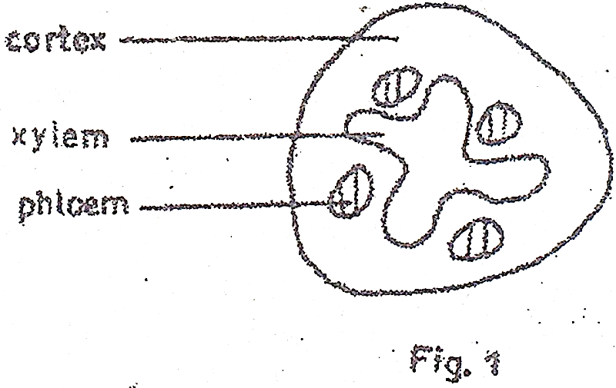

1. Monocotyledonous plant
2. Dicotyledonous stem
3. Monocotyledonous root
4. Dicotyledonous root
5. The following are products of tissue respiration in living organisms
6. Energy
7. Carbon dioxide
8. Water
9. Ethanol
10. Lactic acid

Which of them are common to both aerobic and anaerobic respiration in plants?

1. (i) and (ii)
2. (ii) and (iii)
3. (i), (ii) and (iii)
4. (ii), (iv) and (v)
5. A student wanted to determine the percentage of air in a soil sample. The following measurements were obtained.

Volume of dry soil = 250 cm3

Volume of water added = 160 cm­3

Volume of mixture of soil + water = 380 cm3

What was the percentage of air in the soil sample?

1. 7.9
2. 12
3. 25
4. 34
5. Which one of the following groups of animals uses gills, skin, buccal cavity and lungs for gaseous exchange at some stage in their life cycle?
6. Fish
7. Amphibians
8. Reptiles
9. Mammals
10. A student noted the following characteristics on a vertebrae
11. Long neural spine
12. Wide neural canal
13. Short transverse process

The vertebrae was

1. Cervical
2. Atlas
3. Thoracic
4. Lumbar
5. Which one of the following may result from lack of progesterone hormone in a woman?
6. Implantation may not occur
7. Miscarriage may occur
8. Menstruation may not occur
9. Ovulation may not occur
10. Which one of the following fruits is an example of a drupe?
11. Avocado
12. Passion
13. Tomato
14. Orange
15. To identify a substance Y, a student performed the following experiment.

|  |  |
| --- | --- |
| **Test** | **Observation** |
| 1. Heated Y with Benedict’s   Solution | Solution remained blue |
| 1. Heated Y with hydro-chloric acid, cooled, added sodium hydrogen carbonate, benedict’s solution, then heated again. |  |

From the observations, the most likely food substance in Y is

1. Starch
2. Maltose
3. Sucrose
4. Glucose
5. Which one of the following is true of both photosynthesis and respiration?
6. Involve enzymes
7. Need light energy
8. Are exothermic
9. Occur in all living organisms
10. The reason why urine of a healthy person does not contain glucose is that
11. The glomerulus is impermeable to glucose
12. Glucose is used for respiration before reaching the collecting duct
13. Glucose passes back into the blood stream
14. The kidney converts glucose to urea
15. Which one of the following reactions is likely to occur when a donor of blood group A gives blood to a recipient of blood group B?
16. Antibodies **a** react with antigens **B**
17. Antigens **B** react with antibodies **b**
18. Antibodies **b** react with antigens **A**
19. Antigens **A** react with antigens **B**
20. When round seeded bean plants and long-seeded plants were crossed, all the offspring were oval-seeded plants. This is an example of
21. Complete dominance
22. Incomplete dominance
23. Mutation
24. Recessive genes
25. Which one of the following may not be used for classifying insects?
26. Mouth parts
27. Feeding habits
28. Structure of legs
29. Type of eyes
30. Which one of the following is a possible sequence of plant succession on an undeveloped piece of land?
31. Fungi $⟶$ ferns $⟶$ shrubs $⟶$ trees
32. Fungi $⟶$ mosses $⟶$ shrubs $⟶$ trees
33. Mosses $⟶$ trees $⟶$ fungi $⟶$ ferns
34. Mosses $⟶$ herbs $⟶$ shrubs $⟶$ trees
35. The graph below shows the effect of varying pH on the time taken for an enzyme to break down food.

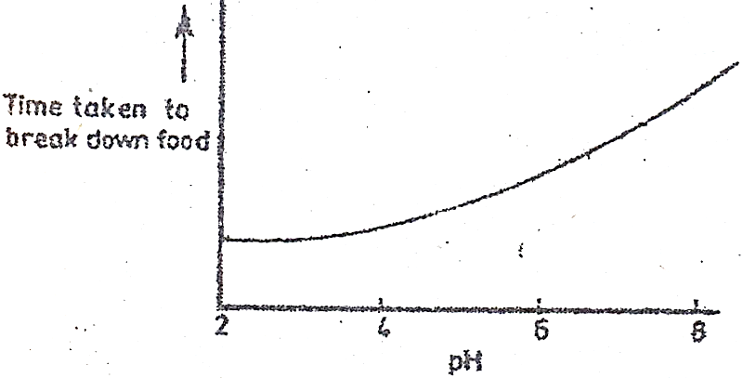

Which one of the following enzymes below could have given that response?

1. Pepsin
2. Lipase
3. Salivary amylase
4. Trypsin
5. Which one of the following fins provides a major propulsion force in a fish?
6. Caudal
7. Pectoral
8. Dorsal
9. Pelvic
10. Which one of the following characteristics of respiratory surfaces is true of humans but not of insects?
11. Highly vascularized
12. Have large surface area
13. Moist
14. Thin walled
15. The rapid elongation of the hypocotyl during germination causes
16. Delay in emergence of photosynthesis leaves
17. Cotyledons to grow above the ground
18. Early emergence of photosynthetic leaves
19. Cotyledons to remain below the ground
20. Which one of the following blood vessels contains the lowest concentration of urea?
21. Hepatic portal vein
22. Renal artery
23. Hepatic vein
24. Renal vein
25. Which one of the following is the correct response increased carbon dioxide in human blood? The rate of
26. Breathing is slowed
27. Heart beat is slowed down
28. Heart beat is increased
29. The pulse is slowed down
30. The tapeworm *Taenia solium* has a primary and a secondary host. Which of the following are the primary and secondary hosts in that order?
31. Pig and man
32. Cow and man
33. Man and cow
34. Man and pig
35. Which one of the following statements is not correct about photosynthesis?
36. Water is required
37. Oxygen is a by-product
38. Sugar is a product
39. Energy is released
40. Figure 2 below shows the cycling of oxygen between the atmosphere and living cells.

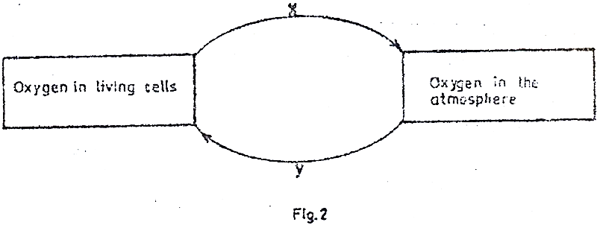

Which process is represented by letter X?

1. Excretion
2. Respiration
3. Decay
4. Photosynthesis
5. Which one of the following is the correct reason for the thickness of the walls of atria and ventricles?
6. Atria are thicker because they have to generate higher pressure
7. Atria are thicker because they have to resist higher pressure
8. Ventricles because they have to generate higher pressure
9. Ventricles are thicker because they have to resist higher pressure
10. Which of the following controls the rate of heart beat in a mammal?
11. Cerebrum
12. Pituitary
13. Medulla oblongata
14. Cerebellum
15. Which one of the following events occurs during osmosis?
16. Solute molecules move from more to less concentrated solution
17. Solvent molecules move from more to less concentrated solution
18. Solvent molecules move from less to more concentrated solution
19. Solute molecules move from less to more concentrated solution
20. Which of the following is characteristic of a soil with low capillarity?
21. Poor water retention
22. Poor drainage
23. Poor aeration
24. Small particles

**SECTION B**

*Answer all questions in this section.*

1. The graph below shows the variation in the amount of sweat and urine with temperature in humans.

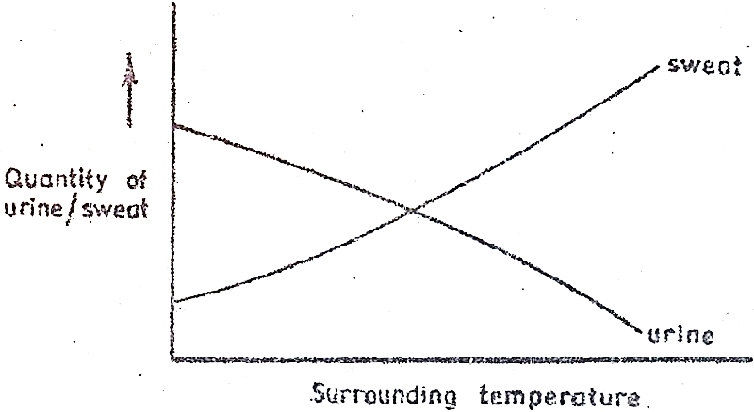

1. How does the increase in temperature affect
2. Urine production?

………………………………………………………………………………………………………

………………………………………………………………………………………………………

………………………………………………………………………………………………………

1. Sweat production?

………………………………………………………………………………………………………

………………………………………………………………………………………………………

………………………………………………………………………………………………………

(02 marks)

1. Explain your answers in (a)(i) and (ii) above.
2. Explanation for (a)(i)

………………………………………………………………………………………………………

………………………………………………………………………………………………………

………………………………………………………………………………………………………

1. Explanation for (a)(ii)

………………………………………………………………………………………………………

………………………………………………………………………………………………………

………………………………………………………………………………………………………

(04 marks)

1. State three conditions under which humans pass out concentrated urine.
2. ………………………………………………………………………………………………
3. ………………………………………………………………………………………………
4. ………………………………………………………………………………………………
5. Apart from sweating, state three other body responses by mammals to overheating.

………………………………………………………………………………………………

(ii)

………………………………………………………………………………………………

(iii)

………………………………………………………………………………………………

1. Figure 3 below is an experimental set up to investigate the conditions for photosynthesis. The Plant is in light but had previously been kept in the dark overnight.

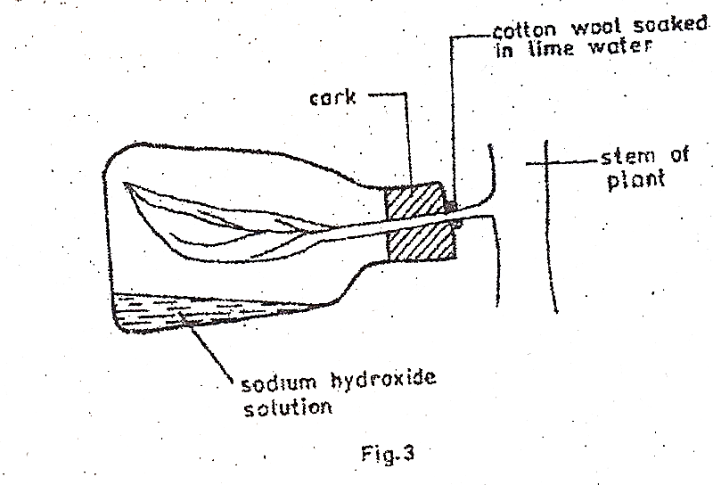

1. Which condition is being investigated? (01 mark)

……………………………………………………………………………………………………….

1. Why
2. Was it necessary to keep the plant in the dark overnight?

……………………………………………………………………………………………………….

……………………………………………………………………………………………………….

1. Is the leaf left attached to the plant?

……………………………………………………………………………………………………….

……………………………………………………………………………………………………….

(02 marks)

1. What is the purpose of sodium hydroxide in the flask? (01 mark)

……………………………………………………………………………………………………….

……………………………………………………………………………………………………….

1. How would you test for starch in the leaf after some time?

……………………………………………………………………………………………………….

……………………………………………………………………………………………………….

……………………………………………………………………………………………………….

……………………………………………………………………………………………………….

……………………………………………………………………………………………………….

……………………………………………………………………………………………………….

……………………………………………………………………………………………………….

……………………………………………………………………………………………………….

……………………………………………………………………………………………………….

……………………………………………………………………………………………………….

……………………………………………………………………………………………………….

……………………………………………………………………………………………………….

……………………………………………………………………………………………………….

……………………………………………………………………………………………………….

……………………………………………………………………………………………………….

……………………………………………………………………………………………………….

……………………………………………………………………………………………………….

1. *The information below is on feeding relationships in an ecosystem.*

Lizards feed on praying mantis, butterflies and herbivorous bugs. Praying mantis feed on butterflies and herbivores bugs. Butterflies and herbivorous bugs feed on grass.

1. Using a suitable method show the feeding relationship between
2. All the organisms

……………………………………………………………………………………………………….

……………………………………………………………………………………………………….

……………………………………………………………………………………………………….

……………………………………………………………………………………………………….

……………………………………………………………………………………………………….

……………………………………………………………………………………………………….

……………………………………………………………………………………………………….

……………………………………………………………………………………………………….

……………………………………………………………………………………………………….

……………………………………………………………………………………………………….

1. The praying mantis, herbivorous lizards and grass.

……………………………………………………………………………………………………….

……………………………………………………………………………………………………….

(04 marks)

1. How would the population of the organisms in (a) (i) above be affected if the praying mantis were removed from the ecosystem?

……………………………………………………………………………………………………….

……………………………………………………………………………………………………….

……………………………………………………………………………………………………….

……………………………………………………………………………………………………….

……………………………………………………………………………………………………….

1. (i) State one group of important organism that have not been included in the ecosystem.

……………………………………………………………………………………………………….

(ii) Why are the organisms named in (c)(i) above important in an ecosystem?

……………………………………………………………………………………………………….

……………………………………………………………………………………………………….

……………………………………………………………………………………………………….

……………………………………………………………………………………………………….

(03 marks)

1. Figure 4 below shows a section through the human eye.

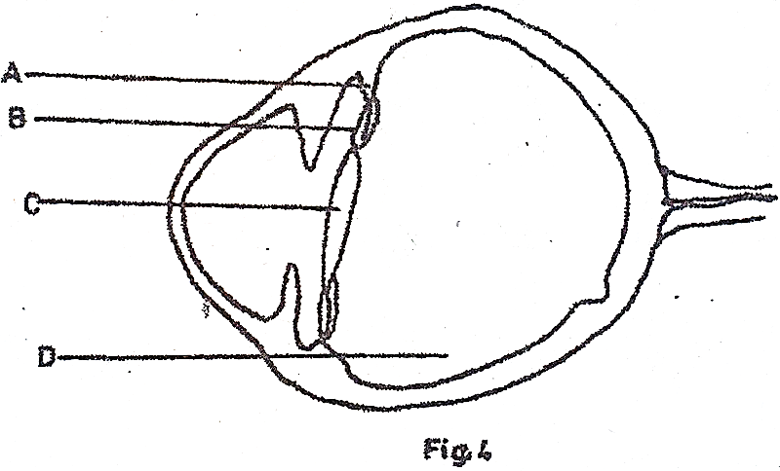

1. Name the parts labelled A, B, C and D (02 marks)

A

……………………………………………………………………………………………………….

B

……………………………………………………………………………………………………….

C

……………………………………………………………………………………………………….

D

……………………………………………………………………………………………………….

1. What function is performed jointly by the parts A, B, C and D?

……………………………………………………………………………………………………….

……………………………………………………………………………………………………….

(01 mark)

1. Other than the joint function, state two other functions of the part labelled D. (02 marks)

……………………………………………………………………………………………………….

……………………………………………………………………………………………………….

1. Give the state of parts A, B and C when the eye is viewing,
2. Near objects

A…………………………………………………………………………………………

B

…………………………………………………………………………………………

C

…………………………………………………………………………………………

1. Distant objects

A

…………………………………………………………………………………………

B

…………………………………………………………………………………………

C

…………………………………………………………………………………………

(06 marks)

1. State two eye defects and how they are corrected.
2. Defect

…………………………………………………………………………………………

Corrective measure

…………………………………………………………………………………………

1. Defect

…………………………………………………………………………………………

Corrective measure

…………………………………………………………………………………………

**SECTION C**

*Answer any two questions*

1. (a) State the dangers of a parasitic mode of life. (5 marks)

(b) Describe how a tapeworm is adapted to its mode of life. (10 marks)

1. (a) Describe the digestion of proteins in a mammal. (6 marks)

(b) Explain how the ileum is suited for its functions. (9 marks)

1. (a) With the aid of well labelled diagrams explain the difference between hypogeal and epigeal germination. (7 marks)

(b) Describe an experiment you would carry out to show that heat is liberated by germinating seeds. (8 marks)

1. (a) Explain why a skeleton is necessary in a mammalian body. (10 marks)

(b) With the aid of diagrams describe how a human arm can bend and straighten. (5 marks)

**2000**

*Answer all questions in this section.*

* + - * 1. The following are characteristics of blood vessels:

1. Presence of valves
2. Thick walls
3. Wide lumen
4. Elastic walls

Which of the characteristics belong to veins?

1. (i) and (ii)
2. (i) and (iii)
3. (ii) and (iii)
4. (iii) and (iv)
   * + - 1. *Mucor* undergoes reproduction to produce
5. Spores
6. Zoospores
7. Zygospores
8. Sporangia
   * + - 1. The fins which keep a fish stable in water are the
9. Anal and dorsal fins
10. Dorsal and pelvic fins
11. Caudal and pelvic fins
12. Pelvic and pectoral fins
    * + - 1. Which one of the following is correct about dividing cells at the tip of plant shoots?
13. Have large vacuoles
14. Are specialized
15. Have soft cell walls
16. Have rigid cell walls
    * + - 1. Which one of the following would contain the highest concentration of proteins?
17. Blood plasma
18. Glomerular filtrate
19. Urine
20. Serum
    * + - 1. Which one of the following would be observed in a plant growing in a soil lacking magnesium?
21. Poorly developed shoot system
22. Yellowing of leaves
23. Poorly developed root system
24. Yellowing of buds
    * + - 1. What mode nutrition is used by *Rhizopus?*
25. Heterotropism
26. Autotrophism
27. Parasitism
28. Saprophytism
    * + - 1. Which one of the following would be the first to colonise a rocky surface?
29. Lichens
30. Mosses
31. Shrubs
32. Ferns
    * + - 1. The blood constituents that help in the formation of blood clot at the site of an injury are
33. Platelets and erythrocytes
34. Hormones and plasma
35. Platelets and leucocytes
36. Platelets and fibrinogen
    * + - 1. Figure 1 shows a gill of a fish.

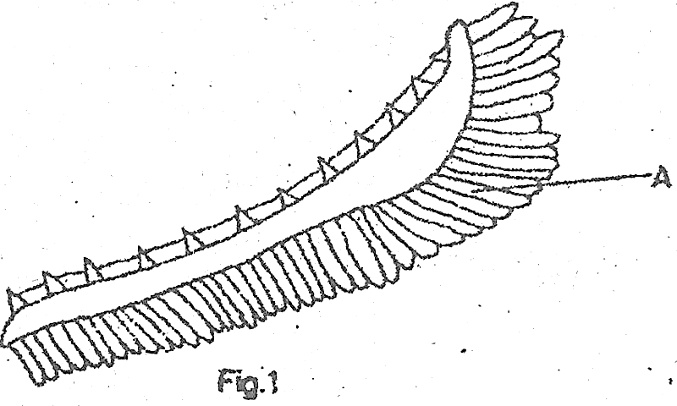

The name and function of part labelled A is

1. Gill filaments for gaseous exchange
2. Gill rakers for filtering food
3. Gill bar for support
4. Gill arch for increasing surface area
   * + - 1. Which one of the following would not be found in the glomerular filtrate?
5. Fibrinogen
6. Glucose
7. Mineral salts
8. Urea
   * + - 1. Which one of the following is an example of discontinuous variation?
9. Height
10. Weight
11. Eye color in *Drosophila*
12. Skin color
    * + - 1. Which one of the following sets consists of substances that are stored in the liver?
13. Glucose, iron and vitamin D
14. Iron, glycogen and vitamin D
15. Glucose, glycogen and vitamin D
16. Iron, glycogen and amino acids
    * + - 1. Albinism is caused by having a double recessive gene for skin pigmentation. What is probability of the children having normal skin color if an albino woman carries a man who is heterozygous for albinism?
17. 100%
18. 75%
19. 50%
20. 25%
    * + - 1. The data below shows the amount of carbon dioxide in haled air, rate of breathing at rest and volume of air in a breath, in humans:

Percentage of carbon dioxide in inhaled air = 0.025%

Number of breaths per minute = 36

Volume of one breath taken in at rest = 500 cm3

The volume of carbon dioxide inhaled per minute while at rest is

1. 0.9 cm3
2. 45 cm3
3. 12.5 cm3
4. 450 cm3
   * + - 1. How is lactic acid produced in muscles got rid of? By
5. Converting it into water
6. Storing it in the liver
7. Converting it into ethanol
8. Oxidation
   * + - 1. Blood flows in the pulmonary artery at a lower pressure than in aorta because in the pulmonary circulation
9. Blood travels a shorter distance
10. The right-ventricle has thinner walls
11. The vessel carrying blood is smaller
12. Fewer organs are supplied
    * + - 1. Which one of the following is an example of a reflex action?
13. Eating
14. Screaming after kicking a stone
15. Riding
16. Salivating on smelling food
    * + - 1. What happens to insect wings when depressor muscles are relaxed? The wings
17. Move downwards
18. Move upwards
19. Rotate freely
20. Move in three directions
    * + - 1. Which one of the parasites is transmitted by *Anopheles* mosquito?
21. Filarial worm
22. *Trypanosome*
23. *Plasmodium*
24. *Schistosoma* 
    * + - 1. The following are body secretions:
25. Amylase
26. Trypsin
27. Hydrochloric acid
28. Pepsin
29. Rennin

Which of them are contained in gastric juice?

1. (i) and (iii)
2. (ii) and (iv)
3. (iii) and (v)
4. (i) and (ii)
   * + - 1. What is the main function of the phloem in green plants?
5. Transporting water
6. Supporting the plant
7. Transporting mineral salts
8. Transporting manufactured food
   * + - 1. Which of the following is an example of a modified root?
9. Irish potato tuber
10. Cassava tuber
11. Rhizome
12. Corn
    * + - 1. Which of the following events occur during inhalation in a mammal?
13. Diaphragm contracts, ribs raised
14. Diaphragm relaxes ribs lowered
15. Internal intercostal muscles contract, pressure in chest cavity increases
16. Internal intercostal muscles relax, pressure in chest cavity increases
    * + - 1. What is the main function of the choroid layer in the human eye?
17. Focusing rays of light on the retina
18. Supplying nutrients to the eye
19. Bringing about accommodation
20. Controlling amount of light entering the eye
    * + - 1. Which one of the following pairs of hormones is produced by reproductive organs in mammals?
21. Follicle stimulating hormone and testosterone
22. Oestrogen and Luteinsing hormone
23. Progesterone and testosterone
24. Insulin and Oestrogen
    * + - 1. When a homozygous black mouse (BB) was mated with homozygous white mouse (WW), the offspring were all brown. What would be the colour of the mice produced?
25. 3 brown : 1 white
26. 1 brown : 3 white
27. 1 brown : 1 white
28. All white
    * + - 1. The scheme below shows a food chain with corresponding concentration of organic chloride in milligrams:

Green plants $⟶$ Herbivorous $⟶$ Predatory $⟶$ Lizard

0.01 bug bug 0.9 2.3 2.8

Which does the tissue of the lizard contain the highest concentration in the organic chloride? Because the

1. Lizard cats all the organisms in the food chain
2. Organic chloride remains persistent in the food chain
3. Organic chloride is cumulative in the issues of the organisms
4. Organic chloride is not toxic to lizard
   * + - 1. Which one of the following structures is found in cervical vertebrae only?
5. Centrum
6. Neural spine
7. Transverse process
8. Vertebra – arterial canal
   * + - 1. The forces which mostly help water to move up a tall plant are
9. Osmosis and diffusion
10. Capillarity and transpiration
11. Osmosis only
12. Capillary and osmosis

**SECTION B**

*Answer all questions in this section.*

* + - * 1. Figure 2 shows an experimental set up to demonstrate transpiration in plants.

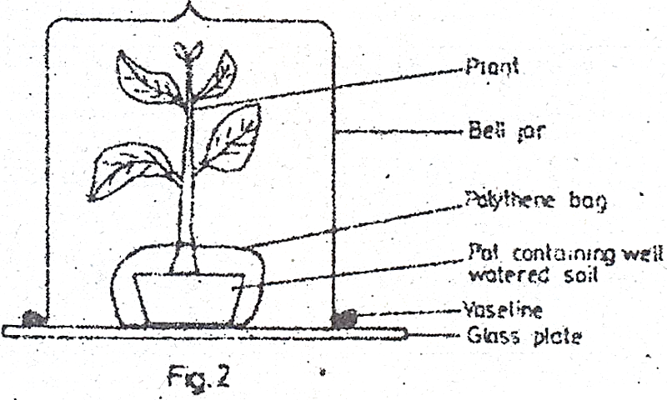

1. Explain why
2. Vaseline is smeared between the glass plate and the bell jar

……………………………………………………………………………………………………

……………………………………………………………………………………………………

(1 mark)

1. Polythene bag is wrapped around the pot and tied at the base of the plant.

……………………………………………………………………………………………………

……………………………………………………………………………………………………

(1 mark)

1. (i) What will be observed in this experiment?

……………………………………………………………………………………………………

……………………………………………………………………………………………………

(1 mark)

(ii) How do you test for the identity of the substance observed in (b)(i)?

……………………………………………………………………………………………………

……………………………………………………………………………………………………

……………………………………………………………………………………………………

……………………………………………………………………………………………………

1. Describe the setup of the control for this experiment. (3 marks)

……………………………………………………………………………………………………

……………………………………………………………………………………………………

……………………………………………………………………………………………………

……………………………………………………………………………………………………

……………………………………………………………………………………………………

1. State two factors which affect the results of this experiment. (2 marks)

……………………………………………………………………………………………………

……………………………………………………………………………………………………

* + - * 1. (a) What is an enzyme?

……………………………………………………………………………………………………

……………………………………………………………………………………………………

……………………………………………………………………………………………………

……………………………………………………………………………………………………

(1 mark)

(b) State three factors which affect enzyme action.

……………………………………………………………………………………………………

……………………………………………………………………………………………………

……………………………………………………………………………………………………

……………………………………………………………………………………………………

(3 marks)

(c) The optimum pH for enzyme X is 2.00 and for enzyme Y is 9.00. suggest the names of the enzymes X and Y, and name the parts of the alimentary canal where you would expect to find each enzyme.

|  |  |  |
| --- | --- | --- |
|  | Name of enzyme | Part of alimentary canal the enzyme is found |
| X  Y | …………………………………………………………………………………………….... | ……………………………………………………………………………………………… |

(d) State two enzymes in the pancreatic juice, the foot substance acted on by each enzyme and the product formed in each case.

|  |  |  |
| --- | --- | --- |
| Enzyme | Food Substance acted upon | Product formed |
| 1. ……………………… 2. ………………………. | ……………………………….  ……………………………….. | ………………………………  ………………………………. |

* + - * 1. Figure 3 below shows a cross section of part of a plant.

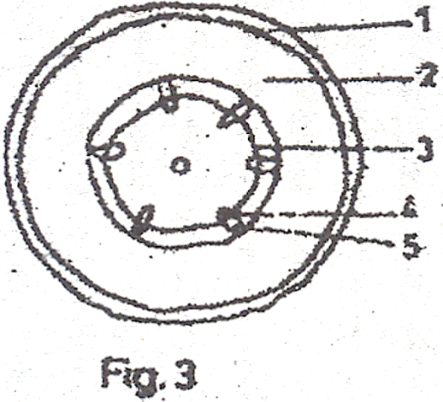

1. Name the parts labelled 1 to 5

1 ………………………………………………………………………………………………

2 ………………………………………………………………………………………………

3 ………………………………………………………………………………………………

4 ………………………………………………………………………………………………

5 ………………………………………………………………………………………………

(2 ½ marks)

1. Using a reason, state the part of the plant from which the section was taken.

Part of plant ……………………………………………………………………………………………………

Reason ……………………………………………………………………………………………………

……………………………………………………………………………………………………

(2 marks)

1. (i) State the functions of the parts labelled 3 and 4.

3 ……………………………………………………………………………………………………….

4 ………………………………………………………………………………………………………

(2 marks)

(ii) Give two similarities between the cells in part labeled 3 and those found at the tips of growing shoots.

……………………………………………………………………………………………………

……………………………………………………………………………………………………

(2 marks)

* + - * 1. Figure 4 shows a longitudinal section of a human skin.

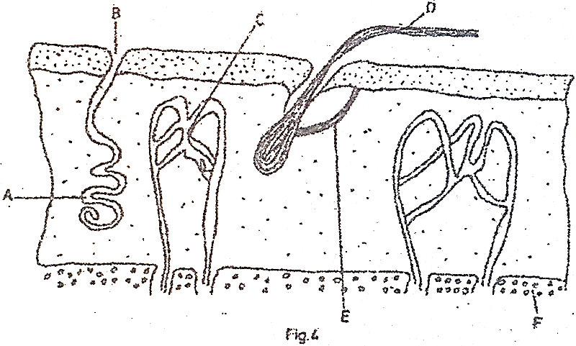

1. (i) Name the parts labeled A to F.

A ……………………………………………………………………………………………………….

B ……………………………………………………………………………………………………….

C ………………………………………………………………………………………………………

D ……………………………………………………………………………………………………….

E ……………………………………………………………………………………………………….

F ……………………………………………………………………………………………………….

(ii) State the function of each of the parts labeled A, B, D and F.

A ……………………………………………………………………………………………………….

B ……………………………………………………………………………………………………….

D ……………………………………………………………………………………………………….

F ……………………………………………………………………………………………………….

(7 marks)

1. Using one observable feature on the diagram, suggest the type of temperature condition the skin is responding to, state the observable feature as a reason for your answer.

Temperature condition

……………………………………………………………………………………………………

……………………………………………………………………………………………………

Observable feature

……………………………………………………………………………………………………

……………………………………………………………………………………………………

(3 marks)

**SECTION C**

*Answer any two questions*

* + - * 1. Describe an experiment to show that carbon dioxide is necessary for photosynthesis. (15 marks)
        2. (a) What is sexual reproduction? (2 marks)

(b) Give the advantages of sexual reproduction in plants. (6 marks)

(c) Describe how sexual reproduction occurs in a *Mucor.* (7 marks)

* + - * 1. Describe human activities which may cause environmental pollution. (15 marks)
        2. (a) What is the importance of water to animals? (5 marks)

(b) Describe how water balance in the mammalian body is maintained. (10 marks)

**1999**

**SECTION A**

*Answer all questions in this section.*

1. Figure 1 below shows the structure of a part of the lower epidermis of a leaf.

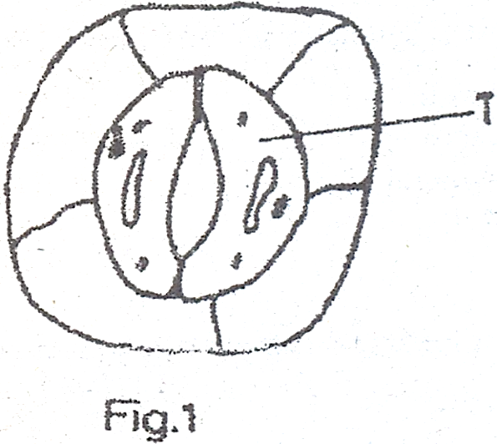

What is the structure labelled T?

1. Stoma
2. Vacuole
3. Chloroplast
4. Guard cell
5. Which of the following blood vessels transports blood most rich in nutrients?
6. Pulmonary artery
7. Hepatic portal vein
8. Mesenteric artery
9. Renal vein
10. Which one of the following is an example of biological control of pests?
11. Application of pesticides
12. Destruction of pests’ habitats
13. Interruption of pests’ breeding cycle
14. Introduction of pests’ predators
15. The effect of unidirectional light on the distribution of auxins in the tip of a plant shoot is
16. Uniform distribution of auxins around the tip
17. Reduction in concentration of auxins on the illuminated side of the plant
18. Increase in auxins on the illuminated side of the plant
19. Inhibition of movement of auxins down the plant
20. Which of the following is a function of thyroxine hormone?
21. Prepares development of follicle in the ovary
22. Prepares the body for fright-flight action
23. Controls body metabolic rate
24. Regulates sugar content of the body
25. Which of the following is an example of a berry?
26. Avocado
27. Passion
28. Groundnut
29. Cotton
30. The mode of feeding displayed by a Mucor is described as
31. Holozoic
32. Filter feeding
33. Parasitic
34. Saprophytic
35. What is the function of the Eustachian tube in the human ear?
36. Detection of body posture
37. Transmission of sound waves to the middle ear
38. Equalizing pressure in the middle ear
39. Transmission of sound waves to the inner ear
40. If a man of blood group A is married to a woman of blood group O, what are the possible genotypes of their children?
41. AA, OO
42. AA, AO
43. AO, OO
44. AO only
45. What relationship exists between a groundnut plant and nitrogen fixing bacteria in its root nodules?
46. Parasitism
47. Saprophytism
48. Naturalism
49. Symbiosis
50. Which type of soil has the following characteristics?
51. Heavy to cultivate
52. Rich in dissolved minerals
53. High capillarity
54. Loam
55. Clay
56. Sand
57. Silt loam
58. In figure 2 below, which part transports water and dissolved minerals?

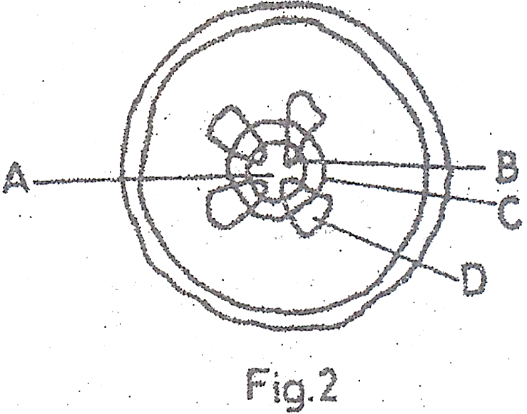

1. Which of the following features belong to both an arachnida and an insect?
2. Cuticle and two pairs of wings
3. Six legs and two pairs of wings
4. Six legs and antennae
5. Jointed legs and cuticle
6. Which one of the following statements best explain why urine does not normally contain glucose?
7. Glucose molecules are too large to pass through the capillaries of the glomerulus
8. Glucose present in the renal tubule is changed to carbondioxide and water
9. All the glucose filtered is re-absorbed back into the blood in the renal tubules
10. The bladder re-absorbs all the glucose filtered.
11. Aerobic respiration is more efficient than anaerobic respiration because it
12. Uses more oxygen
13. Yields lactic acid
14. Uses less oxygen
15. Yields more energy
16. In humans, the hormone progesterone stimulates the
17. Formation of egg cells
18. Formation of sperm cells
19. Production of milk by a lactating mother
20. Thickening of the uterine wall
21. What is the destination of the impulses moving along the nerve fibre marked Z in figure 3 below?

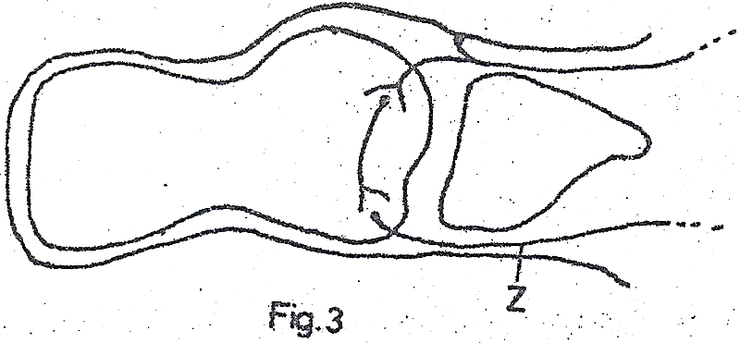

1. The spinal cord
2. The brain
3. The effector organ
4. The receptor organ
5. Which of the diseases listed below is a result of lack of the anti – Diuretic Hormone (ADH) in the body?
6. Diabetes mellitus
7. Anaemia
8. Goiter
9. Diabetes
10. The following are body responses to changes in temperature of a mammal:
11. Shivering
12. Increased blood supply to the skin
13. Decreased sweat production
14. Relaxation of erector Pilli muscles

Which two of these are responses to a fall in body temperature?

1. (i) and (ii)
2. (ii) and (iii)
3. (iii) and (iv)
4. (i) and (iii)
5. Which one of the following pairs of bones form a ball and socket joint?
6. Humerus and ulna
7. Femur and pelvis
8. Humerus and radius
9. Femur and tibia
10. Which of the following characteristics show discontinuous variation?
11. Body weight
12. Blood groups
13. Size of leaves
14. Colour of flowers
15. Which one of the following responses is a directional growth movement?
16. Taxis
17. Reflex
18. Tropic
19. Nastic
20. The blood serum of a universal donor contains
21. Antigens A
22. Antigens B
23. Neither antigens A nor B
24. Both antigens A and B
25. Meiosis leads to the production of
26. Two daughter cells each with original number of chromosomes
27. Four daughter cells each with original number of chromosomes
28. Two daughter cells each with half the original number of chromosomes
29. Four daughter cells each with half the original number of chromosomes
30. Which one of the following organisms carries out intracellular digestion?
31. Fungi
32. Algae
33. Amoeba
34. Hookworm
35. If energy from the sun was cut off from an ecosystem containing the following organisms:
36. Green plants
37. Herbivores
38. Saprophytes
39. Carnivores

In which order would the organisms die out?

1. (i), (ii), (iii) and (iv)
2. (i), (ii), (iv) and (iii)
3. (iii), (i), (ii) and (iv)
4. (i), (iii), (ii) and (iv)
5. A plant with poorly developed roots is likely to be growing in a soil that is deficient in
6. Sulphur
7. Phosphorous
8. Magnesium
9. Iron
10. In fish, the fins which are used in propulsion movements are
11. Caudal
12. Dorsal
13. Pelvic
14. Ventral
15. Phagocytosis is the process whereby white blood cells
16. Ingest bacteria
17. Cause the bacteria to stick together
18. Dissolve the outer coats of invading bacteria
19. Neutralize bacteria
20. The following are factors that affect the rate of transpiration:
21. High temperature
22. High relative humidity
23. Low atmosphere
24. Low light energy

Which two of these would favour increased transpiration?

1. (i) and (ii)
2. (i) and (iii)
3. (ii) and (iv)
4. (iii) and (iv)

**SECTION C**

*Answer all questions in this section.*

1. (a) What is an enzyme?

……………………………………………………………………………………………………

……………………………………………………………………………………………………

(b) Study the experimental set up in figure 4 below and answer the questions that follow:

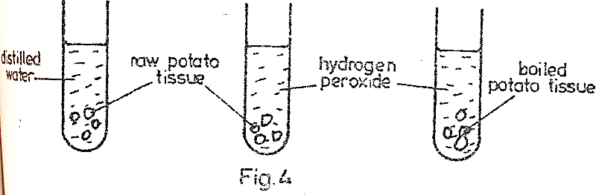

1. What is being investigated?

……………………………………………………………………………………………………

……………………………………………………………………………………………………

1. Suggest what was observed in each of the test tubes.

……………………………………………………………………………………………………

……………………………………………………………………………………………………

……………………………………………………………………………………………………

……………………………………………………………………………………………………

……………………………………………………………………………………………………

1. Explain the observations suggested in (b) (ii) above.

……………………………………………………………………………………………………

……………………………………………………………………………………………………

……………………………………………………………………………………………………

……………………………………………………………………………………………………

1. (a) Distinguish between predator and prey?

……………………………………………………………………………………………………

……………………………………………………………………………………………………

……………………………………………………………………………………………………

……………………………………………………………………………………………………

(b) Figure 5 below shows a predator/prey relationship. Study the figure out answer the questions that follow.

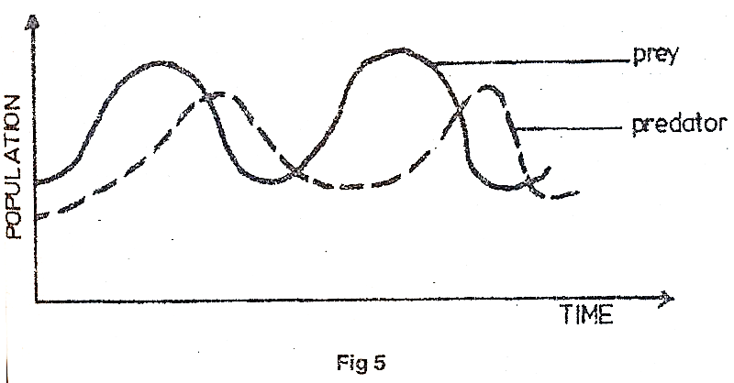

1. Describe the relationship between the predator and prey

……………………………………………………………………………………………………

……………………………………………………………………………………………………

……………………………………………………………………………………………………

……………………………………………………………………………………………………

……………………………………………………………………………………………………

1. Explain the relationship of the predator and prey described in (b) above.

……………………………………………………………………………………………………

……………………………………………………………………………………………………

……………………………………………………………………………………………………

……………………………………………………………………………………………………

……………………………………………………………………………………………………

……………………………………………………………………………………………………

……………………………………………………………………………………………………

1. Name two other external factors that may affect the population of the prey in the habitat.

……………………………………………………………………………………………………

……………………………………………………………………………………………………

……………………………………………………………………………………………………

……………………………………………………………………………………………………

1. (a) What is erosion?

……………………………………………………………………………………………………

……………………………………………………………………………………………………

……………………………………………………………………………………………………

(b) Name four types of soil erosion.

……………………………………………………………………………………………………

……………………………………………………………………………………………………

……………………………………………………………………………………………………

……………………………………………………………………………………………………

(c) State the causes of soil erosion.

……………………………………………………………………………………………………

……………………………………………………………………………………………………

……………………………………………………………………………………………………

……………………………………………………………………………………………………

(d) How does mulching help the farmer in

(i) Water conservation?

……………………………………………………………………………………………………

……………………………………………………………………………………………………

……………………………………………………………………………………………………

……………………………………………………………………………………………………

(ii) Soil conservation?

……………………………………………………………………………………………………

……………………………………………………………………………………………………

……………………………………………………………………………………………………

1. (a) (i) State the difference between cross-pollination and self-pollinaton.

……………………………………………………………………………………………………

……………………………………………………………………………………………………

……………………………………………………………………………………………………

……………………………………………………………………………………………………

(ii) Give three structural features of flowers that ensure cross-pollination

……………………………………………………………………………………………………

……………………………………………………………………………………………………

……………………………………………………………………………………………………

(b) Give five adaptations of flowers for insect-pollination.

……………………………………………………………………………………………………

……………………………………………………………………………………………………

……………………………………………………………………………………………………

……………………………………………………………………………………………………

……………………………………………………………………………………………………

**SECTION C**

*Answer any two questions*

1. Describe an experiment to show that oxygen is produced during photosynthesis.
2. (a) Give three secondary sexual characteristics in a human female.

(b) Describe the main events that occur during the menstrual cycle in a mammal.

1. (a) Describe the life cycle of a housefly.

(b) What is the economic importance of a housefly?

(c) How would you minimize the spread of houseflies in a home?

1. (a) Define:
2. Phototropism
3. Geotropism

(b) Describe an experiment you would carry out to determine the effects of gravity on the root of a dicotyledonous plant.

**1998**

**SECTION A**

*Answer all questions in this section.*

1. What would happen to an enzyme if the temperature of its medium was increased to above 500C? The Enzyme would be
2. Killed
3. Activated
4. Denatured
5. Inactivated
6. In which of the following does active transport not occur?
7. Kidney tubules
8. Phloem sieve tubes
9. Xylem vessels
10. Ileum villi
11. Which one of the following is an adaptation of reptiles for terrestrial environment?
12. Limbs
13. Lungs
14. Scales
15. Elongated body
16. Figure 1 below shows a longitudinal section through a maize grain.

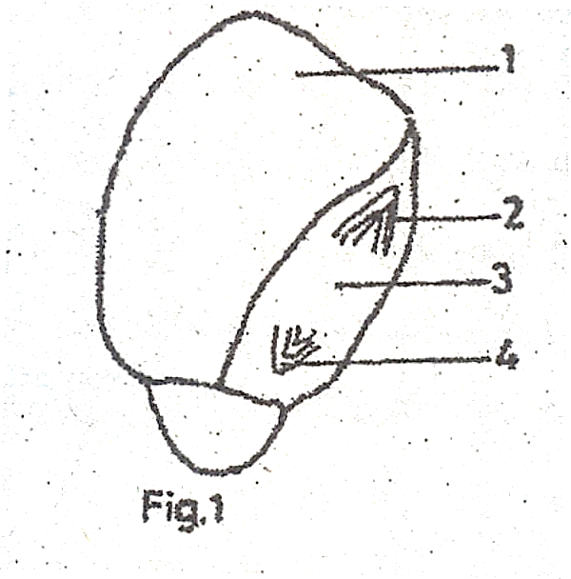

Which of the parts 1 – 4 of the grain would you expect to decrease in weight during germination?

1. 1
2. 2
3. 3
4. 4
5. Which one of the following parts of the ear, transmits sound waves from the middle ear to the linner ear?
6. Tympanic membrane
7. Ossicles
8. Auditory nerve
9. Oval window membrane
10. Which one of the following would you use to estimate the frequency of a plant species in an area?
11. Quadrant method
12. Belt transect
13. Line insect
14. Random sampling
15. An unknown sample of blood was found to agglutinate with blood of group AB, but not with blood of O. what was the blood group of the unknown sample?
16. O
17. AB
18. A
19. B
20. A rabbit is able to utilize cellulose because it
21. Has symbiotic bacteria in the stomach
22. Has symbiotic bacteria in the caecum
23. Has a very long alimentary canal
24. Secretes the enzyme cellulose
25. Which one of the following factors is not important in as far as nutrition of the common mould is concerned?
26. It produces large quantities of sports
27. It can respire anaerobically
28. It has a highly branched mycelium
29. It secrets enzymes
30. In the human heart, the mixing of oxygenated and de-oxygenated blood is prevented by the
31. Septum
32. Bicuspid valve
33. Tricuspid valve
34. Semilunar valve
35. Removal of the thyroid gland in a young child may lead to
36. Stunted growth and mental retardation
37. Failure to develop secondary sexual characteristics
38. Development of diabetes
39. Increased metabolic rate and restlessness
40. The following are physiological processes that occur in the body of a mammal:
41. Elimination of urea
42. Regulation of salts in the body
43. Regulation of water in the body
44. Deamination of excess amino acids

Which of them are carried out by the kidney?

1. (i), (ii) and (iv)
2. (ii), (iii) and (iv)
3. (i), (ii) and (iii)
4. (ii), and (iii) only
5. Which one of the following is a respiratory organ in an insect?
6. Malphigian tubule
7. Spiracle
8. Trachea
9. Zygote
10. Which one of the following is a diploid cell?
11. Pollen grain
12. Ovum
13. Spermatoon
14. Alveolus
15. What gas is likely to be evolved from a submerged aquatic plant placed in bright sunlight?
16. Carbon dioxide
17. Oxygen
18. Hydrogen
19. Nitrogen
20. Which of the following is a characteristic of cervical vertebra?
21. Broad neutral spine
22. Long transverse processes
23. Presence of Vertebraterial canals
24. Presence of facets
25. Which one of the following has the least energy content in a food chain?
26. Producer
27. Secondary consumer
28. Tertiary consumer
29. Primary consumer
30. A certain plant had the following characteristics

Leaves reduced to spikes

Stomata shrunken in pits

Leaves covered with thick cuticle

Which one of the following would be the likely habitat for the plant?

1. Open grass land
2. Arid land
3. Wet land
4. Tropic rainforest
5. Yellowing of leaves in growing maize plants indicates a deficiency of
6. Calcium
7. Sulphur
8. Nitrogen
9. Magnesium
10. What are the products of digestion of lactose sugar?
11. Glucose only
12. Glucose and galactose
13. Fructose and galactose
14. Fructose and glucose
15. Which one of the following is a characteristic of insects only?
16. Exoskeleton
17. Jointed legs
18. Two pairs of wings
19. Three body divisions
20. Which of the following vegetative plants would appear earliest in a rocky habitat?
21. Moss
22. Lichens
23. Algae
24. Ferns
25. Which one of the organisms below has a growth curve represented by the graph in figure 2?

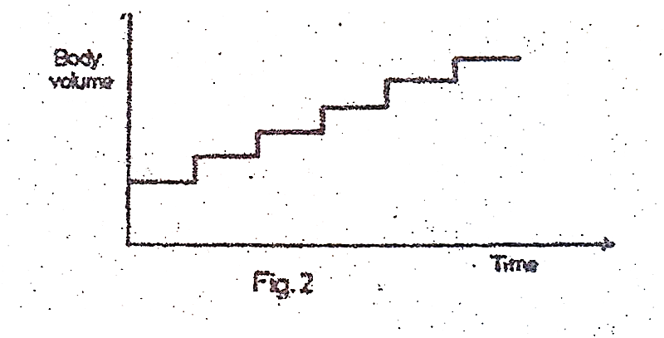

1. A bacterium
2. An insect
3. A human being
4. A bony fish
5. Which one of the following is a modified root?
6. Sweet potato tuber
7. Rhizome
8. Irish potato tuber
9. Corm
10. Which one of the following hormone is responsible for ovulation in mammals?
11. Oestrogen
12. Progesterone
13. Follicle stimulating hormone
14. Luteinsing hormone
15. Which of the following are characteristics of sandy soil?
16. Poor aeration and poor drainage
17. Good water retention and poor drainage
18. Sticky when wet and poor drainage
19. Good aeration and good drainage
20. Which of the following is not true about mutation?
21. Mutation may affect single genes or chromosomes
22. All mutations produce harmful effects
23. A mutant gene can be passed onto the offspring during fertilization
24. Mutations are the raw materials for evolution
25. A maize grain is both a seed and a fruit because it
26. Shows hypogeal germination
27. Has a fused pericarp and testa
28. Shows two attachments or scars
29. Has both endosperm and cotyledon
30. Figure 3 below is an experiment set up to investigate the action of enzyme pepsin on egg albumen.

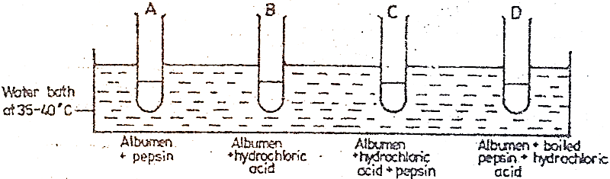

In which tube will the contents clear after sometime?

1. Which one of the following substances does not contain nitrogen?
2. Glycerol
3. Amino acids
4. Amylase
5. Urea

**SECTION B**

*Answer all questions in this section.*

1. Figure 4 below, shows a mammalian system.

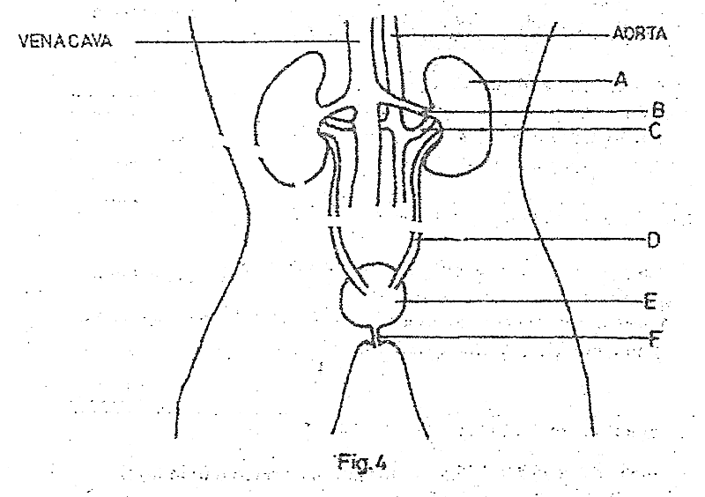

1. Name the parts A – F

A ………………………………………………………………………………………………

B ………………………………………………………………………………………………

C ………………………………………………………………………………………………

D ………………………………………………………………………………………………

E ………………………………………………………………………………………………

F ………………………………………………………………………………………………

(b) Briefly explain why the concentration of urea in B is less than that in C.

………………………………………………………………………………………………………

………………………………………………………………………………………………………

………………………………………………………………………………………………………

………………………………………………………………………………………………………

………………………………………………………………………………………………………

(c) What is the function of E?

………………………………………………………………………………………………………………

………………………………………………………………………………………………

(d) A sample of urine was found to contain sugar.

(i) Suggest the type of sugar likely to be contained in the urine sample

………………………………………………………………………………………………………

(ii) What hormone is likely to be deficient in the person from whom the urine sample was taken?

………………………………………………………………………………………………………

(iii) Name the disease that the person is likely to be suffering from.

………………………………………………………………………………………………………

(e) Another individual was found to be passing out a lot of urine but without sugar and complaining if thirst most of the time.

(i) Suggest a hormone that is deficient in this individual.

………………………………………………………………………………………………………

(ii) Name the organ which produces the hormone referred to in (e) (i) above.

………………………………………………………………………………………………………

1. (a) Give five differences between respiration and photosynthesis.

………………………………………………………………………………………………………

…………………………………………………………………………………………………………

…………………………………………………………………………………………………………

…………………………………………………………………………………………………………

…………………………………………………………………………………………………………

…………………………………………………………………………………………………………

…………………………………………………………………………………………………………

(b) Give three ways in which respiration is important to living organisms.

…………………………………………………………………………………………………………

…………………………………………………………………………………………………………

…………………………………………………………………………………………………………

…………………………………………………………………………………………………………

…………………………………………………………………………………………………………

…………………………………………………………………………………………………………

(c) Name two commercial uses of anaerobic respiration.

…………………………………………………………………………………………………………

…………………………………………………………………………………………………………

…………………………………………………………………………………………………………

1. (a) What is germination?

…………………………………………………………………………………………………………

…………………………………………………………………………………………………………

…………………………………………………………………………………………………………

(b) State the external factors that affect germination.

…………………………………………………………………………………………………………

…………………………………………………………………………………………………………

…………………………………………………………………………………………………………

…………………………………………………………………………………………………………

…………………………………………………………………………………………………………

(c) Figure 5 below shows a growth curve of a bean seedling.

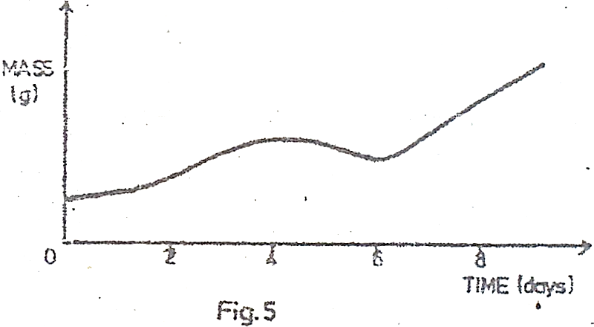

1. Why does the mass of the seedling increase between day 0 and day 4?

…………………………………………………………………………………………………………

…………………………………………………………………………………………………………

1. What has caused a drop in the mass between day 4 and day 6?

…………………………………………………………………………………………………………

…………………………………………………………………………………………………………

…………………………………………………………………………………………………………

…………………………………………………………………………………………………………

…………………………………………………………………………………………………………

1. Give reasons for the steady increase in mass after day 6.

…………………………………………………………………………………………………………

…………………………………………………………………………………………………………

…………………………………………………………………………………………………………

…………………………………………………………………………………………………………

1. Figure 6 below shows the nitrogen cycle.

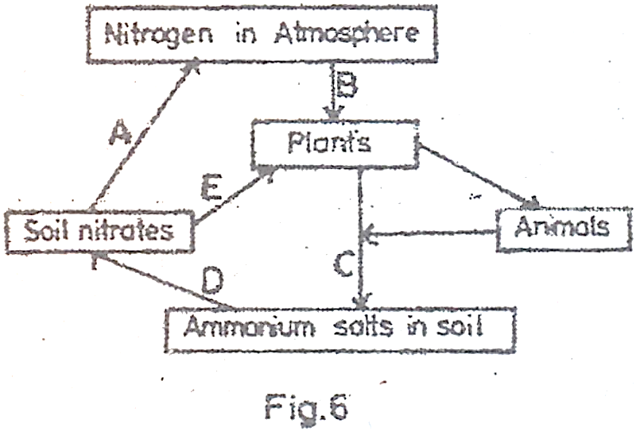

1. Name the processes taking place at A, B, C, D and E.

A ………………………………………………………………………………………………

B ………………………………………………………………………………………………

C ………………………………………………………………………………………………

D ………………………………………………………………………………………………

E ………………………………………………………………………………………………

1. (i) How is the process at B useful to plants?

…………………………………………………………………………………………………………

…………………………………………………………………………………………………………

(ii) What organisms are responsible for the process at C?

…………………………………………………………………………………………………………

1. State the importance of the process at A in the cycle.

…………………………………………………………………………………………………………

…………………………………………………………………………………………………………

**SECTION C**

*Answer any two questions.*

1. (a) Outline the mechanism of
2. Inspiration
3. Expiration
4. How are gills adapted for gaseous exchange in a bony fish?
5. (a) What is self-pollination?

(b) How is self-pollination naturally prevented in plants?

(c) Describe the features of a flower that favour pollination by insects.

1. (a) Giving two examples in each case, explain the following:
2. Parasitism
3. Commensalism
4. Symbiosis

(b) How is the tape worm adapted to its parasitic mode of life?

1. (a) What is transpiration?

(b) Describe an experiment to show that transpiration occurs in plants.

(c) State the factors that affect transpiration in plants.

**1997**

**SECTION A**

*Answer all questions in this section.*

1. Which of the following processes need energy?
2. Osmosis
3. Diffusion
4. Plasmolysis
5. Active transport
6. What is the normal blood sugar level in an adult person?
7. 140 mg/100 cm3
8. 100 mg/100 cm3
9. 90 mg/100 cm3
10. 80 mg/100 cm3
11. The diagram in figure 1 is of a transverse section of a plant part.

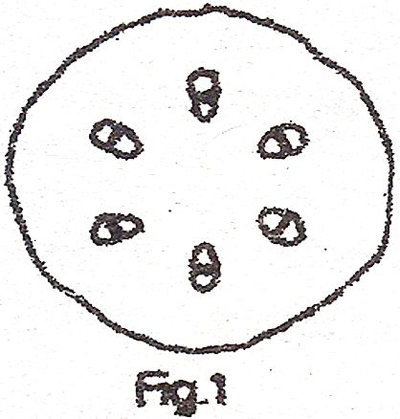

From which one of the following was the section taken? A

1. Monocotyledonous stem
2. Monocotyledonous root
3. Dicotyledonous stem
4. Dicotyledonous stem
5. Which one of the following represents a reflex arc?
6. Receptor $⟶$ motor neurone $⟶$ effector $⟶$ central nervous system $⟶$ sensory neurone $⟶$ effector
7. Receptor $⟶$ sensory neurone $⟶$ effector $⟶$ central nervous system $⟶$ motor neurone
8. Receptor $⟶$ central nervous system $⟶$ motor neurone $⟶$ sensory neurone $⟶$ effector
9. Receptor $⟶$ sensory neurone $⟶$ central nervous system $⟶$ motor neurone $⟶$ effector
10. The following are characteristics of insecta:
11. They undergo complete metamorphosis
12. They have 1 or 2 pairs of wings
13. They have 3 pairs of jointed legs
14. Their bodies are divided into 3 main parts
15. They possess exoskeletons

Which of them are common to all insects?

1. (iii), (iv) and (v)
2. (i), (ii) and (iii)
3. (i), (iii) and (v)
4. (iii), (ii) and (v)
5. Which one of the following combination of words about amoeba are related?
6. Pseudopodia, reproduction
7. Nucleus, movement
8. Contractile vacuole, water
9. Ectoplasm, digestion
10. The results of an experiment to determine percentage of water in a sample of soil are shown below:

Mass of crucible = 15g

Mass of crucible plus soil = 30g

Mass of crucible plus soil after drying = 25g

What is the percentage of water?

1. 33.3%
2. 18.7%
3. 66.7%
4. 20.0%
5. Which of the following reasons supports natural feeding of baby on mother’s milk? Mother’s milk is
6. Easy to digest
7. Made up mainly of carbohydrates
8. Contains correct antibodies
9. Fosters relationship between mother and baby
10. (i) and (ii)
11. (ii) and (iii)
12. (ii), (iii) and (iv)
13. (i), (iii) and (iv)
14. The milk teeth in humans consist of
15. Incisors only
16. Incisors and canines
17. Incisors, canines and premolars
18. Incisors and premolars
19. Which one of the following is not transported in blood?
20. Amylase
21. Urea
22. Insulin
23. Sodium chloride
24. Which one of the following is not a primary function of roots?
25. Conduct water and mineral salts
26. Anchor the plant into the soil
27. Store food and water
28. Absorb water and mineral salts
29. Within an ecosystem, the total number of secondary consumers must be
30. Less than the total number of herbivores
31. Greater than the total number of herbivores
32. Equal to the total number of producers.
33. Constant year after year
34. Which one of the following hormones is not secreted from the pituitary gland?
35. Gonadotrophic hormone
36. Luteinizing hormone
37. Progesterone hormone
38. Follicle stimulating hormone
39. Why is it necessary to keep both eyes open when you are using a monocular microscope?
40. Straining one eye is avoided
41. One eye is set on the drawing paper
42. It enables one to see the object clearly
43. It eases the control of the adjustment knobs
44. Which one of the following food substances are not changed by the gut enzymes?
45. Lipids and vitamins
46. Minerals and vitamins
47. Minerals and disaccharides
48. Lipids and lactose
49. The structure in insects that serve as respiratory surfaces for gaseous exchange are
50. Trachea
51. Bronchioles
52. Tracheoles
53. Spiracles
54. A man’s urine gave a positive test with Benedict’s solution. What is the best deduction about this man?
55. He had been eating a lot of sugar
56. There was too much insulin in his blood
57. There was too much glycogen in his blood
58. He was suffering from diabetes
59. Figure 2 below is a diagram showing a plan of the pentadactyl limb.

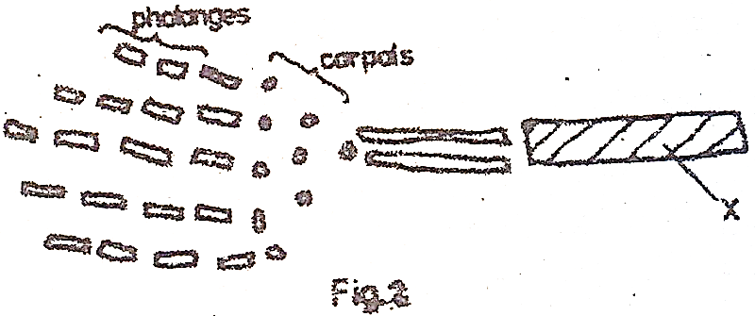

What part is represented by letter X?

1. Femur
2. Humerus
3. Radius
4. Ulna
5. What do the rhizobium bacteria gain in their association with leguminous plant?
6. Air
7. Heat
8. Shelter
9. Nitrates
10. Which of the following is the best advantage of crop rotation?
11. It helps reduce soil erosion
12. The growth of weeds is brought under control
13. It prevents exhaustion of particular mineral salts from the soil
14. It helps improve soil conditions
15. Which one of the following events does not occur following the contraction of the ventricles in mammalian heart?
16. Blood flows from ventricles into arteries
17. The blood pressure increases in the aorta
18. Atrio-ventricular valves open
19. Arterial valves open
20. Which of the following mineral elements are for home formation?
21. Iodine, sodium and calcium
22. Iron, fluorine and calcium
23. Phosphorous, sodium and fluorine
24. Calcium, fluorine and phosphorous
25. What is the function of albumen in an egg? It
26. Is a source of fat and protein for the embryo
27. Is a source of protein and water for the embryo
28. Suspends the embryo
29. Stores embryo’s excretory products
30. A heterozygous red flowered plant (Rr) is crossed with a homozygous white flowered plant (rr). If R is dominant over r, what will be the phenotypes of the offsprings?
31. All red
32. All white
33. Pink and white
34. Red and white
35. The dry fruit which splits open along both sutures is
36. A follide
37. A capsule
38. An achene
39. A legume
40. Which one of the following structures is not essential in the life of a tadpole?
41. Lungs
42. Horny jaws
43. Gills
44. Tail
45. The diagram in figure 3 below represents the frequency of occurrence of a character in human population.

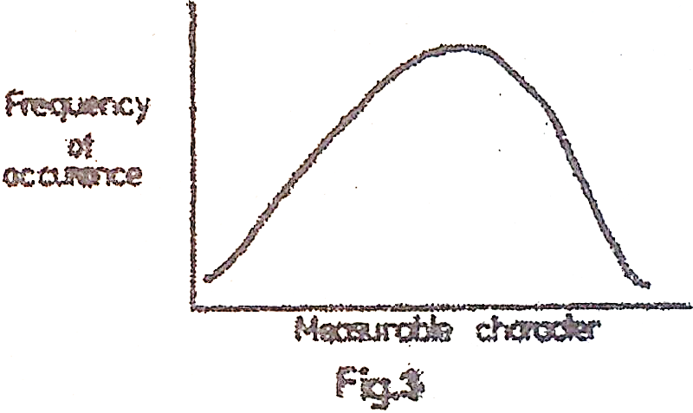

Which one of the following characters in the population does not conform to this pattern?

1. Height
2. Weight
3. Length of feet
4. Eye colour
5. Which of the following is not a function of the liver?
6. Storage of vitamins
7. Manufacture of plasma proteins
8. Storage of proteins
9. Formation of bile
10. Which of the following cells in the leaf contain the least number of chloroplasts?
11. Palisade cells
12. Guard cells
13. Epidermal cells
14. Spongy mesophyll cells
15. Which one of the following organisms is not a heterotroph?
16. Mushroom
17. Alga
18. Tick
19. Grass hopper

**SECTION B**

*Answer all questions in this section.*

1. (a) What do you understand by the following terms?
2. Habitat

……………………………………………………………………………………………………….

……………………………………………………………………………………………………….

……………………………………………………………………………………………………….

1. Ecosystem

……………………………………………………………………………………………………….

……………………………………………………………………………………………………….

……………………………………………………………………………………………………….

(b) There are four possible trophic levels that can exist in a food chain. State them below.

(i)

……………………………………………………………………………………………………….

(ii)

……………………………………………………………………………………………………….

(iii)

……………………………………………………………………………………………………….

(iv)

……………………………………………………………………………………………………….

(c) Give an example of a food chain consisting of four levels of organisms found in a grassland.

……………………………………………………………………………………………………….

……………………………………………………………………………………………………….

(d) Construct a diagram of a food web which may exist in a freshwater lake in Uganda, comprising of the following organisms.

Tadpole, Green alga, Heron, Saprophytic bacteria, small fish, big fish and mosquito larvae.

1. In an experiment, a long winged male drosophila was crossed with a short winged female drosophila. All the offspring in the F1 generation were long winged. When two members of the F1generation were mated, the F2 generation consisted of 62 long winged flies and 21 short winged flies.
2. Suggest an explanation why all the F1 generation flies were long winged.

……………………………………………………………………………………………………….

……………………………………………………………………………………………………….

……………………………………………………………………………………………………….

……………………………………………………………………………………………………….

1. (i) What type of flies would develop from a mating between short winged flies in the second generation?

……………………………………………………………………………………………………….

(ii) Give a reason for your answer.

……………………………………………………………………………………………………….

……………………………………………………………………………………………………….

1. Mating between a short winged fly in F2 generation with a long winged fly in F­1 generation produced 90 flies. How many of them were long winged? Show your working.

……………………………………………………………………………………………………….

……………………………………………………………………………………………………….

……………………………………………………………………………………………………….

……………………………………………………………………………………………………….

……………………………………………………………………………………………………….

……………………………………………………………………………………………………….

……………………………………………………………………………………………………….

……………………………………………………………………………………………………….

……………………………………………………………………………………………………….

……………………………………………………………………………………………………….

……………………………………………………………………………………………………….

……………………………………………………………………………………………………….

……………………………………………………………………………………………………….

……………………………………………………………………………………………………….

……………………………………………………………………………………………………….

……………………………………………………………………………………………………….

1. The diagram is figure 4 shows part of the body of a man.

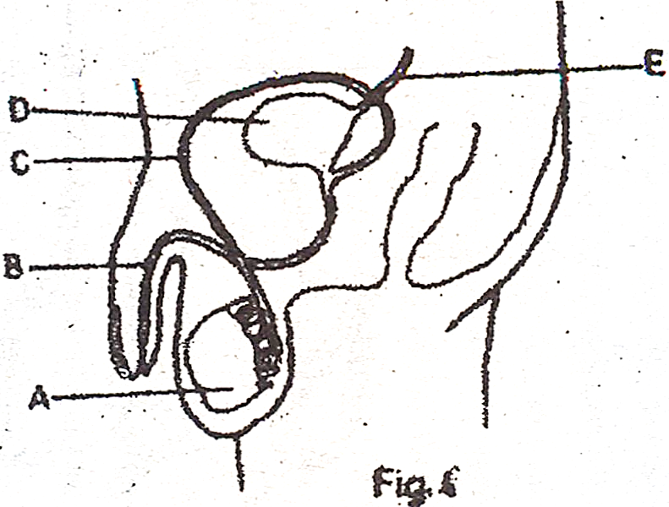

1. Name the parts labelled A to E.

A ………………………………………………………………………………………………

B ………………………………………………………………………………………………

C ………………………………………………………………………………………………

D ………………………………………………………………………………………………

E ………………………………………………………………………………………………

1. (i) Name the hormone made in the male which brings about the secondary sexual characteristics.

………………………………………………………………………………………………

(ii) On the diagram, write H where the hormone is made.

(iii) Name two secondary sexual characteristics in the human male.

………………………………………………………………………………………………

………………………………………………………………………………………………

1. What is the function of part D?

………………………………………………………………………………………………

1. From which organ would fluid in the tube E come from?

………………………………………………………………………………………………

1. The diagram in figure 5 shows the structure of a villus.

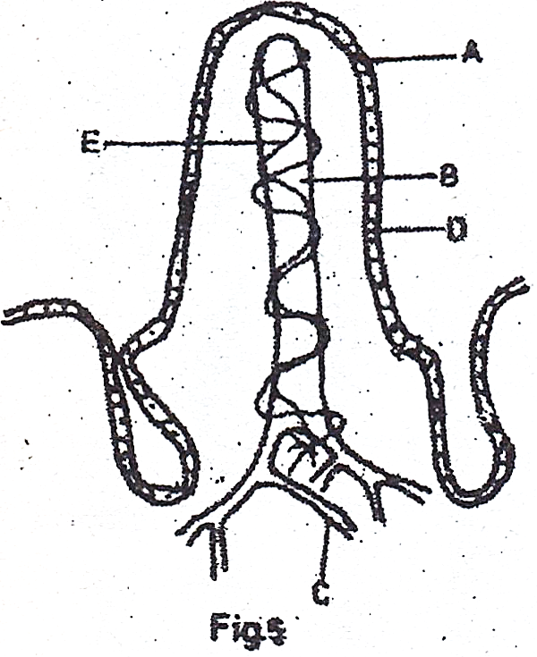

1. Label parts marked A, B, C and D.

A ………………………………………………………………………………………………

B ………………………………………………………………………………………………

C ………………………………………………………………………………………………

D ………………………………………………………………………………………………

1. What food substance enters
2. A

………………………………………………………………………………………………

1. B

………………………………………………………………………………………………

1. State two factors which make a villus an effective absorbing structure.
2. …………………………………………………………………………………………
3. …………………………………………………………………………………………

(d) How does the absorbed food in B reach the general circulation?

………………………………………………………………………………………………

(e) State two nutrients which are absorbed in the gut before reaching the villus.

(i) ………………………………………………………………………………………………

(ii)

………………………………………………………………………………………………

**SECTION C**

*Answer any two questions.*

1. (a) What is soil erosion?

(b) State the various types of soil erosion.

(c) Explain how man’s activities may lead to soil erosion.

1. (a) Describe how plants loss water through their leaves.

(b) Describe two features of plants and two features of animals which help them reduce water loss in dry conditions.

1. (a) What is meant by the word metamorphosis?

(b) Using a written description and labelled diagrams, describe the life cycle of a grass hopper.

1. (a) What is respiration?

(b) State three differences between aerobic and anaerobic respiration.

(c) Describe gaseous exchange in a frog.

**1996**

**SECTION A**

*Answer all question in this section.*

1. Individuals with blood group AB are said to be universal recipients because they have
2. No antigens
3. No antibodies
4. Both antigens and antibodies
5. Antibodies a and b
6. Which one of the following is true about the nervous system of a mammal?
7. Cell bodies of the sensory neurons are found in the ganglia
8. Cell bodies of the sensory neurones are found in the grey matter
9. Sensory neurones transmit impulses from the central nervous system
10. Cell bodies of sensory neurones are found in the receptors.
11. The last segment of a caterpillar bears a pair of structures called
12. Prolegs
13. Ovipositors
14. Claspers
15. True legs
16. In cattle the gene for red coat colour, R, is co-dominant to that for white coat colour, W. if a red cow was mated to a white bull, what would be the phenotype of the F1 generation?
17. All red
18. All white
19. 3 red : 1 white
20. Intermediate coat colour (roan)
21. What are the products of the hydrolysis of lactose?
22. Galactose and fructose
23. Glucose and galactose
24. Glucose only
25. Glucose an fructose
26. Photosynthesis is said to have a pair of raw materials, a pair of conditions, and a pair of products. Which of these is the correct set?
27. Carbon dioxide and light; water and chlorophyll; oxygen and sugars
28. Water and light; carbon dioxide and chlorophyll; oxygen and sugars
29. Light and chlorophyll; carbon dioxide and sugar; water and oxygen
30. Carbon dioxide and water; light and chlorophyll; oxygen and sugars
31. Which one of the following controls the activities of other ductless glands?
32. Thyroid
33. Adrenal
34. Pituitary
35. Islets of Langerhans
36. A runner is a
37. Stem which bends over and roots in the soil
38. Horizontal stem above the ground which gives roots and aerial shoots at the nodes
39. Horizontal stem beneath the ground which gives rise to roots and aerial shoots at the nodes
40. Short vertical stem which buds beneath the soil
41. What would result if secretion of gastric juice were inhibited in an individual who has just had a meal of posho and beans?
42. The person would suffer from heartburn
43. The person would suffer from constipation
44. Digestion would not take place
45. Digestion of certain food types would be delayed
46. Which of the following is true about arteries? They
47. Carry blood away from the heart
48. Carry deoxygenated blood
49. Carry oxygenated blood
50. Possess valves along their length
51. Which of the following is true nastic response?
52. Depends on the direction of the stimulus
53. Does not involve hormones
54. It is relatively slow
55. Does not involve only growth
56. Urine is formed by
57. Ultrafiltration and selective reabsorption
58. Selective reabsorption in the proximal tubule
59. Selective reabsorption at the loop of Henle
60. Ultrafiltration in the Bowman’s capsule
61. Which one of the following substances accumulates in muscles during vigorous exercise?
62. Water
63. Lactic acid
64. Carbon dioxide
65. Oxygen
66. The best method of measuring the growth rate of a seedling is by
67. Taking records of dry weight
68. Measuring the fresh weight
69. Observing the increase in volume
70. Observing the increase in the size of the leaves
71. Which one of these methods is not important in the maintenance of soil fertility on a given piece of land?
72. Practising crop rotation
73. Addition of organic manure
74. Maintaining of vegetation cover
75. Burning of the grass in the plot regularly
76. Short sightedness is caused by the
77. Lens becoming thicker
78. Suspensory ligament becoming shorter
79. Contraction of the Ciliary muscles
80. Expansion of iris muscles
81. Which one of the following soil types has the highest capillarity?
82. Silt
83. Loam
84. Clay
85. Sand
86. When blood passes from the lungs to the kidney it has to go through the
87. Pulmonary artery, tricuspid valve and aorta
88. Pulmonary vein, bicuspid valve and aorta
89. Anterior Venacava, tricuspid valve and aorta
90. Posterior Venacava, bicuspid valve and aorta

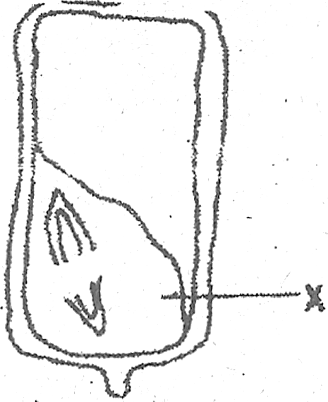

In a germinating grain, the function of X is to

1. Absorb food from the endosperm
2. Provide the first leaves
3. Hydrolyze the food in the endosperm
4. Protects the plumb
5. A mammalian embryo exchanges materials with its mother by
6. Osmosis
7. Secretion
8. Circulation
9. Diffusion
10. Which one of the following statements is the most appropriate definition of respiration?
11. The oxidation of sugar to produce energy and water
12. Breathing in oxygen, oxidation of food and release of water, carbon dioxide and energy
13. The exchange of oxygen and carbon dioxide in the lungs
14. The oxidation of sugar to produce carbon dioxide and energy

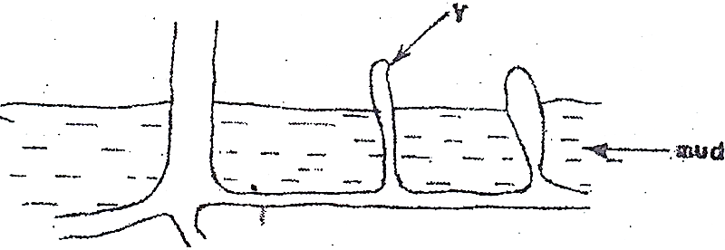

The root modification shown by Y above is for

1. Storage
2. Excretion
3. Breathing
4. Extra support
5. In what part of the green flowering plant does meiosis occur?
6. Seed
7. Flower
8. Fruit
9. Short apex
10. A bat is classified as a mammal because
11. It does not possess feathers
12. It has specialized teeth
13. It has four limbs
14. Its digits have claws

Study the food web below and use it to answer questions 25 and 26.

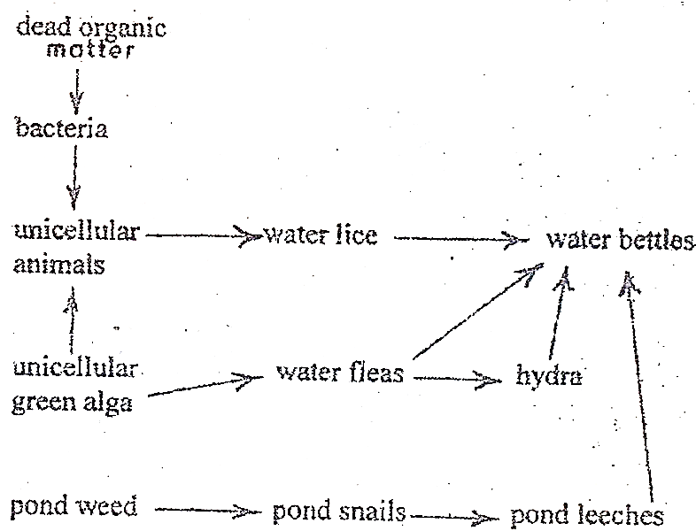

1. In this foo web, which of the following groups of organisms are primary consumers?
2. Pond leeches and water fleas
3. Pond snails and unicellular animals
4. Hydra and water beetles
5. Bacterial and water fleas
6. In this food web which one of the following groups of organisms are decomposers?
7. Unicellular green algae
8. Water beetles
9. Water lice
10. Bacteria
11. Which one of the following features is typical of the class insecta?
12. Jointed legs
13. Three body parts
14. Complete metamorphosis
15. Exoskeleton
16. Which one of the following types of feathers is most widespread?
17. Covert feather
18. Filiplumes
19. Quill feathers
20. Down feathers
21. Which of the following pairs of cells does not have nuclei when mature?
22. Sieve tube cells and companion cells
23. Erythrocytes and leucocytes
24. Sieve tube cells and erythrocytes
25. Companion cells and leucocytes
26. Which one of the following processes need energy?
27. Absorption of water by root hairs
28. Gaseous exchange in the alveoli
29. Loss of turgidity by a plant cell
30. Absorption of mineral salts by root hairs

**SECTION B**

*Answer all questions in this section.*

1. (a) (i) What is meant by the term mutation?

……………………………………………………………………………………………………….

……………………………………………………………………………………………………….

(b) The gene for normal production of haemoglobin is dominant to the mutant gene which causes sickle cell anaemia. If a female heterozygous for the sickle cell anaemia marries a normal man, illustrate, using suitable symbols, the possible genotypes and phenotypes of the offspring.

……………………………………………………………………………………………………….

……………………………………………………………………………………………………….

……………………………………………………………………………………………………….

……………………………………………………………………………………………………….

……………………………………………………………………………………………………….

……………………………………………………………………………………………………….

……………………………………………………………………………………………………….

……………………………………………………………………………………………………….

……………………………………………………………………………………………………….

……………………………………………………………………………………………………….

1. (a) Distinguish between endocrine and exocrine glands.

……………………………………………………………………………………………………….

……………………………………………………………………………………………………….

……………………………………………………………………………………………………….

……………………………………………………………………………………………………….

(b) Below is a diagram of a human female showing the location of two endocrine glands.

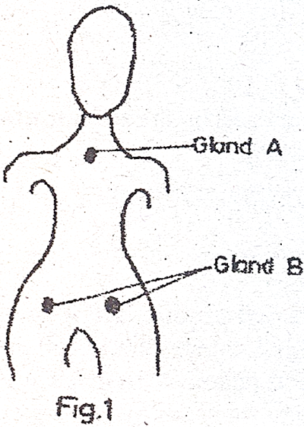

Name the glands A and B and one hormone produced by each.

……………………………………………………………………………………………………….

……………………………………………………………………………………………………….

……………………………………………………………………………………………………….

(c) Give three effects of adrenaline in the body

……………………………………………………………………………………………………….

……………………………………………………………………………………………………….

……………………………………………………………………………………………………….

……………………………………………………………………………………………………….

1. Figure 2 (a) shows a vertical section of the end region of a growing root and figure 2 (b) shows an

enlargement of a cell from the root.

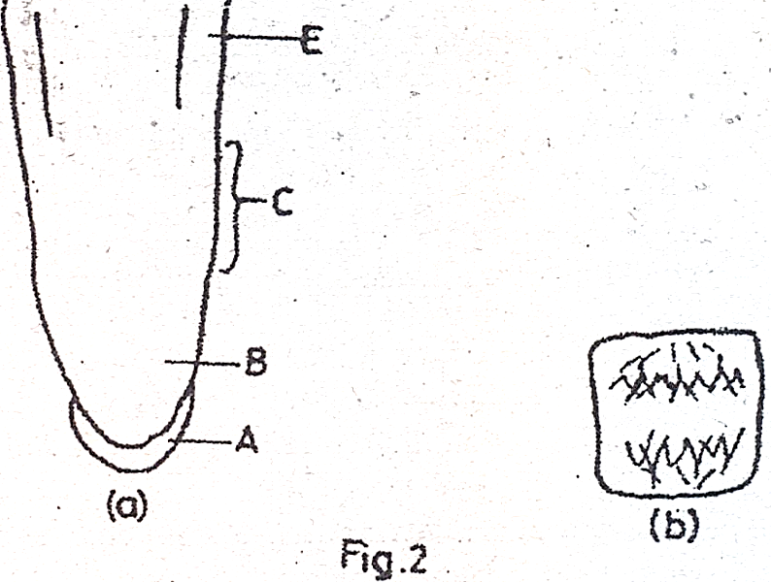

1. (i) Name the region labelled A.

……………………………………………………………………………………………………….

(ii) How does growth occur in the region labelled B?

……………………………………………………………………………………………………….

……………………………………………………………………………………………………….

(iii) Describe briefly what happens to the cells in the region labelled C.

……………………………………………………………………………………………………….

……………………………………………………………………………………………………….

(iv) What structures might be expected to grow at the region marked D?

……………………………………………………………………………………………………….

1. State the function of region marked A.

……………………………………………………………………………………………………….

……………………………………………………………………………………………………….

1. Figure 2 (b) shows a cell from region B.
2. Name the process taking place in this cell.

……………………………………………………………………………………………………….

1. Briefly describe what is happening at this particular stage of the process.

……………………………………………………………………………………………………….

……………………………………………………………………………………………………….

……………………………………………………………………………………………………….

1. The graph below shows the relationships between body temperatures and external temperatures in a human being and a lizard.

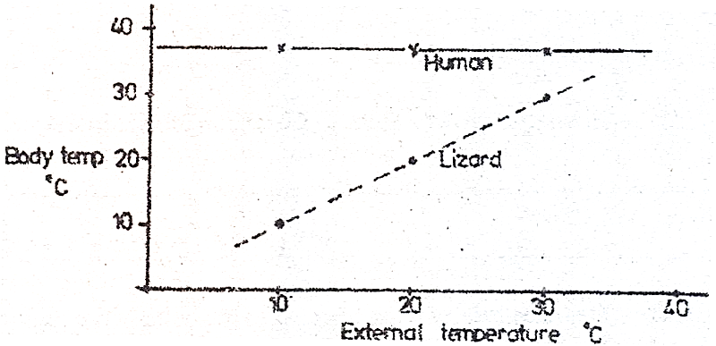

1. What happens to the temperature of each organism as the external temperature increases?

Human

……………………………………………………………………………………………………….

……………………………………………………………………………………………………….

Lizard

……………………………………………………………………………………………………….

……………………………………………………………………………………………………….

1. Humans are sometimes described as warm-blooded (homoiotheric). State the advantage of this condition.

……………………………………………………………………………………………………….

……………………………………………………………………………………………………….

……………………………………………………………………………………………………….

1. Suggest how a lizard living in hot desert, conditions might avoid overheating if external temperatures rose above 400C.

……………………………………………………………………………………………………….

……………………………………………………………………………………………………….

**SECTION C**

Answer any two questions from this section.

1. (a) How does gaseous exchange take place in an insect?

(b) How does gaseous exchange in insects differ from that in mammals?

1. Describe an experiment you would carry out to test for the presence of starch in a leaf.
2. (a) Draw a well labelled diagram of a human female reproductive system.

(b) Outline the events that lead to the fertilization of the ovum in the human female.

1. (a) Describe the structure of a motor neurone

(b) (i) What is meant by reflex action?

(ii) By means of a diagram, show the path followed by a nerve impulse during a reflex action.

**1995**

**SECTION A**

*Answer all questions in this section.*

1. Enzymes are said to be specific in nature because they
2. Are proteins
3. Act in a particular pH medium
4. Act on one kind of substrate
5. Remain unchanged at the end of the reaction.
6. A sample of urine from a man was boiled with Benedict’s solution and the mixture turned orange in colour. Which of the following is the best deduction about the condition of this man?
7. There was a lot of glycogen in his blood
8. He has a deficiency of insulin in his blood
9. His diet has a lot of sugar
10. His kidneys were damaged
11. Which of the following will not cause an evolutionary change in an animal species?
12. Having more males than females in the population
13. Abundant food supply
14. Presence of many predators
15. Severe change in environmental conditions
16. Which of these are characteristic of all insects?
17. Complete metamorphosis and possession of three pairs of jointed legs
18. Possession of three pairs of jointed legs and body divided into three main parts
19. Possession of one or two pairs of wings and having three pairs of jointed legs
20. Complete metamorphosis and body divided into three main parts
21. In body temperature regulation, vasoconstriction
22. Allows less blood to enter the skin capillary network
23. Allows less urine to be secreted into the bladder
24. Allows more swear to be secreted by the sweat glands
25. Increases heat loss by radiation
26. Which type of soil has the following properties?
27. Heavy to cultivate
28. High water retention
29. High capillarity
30. Sandy loam
31. Loam
32. Sand
33. Clay
34. The main function of the Eustachian tube in the mammalian ear is to
35. Concentrate the sound waves into the middle ear
36. Transmit sound waves to the brain
37. Transmit sound waves to the middle ear
38. Regulate pressure in the middle ear
39. Which one of the following results of seed dispersal may not be an advantage to a plant?
40. Reduces overcrowding
41. Minimizes spread of disease
42. Stops competition for light and air
43. Results in colonization of new areas
44. A heterozygous red flowered plant is crossed with a homozygous white flower. If red is dominant over white, what will be the phenotypes of the offspring?
45. ½ red and ½ white
46. All white
47. All red
48. ¾ red and ¼ white
49. Which of the following is the best description of the term double circulation in a mammal?
50. Blood flows into the two lungs and then into the body
51. Blood passes through two chambers of the heart
52. Blood passes through the heart twice in one circulation
53. Blood first flows through arteries and then through veins
54. Which one of the following is an example of a tactic response?
55. Rolling up of leaves on a sunny day
56. Withdrawal by blowfly larvae from light
57. Withdrawal of the hand from a hot object
58. Bending of a plant shoot towards light
59. The best method that prevents the start of gully erosion on a cultivated hill is
60. Contour cultivation
61. Strip cropping
62. Tree belts
63. Mulching
64. An adult person who constantly feeds on an iodine – deficient diet may show one of the following conditions:
65. Anaemia
66. Goiter
67. Cretinism
68. Dry scaly skin
69. In the flowering plants translocation of photosynthetic products is by the
70. Xylem vessels
71. Sclerenchyma
72. Sieve tubes
73. Companion cells
74. In which part of the gut does mucus (mucin) have a protective function?
75. Oesophagus
76. Stomach
77. Small intestine
78. Rectum
79. The main function of Luteinsing hormone in the reproductive cycle of a mammal is that it
80. Causes ovulation
81. Causes thickening of the uterine walls
82. Initiates the growth of a Graafian follicle
83. Maintains pregnancy for the first 3 months
84. During seed germination, the dry weight initially decreases because
85. Stored food is used up for growth and respiration
86. Soluble food materials diffuse out of the seedlings
87. Rate of water absorption is low
88. Rate of cell division is low
89. A sample of blood from the hepatic portal vein contains
90. Fats
91. Proteins
92. High concentration of urea
93. High concentration of products of digestion
94. Which of the following does not affect the rate of diffusion?
95. Density of the diffusion medium
96. Size of diffusing particles
97. Distance through which particles diffuse
98. Temperature of the diffusion medium
99. The function of amniotic fluid in foetal development is
100. Protection of the foetus from shock
101. Transfer of nutrients from mother to foetus
102. Allowing gaseous exchange between mother and foetus
103. Prevention of dangerous substances from reaching the foetus
104. Which of the following is not a component of joints in the endoskeleton?
105. Cartilage
106. Tendon
107. Ligament
108. Synovial fluid
109. Which one of the following structures represents the respiratory surface of a fish?
110. Gill bars
111. Gill rakers
112. Gill chamber
113. Gill filaments
114. Meiosis normally results in
115. Halving the number of chromosomes
116. Production of identical cells
117. Maintaining the number of chromosomes
118. Propagation of new organisms
119. Which of these statements is not true of an ecosystem?
120. Consumers use less food compared to what producers make
121. One of the ways constructing a food chain is by observing the animals feeding
122. The numbers of organisms decrease from the bottom to the top of the pyramid of numbers
123. Because of mains feeding habits, he can be placed in any of the feeding levels.
124. In humans, the male sec chromosomes are X and Y (XY) and the female sex chromosomes are X and X (XX). When a male gamete fuses with female gamete the sex ratio is
125. 1 : 2
126. 1 : 3
127. 1 : 1
128. 1 : 4
129. Artificial immunity to a disease is developed by
130. Catching the disease and recovering from it
131. Inoculation with a mild strain of the pathogen
132. Receiving antibiotic injections against the disease
133. Taking drugs that prevent the disease
134. Which one of the following is an example of discontinuous variation in humans?
135. Skin color
136. Intelligence
137. Height
138. Blood groups
139. What are final products of anaerobic respiration?
140. Carbon dioxide, water and energy
141. Carbon dioxide, water and alcohol
142. Carbon dioxide, alcohol and energy
143. Carbon dioxide and alcohol
144. Which one of the following is characteristic of monocotyledons?
145. Leaf sheath
146. Net venation
147. Prominent tap root
148. Cork layer
149. What is the functional unit in a nervous system called?
150. Dendrite
151. Neurone
152. Axon
153. Synapse

**SECTION B**

*Answer all questions in this section.*

1. The table below shows the effect of temperature on the activity of amylase on starch, six test tubes, each containing a mixture of starch and amylase, were placed in water baths maintained at 00c, 100C, 200C, 300C, 400C and 500C and allowed to stand. Study the table and answer the questions that follow.

|  |  |  |
| --- | --- | --- |
| Test tube | Temperature (0C) | Time taken for starch  Digestion (minutes) |
| 1  2  3  4  5  6 | 0  10  20  30  40  50 | Starch still present after 60 minutes  22  11  5  3.5  Starch still present after 60 minutes |

1. How does temperature affect the action of amylase?

……………………………………………………………………………………………………….

……………………………………………………………………………………………………….

……………………………………………………………………………………………………….

1. Give one reason in each case for the results obtained in the tubes kept at
2. 00C

……………………………………………………………………………………………………….

1. 500C

……………………………………………………………………………………………………….

Section C

37. (a) Giving two examples in each case explain what you understand by the terms

1. Parasitism
2. Symbiosis

(b) How are parasites adapted to their mode of life?

38. (a) Why do flowering plants possess simpler excretory organs than those found in mammals?

(b) Describe how the mammalian kidney forms urine

(c) What part is played by the mammalian skin in excretion?

**1994**

**SECTION A**

*Answer all questions in this section.*

1. The following results were obtained from an experiment done to determine the percentage of air in a sample of soil.

Volume of water used = 10 cm3

Volume of soil + water = 40 cm3

Volume of soil + water after stirring = 37 cm3

From the results, the percentage of air in the soil is

1. 7.5
2. 8.1
3. 10
4. 23.3
5. Which one of the following flower parts is most important in promoting insect pollination?
6. Calyx
7. Corolla
8. Stamens
9. Pistil
10. Figure 1 shows an experiment which was set up and left to be observed the following day.

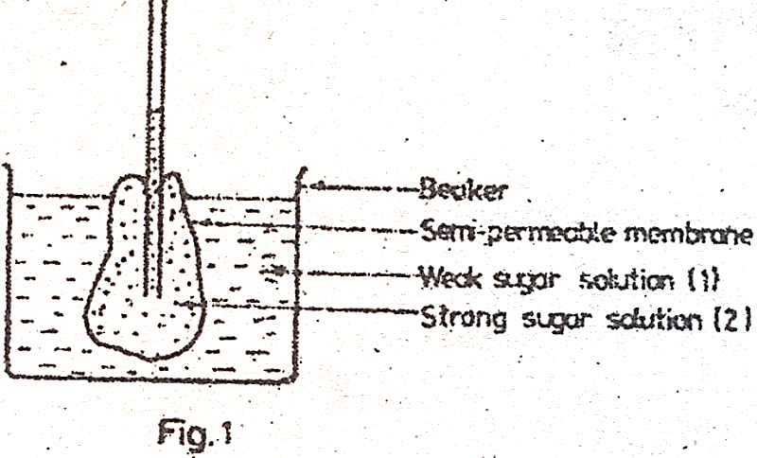

Which of the following events will have taken place?

1. Solution 2 will have risen higher in the capillary tube
2. The level of solution 1 will have fallen
3. The level of solution 2 in the capillarity tube will have fallen
4. Concentration of solution 1 in the beaker will not have changed at all
5. (i) and (iii)
6. (ii) and (iv)
7. (i) and (ii)
8. (iii) and (iv)
9. 2 g of a food substance was burnt, and the heat produced raised the temperature of 50 cm3 of water from 250C to 370C. What is the energy content of the food substance in joules per gram? (specific host capacity of water = 4.2 j per gram)
10. 1260 joules
11. 2520 joules
12. 300 joules
13. 105 joules
14. Which one of the following activities takes place during the pupal stage in the life cycle of an insect?
15. Hibernation
16. Organ formation
17. Feeding
18. Resting
19. A couple produced four children who were at different blood groups with the following genotypes: AO, BO, AB and OO. What were the genotypes of their parents?
20. AA and OB
21. AO and OB
22. BB and OB
23. AB and OO
24. Which one of the following can be applied so as to reduce the acidity of a soil?
25. Ammonium compound
26. Nitrate
27. Phosphate
28. Line
29. The following are some characteristics of flowers
30. Large feathery stigma
31. Large brightly coloured petals
32. Produce large quantities of pollen grains
33. Flowers are often scented

Which of the characteristics belong to wind pollinated flowers?

1. (i) and (ii)
2. (iii) and (iv)
3. (i) and (iii)
4. (ii) and (iv)
5. The living together of a fungus and an alga as a lichen is called
6. Symbiosis
7. Parasitism
8. Saprophytism
9. Commensalism
10. Which one of the following seed parts plays both roles of protection and nutrition during germination?
11. Endosperm
12. Testa
13. Coleorhiza
14. Cotyledons
15. Why is a shoot being prepared for transpiration experiments normally cut under water? To
16. Avoid water loss which may cause wilting
17. Prevent loss of sap
18. Prevent air from entering the xylem vessel
19. Remove damaged tissue
20. Meiotic cell division is important because it ensures that
21. There is variation in the number of chromosomes
22. The number of chromosomes of a species is not double at fertilization
23. The chromosomes of the daughter cells are identical
24. Bad traits are not passed on from parents to offspring
25. The following are features found in birds
26. Light bones
27. Webbed feet
28. Presence of feathers
29. Streamlined body

Which of the features are adaptations for flight?

1. (i) and (ii)
2. (ii) and (iii)
3. (iii) and (iv)
4. (i) and (iv)
5. Which of the following substances are secreted in mammalian sweat?
6. Urea, ammonia, water
7. Urea, carbon dioxide, sodium chloride
8. Urea, water, sodium chloride
9. Urea, carbon dioxide, water

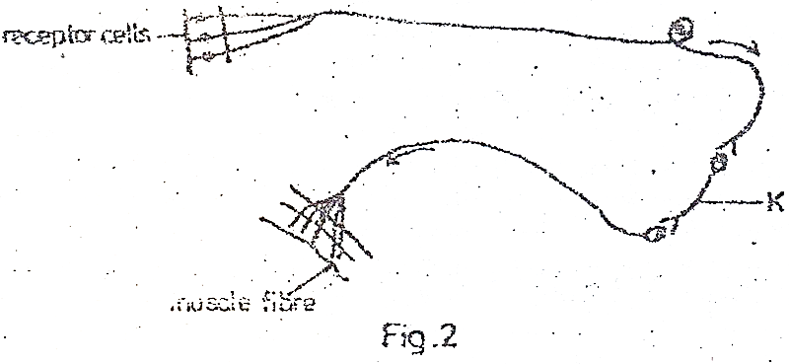

Figure 2 is a simplified reflex arc. The part labelled K is

1. The relay neurone
2. A ganglion
3. The sensory neurone
4. The motor neurone
5. Nerves, the spinal cord and the brain make up
6. A tissue
7. A system
8. An organ
9. An organism
10. Which one of the following shows the correct path followed by light rays to produce an image at the retina?
11. Cornea, aqueous humour, lens, pupil, vitreous humour, retina
12. Cornea, vitreous humour, pupil, lens, aqueous humour, retina
13. Cornea, pupil, vitreous humour, lens, aqueous humour, retina
14. Cornea, aqueous humour, pupil, lens, vitreous humour, retina
15. Decrease the number of mammalian red blood cells could reduce the ability of the blood to
16. Clot
17. Transport oxygen
18. Destroy harmful bacteria
19. Distribute heat
20. Which one of the following characters shows discontinuous variation?
21. Blood groups
22. Height
23. Intelligence
24. Skin colour in people
25. The similarity in feeding between an amoeba and the fungus Mucor is that both
26. Feed on dead organic matter only
27. Ingest undigested food materials
28. Digest their food materials
29. Secrete enzymes onto food materials from their cytoplasm
30. Which of the following make the skin of a toad an effective respiratory surface?
31. Moist surface
32. Rough skin
33. Rich blood supply to the skin
34. Large numbers of secretory glands on the skin
35. (i) and (iii)
36. (i) and (ii)
37. (ii) and (iv)
38. (iii) and (iv)
39. Below are some food chains: which one of them is correct?
40. Dead wood $⟶$ termite $⟶$ chicken
41. Chameleon $⟶$ mantid $⟶$ grass hopper
42. Termite $⟶$ hawk $⟶$ snake
43. Carnivore $⟶$ plant $⟶$ herbivore
44. Which one of the following types of cells is unspecialized?
45. Companion cell in plants
46. Red blood cell
47. Meristematic cell
48. Nerve cell
49. During inspiration the
50. Pressure in the thoracic cavity is reduced
51. External intercostal muscles relax
52. Diaphragm becomes dome shaped
53. The thoracic cavity becomes smaller
54. A heterozygous flowered plant (Rr) is crossed with a homozygous white plant (rr): If R is dominant over r, what will be the phenotypes of the offspring?
55. All red
56. All white
57. Pink and white
58. Red and white
59. Which one of the following is a characteristic of animal cells?
60. Presence of cell walls
61. Cells consist entirely of cytoplasm
62. Have regular shape
63. Have large centrally placed vacuoles
64. Which one of the following dental formulae represents that of a ruminant e.g sheep?
65. $\frac{2}{2}$: $\frac{1}{1}$: $\frac{2}{2}$: $\frac{3}{3}$
66. $\frac{2}{2}$: $\frac{1}{1}$: $\frac{2}{2}$: $\frac{0}{3}$
67. $\frac{0}{2}$: $\frac{1}{1}$: $\frac{2}{2}$: $\frac{3}{3}$
68. $\frac{0}{3}$: $\frac{1}{1}$: $\frac{3}{3}$: $\frac{3}{3}$
69. In plants, anaerobic respiration is less efficient than aerobic respiration because during anaerobic respiration
70. Not all the carbohydrates are broken down
71. The amount of carbon dioxide released is less than in aerobic respiration
72. There is less energy released per unit weight of carbohydrate broken down
73. Less water is produced in anaerobic respiration
74. Which one of the following characteristics is common to birds, fish and reptiles?
75. Regulation of body temperature
76. Bodies are covered with scales
77. Use of nostrils
78. Internal fertilization
79. Which of the following vitamins is deficient in a person whose gums bleed?
80. Vitamin C
81. Vitamin E
82. Vitamin B2
83. Vitamin K

**SECTION B**

*Answer all questions in this section.*

1. The table below shows the effect of wind, still air and stomatal opening on the rate of transpiration of a plant in milligrams of water lost per hour per dm2. Study the table and answer the questions following.

|  |  |  |  |  |  |  |  |
| --- | --- | --- | --- | --- | --- | --- | --- |
| Stomatal Opening ($μm$) | 1 | 2 | 3 | 4 | 5 | 6 | 7 |
| Wind | 40 | 63 | 74 | 86 | 94 | 110 | 124 |
| Still air | 0 | 6 | 12 | 19 | 23 | 27 | 30 |

1. (i) Compare the rates of transpiration in windy and still air conditions.

……………………………………………………………………………………………………….

……………………………………………………………………………………………………….

……………………………………………………………………………………………………….

(ii) Explain your observation.

……………………………………………………………………………………………………….

……………………………………………………………………………………………………….

……………………………………………………………………………………………………….

1. How does stomatal opening affect transpiration rate?

……………………………………………………………………………………………………….

……………………………………………………………………………………………………….

……………………………………………………………………………………………………….

1. Name three other factors that affect the rate of transpiration.

……………………………………………………………………………………………………….

……………………………………………………………………………………………………….

……………………………………………………………………………………………………….

1. State two functions of transpiration to plants.

……………………………………………………………………………………………………….

……………………………………………………………………………………………………….

……………………………………………………………………………………………………….

1. Two different-sized cubes of colourless jelly A and B were used to represent models of living organisms. They were submerged in a coloured dye for a period of time and then removed and cut into half.

The diagrams below show the penetration of the dye.

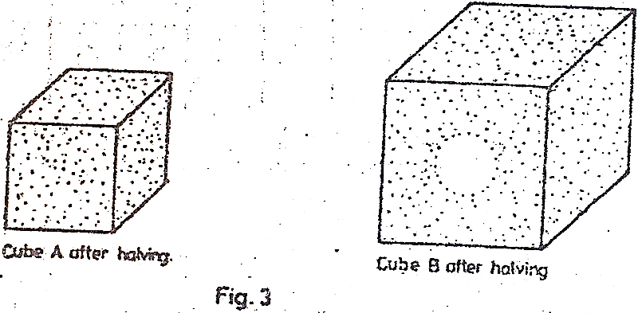

1. (i) Explain the different between the penetration of the coloured dye in the two cubes.

……………………………………………………………………………………………………….

……………………………………………………………………………………………………….

……………………………………………………………………………………………………….

(ii) Suppose that dye represents an essential substance being absorbed by a living organism. Explain how the problem in B could be overcome by a living organism without altering its shape.

……………………………………………………………………………………………………….

……………………………………………………………………………………………………….

……………………………………………………………………………………………………….

……………………………………………………………………………………………………….

1. Explain how the shape of a red blood cell helps it to function efficiently.

……………………………………………………………………………………………………….

……………………………………………………………………………………………………….

……………………………………………………………………………………………………….

……………………………………………………………………………………………………….

33. (a) In cattle, the gene for hornless condition is dominant over the one for horned condition. A hornless cow was mated to a horned bull. Using genetic symbols, show the possible genotypes and phenotypes of the F1 offspring.

Genotypes of F1 offspring

……………………………………………………………………………………………………….

……………………………………………………………………………………………………….

……………………………………………………………………………………………………….

……………………………………………………………………………………………………….

……………………………………………………………………………………………………….

……………………………………………………………………………………………………….

……………………………………………………………………………………………………….

……………………………………………………………………………………………………….

……………………………………………………………………………………………………….

Phenotype(s) of F­1 offspring

……………………………………………………………………………………………………….

……………………………………………………………………………………………………….

……………………………………………………………………………………………………….

……………………………………………………………………………………………………….

……………………………………………………………………………………………………….

(b) (i) A bull whose horns were removed was mated to a horned cow. Show the possible genotypes and phenotypes of the F1 offspring.

Genotypes of F1 offspring

……………………………………………………………………………………………………….

……………………………………………………………………………………………………….

……………………………………………………………………………………………………….

……………………………………………………………………………………………………….

Phenotypes of F1 offspring

……………………………………………………………………………………………………….

……………………………………………………………………………………………………….

……………………………………………………………………………………………………….

……………………………………………………………………………………………………….

(ii) Give a reason for your answer in (b) (i) above.

……………………………………………………………………………………………………….

……………………………………………………………………………………………………….

1. (a) (i) Give the main difference between cold-blooded (ectothermic) and warm-blooded (endothermic) animals.

……………………………………………………………………………………………………….

……………………………………………………………………………………………………….

……………………………………………………………………………………………………….

……………………………………………………………………………………………………….

……………………………………………………………………………………………………….

(ii) Give one advantage that an endothermic animal has over an ectothermic animal.

……………………………………………………………………………………………………….

……………………………………………………………………………………………………….

……………………………………………………………………………………………………….

(iii) Why are ectothermic animals said to be cold-blooded?

……………………………………………………………………………………………………….

……………………………………………………………………………………………………….

……………………………………………………………………………………………………….

(b) Give four ways in which an ectotherm reacts to the lowering of external temperature.

……………………………………………………………………………………………………….

……………………………………………………………………………………………………….

……………………………………………………………………………………………………….

……………………………………………………………………………………………………….

……………………………………………………………………………………………………….

……………………………………………………………………………………………………….

……………………………………………………………………………………………………….

**SECTION C**

*Answer any two questions from this section.*

1. (a) (i) What are the similarity(ies) and differences between asexual and sexual reproduction in the spirogyra?

(ii) What is the advantage of asexual reproduction to such a plant?

(b) Describe sexual reproduction in the spirogyra.

1. (a) Describe the digestion of proteins in the human alimentary canal.

(b) What may happen to the products of digestion of proteins?

1. Explain how a dicotyledonous leaf is adapted for the process of photosynthesis.
2. (a) Give six features which are common to adult insects.

(b) (i) What is understood by the term *metamorphosis?*

(ii) With the aid of labelled diagrams, give an account of the life cycle of a house-fly.

**1993**

**SECTION A**

*Answer all questions in this section.*

1. Which one of these processes helps to lower mammalian body temperature to normal?
2. Vasodilation
3. Vasoconstriction
4. Shivering
5. Raising of hair on the skin
6. Six fingers in man is controlled by a sex-linked recessive gene. If a normal woman marries a six fingered man. Which of the children will have six fingers?
7. All the sons
8. All the daughters
9. All will be normal
10. Half the number of girls and boys will be normal
11. Which one of the following tissues has a protective function in plants?
12. Xylem
13. Phloem
14. Cambium
15. Epidermis
16. What disease would you be controlling by pouring molluscicides in water?
17. Schistosomiasis
18. Guinea worm infestation
19. Typhoid
20. Cholera
21. Which one of the following takes place by the process of active transport in plants?
22. Uptake of water
23. Intake of carbon dioxide
24. Transpiration
25. Uptake of mineral salts
26. In an ecosystem the survival of all living things depend on
27. Decomposers
28. Primary producers
29. Primary consumers
30. Secondary consumers
31. If a gecko on a wall is seen eating mosquitoes, flies, moths and grasshoppers, this animal is said to be a
32. Parasite
33. Symbiont
34. Predator
35. Saprophyte
36. Which one of the following structural adaptations of leaves is important for light absorption during photosynthesis?
37. Dense network of veins
38. Large numbers of stomata on leaf surfaces
39. Large intercellular air spaces in the spongy layer
40. Broad and flat shapes of leaves
41. Which of the following is a function of progesterone?
42. Prepares the uterine walls for implantation
43. Initiates the process of birth
44. Initiates ovulation
45. Initiates formation of corpus luteum
46. The part of the brain that controls breathing is the
47. Cerebellum
48. Medulla oblongata
49. Cerebrum
50. Hypothalamus
51. Which of the following are respiratory surfaces in toads and frogs?
52. The mouth, webbed toes and skin
53. Nostrils, mouth and skin
54. Webbed toes, lungs and mouth
55. The mouth, lungs and skin

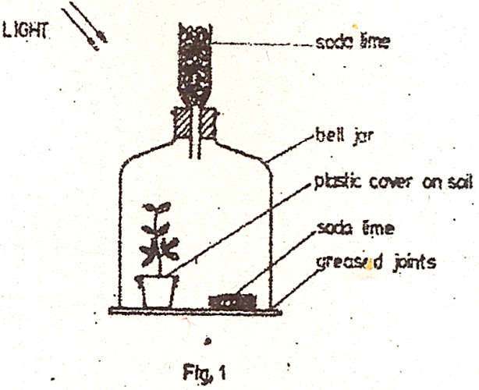

Figure 1 above shows an experiment on photosynthesis set up by a student. The soda lime was used to absorb

1. Any oxygen off by the plant
2. Any carbon dioxide from the air
3. Moisture from the air
4. Carbon dioxide give off by the plant
5. Which one of the following glands produces a hormone whose normal effect is to influence the rate of heartbeat?
6. Pituitary gland
7. Islets of Langerhans
8. Adrenal gland
9. Thyroid gland
10. The condition known as ‘oxygen debt’ occurs during active physical exercise in animals because of the
11. Accumulation of carbon dioxide during physical exercise
12. The high rate of breathing during physical exercise
13. Accumulation of lactic acid in the body
14. Accumulation of alcohol in the body
15. The stem root which grows from near the base of the trunk of some woody plants is called
16. Lateral root
17. Prop root
18. Aerial root
19. Adventitious root
20. Which one of the following farming methods would cause pollution in an aquatic habitat?
21. Mulching
22. Crop rotation
23. Use of fertilisers
24. Application of farm yard manure
25. The graph below shows changes in dry weight of a seedling of a non – woody plant.

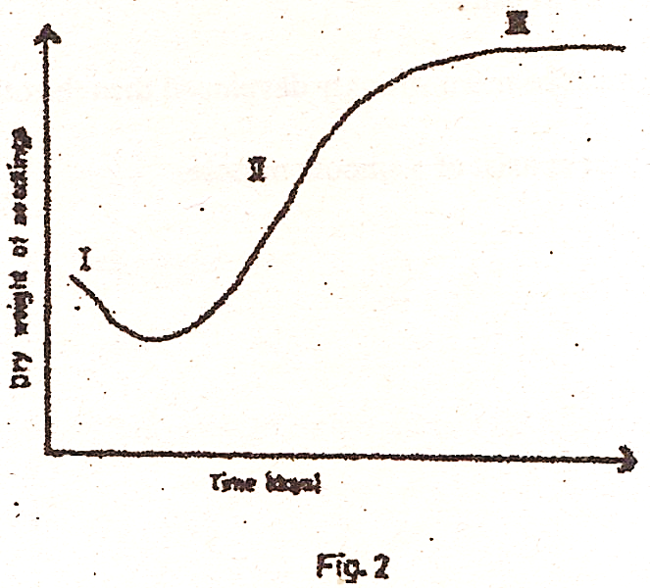

What is the possible explanation for the shape of the curve in phase III? Rate of

1. Respiration is constant
2. Respiration is greater than that of photosynthesis
3. Growth is highest
4. Assimilation is equal to respiration
5. Which one of the blood groups will not agglutinate with any blood serum when mixed?
6. O
7. A
8. AB
9. B
10. A male cockroach is different from the female cockroach by having
11. Styles
12. Cercus
13. Longer antennae
14. Larger abdomen
15. Which of the following conditions are necessary for producing movement in vertebrates?
16. Muscles must be attached to the end of bones
17. Muscular bundles must occur in pairs
18. One of a pair of muscles must be more strongly developed than the other
19. One of a pair of muscles must consist of a smooth muscle
20. (i), (iii), (iv)
21. (i), (ii), (iii)
22. (i), (ii), (iv)
23. (iii), (iv)
24. Which one of the following compounds is a constituent of enzymes?
25. Lipids
26. Polysaccharides
27. Protein
28. Vitamins
29. One of the two identical twins brought up differently was fatter and more healthy than the other. What kind of variation do these show?
30. Discontinuous variation
31. Genetic variation
32. Social variation
33. Habitat variation
34. Which one of the following structures in the mammalian ear is concerned with balance? The
35. Cochlea
36. Semicircular canals
37. Eustachian tube
38. Oval window
39. The type of soil with minute air spaces and high water retention capacity is
40. Sand
41. Clay
42. Silt
43. Loam
44. Which one of the following cannot be used in the classification of plants?
45. Structure of the flowers
46. Leaf structure
47. Type of seeds
48. Leaf colour
49. Figure 3 below shows some fruits. Which of them are likely to be dispersed by animals?

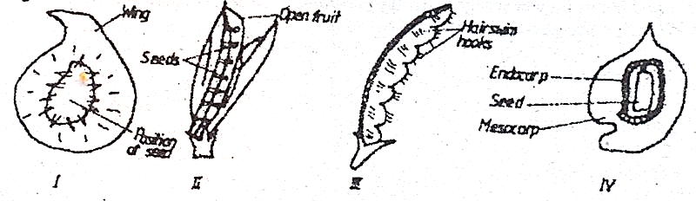

1. I and II
2. II and III
3. III and IV
4. I and IV
5. Which one of the following is not a property of a fully turgid plant cell?
6. The vacuole has maximum volume
7. There is no more absorption of water by the cell
8. The cell wall resists further expansion of the vacuole
9. The cytoplasm is only slightly separated from the cell wall
10. Which one of the following diets would be recommended for an overweight person?
11. Low carbohydrate, high protein, low fat
12. High carbohydrate, low protein, low fat
13. High carbohydrate, high protein, low fat
14. Low carbohydrate, low protein, high fat
15. Intestinal parasites are not digested by the host’s enzymes because of
16. Possession of attachment devices
17. Secretion of large quantities of mucus
18. Having a high rate of reproduction
19. Lack of their own digestive system
20. Which one of these is the correct order in which the following organisms occur in a food chain?
21. Vulture, antelope, lion
22. Lion, vulture, antelope
23. Antelope, lion, vulture
24. Lion, antelope, vulture

**SECTION B**

*Answer all questions in this section.*

1. The table below shows the concentrations of different substances in the glomerular filtrate and urine. Study the table and answer the questions that follow.

|  |  |  |
| --- | --- | --- |
| SUBSTANCE | CONCENTRATIONS (%)  GLOMERULAR FILTRATE URINE | |
| Water  Proteins  Glucose  Sodium  Urea | 93  0  0.1  0.3  0.003 | 95  0  0  0.35  2.0 |

1. Give any one reason for the difference in the concentration of water in the glomerular filtrate and in urine.

………………………………………………………………………………………………………

………………………………………………………………………………………………………

1. Explain the absence of proteins from both the glomerular filtrate and urine.

………………………………………………………………………………………………………

………………………………………………………………………………………………………

1. (i) Which substance is reabsorbed with

* The highest efficiency ……………………………………………………………………...
* The lowest efficiency ………………………………………………………………………

(ii) Which substance is not reabsorbed at all?

………………………………………………………………………………………………………

1. By what factor is urea more concentrated in urine than in glomerular filtrate?

………………………………………………………………………………………………………

………………………………………………………………………………………………………

1. Under what condition does glucose appear in urine?

………………………………………………………………………………………………………

………………………………………………………………………………………………………

………………………………………………………………………………………………………

1. Figure 4 below shows a longitudinal section through the female reproductive system of a mammal.

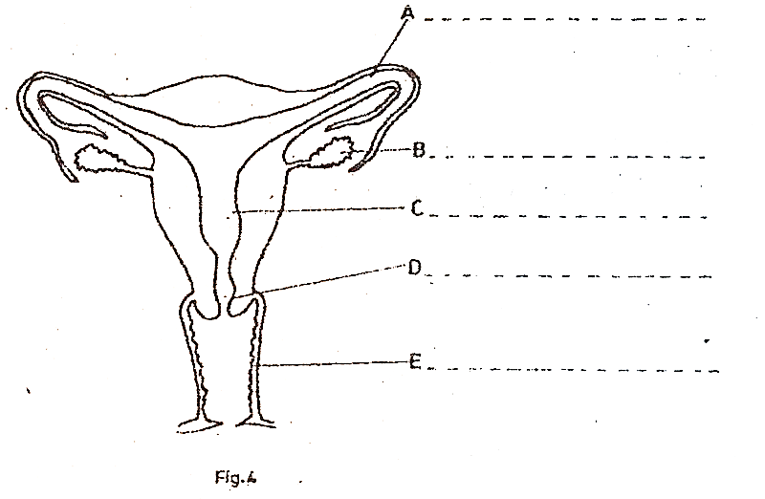

1. Name the parts labelled A, B, C, D and E on the diagram.
2. State any two functions of B
3. ………………………………………………………………………………………...
4. ………………………………………………………………………………………..
5. In what two ways are parts A and C adapted to their functions?

A

………………………………………………………………………………………………………

………………………………………………………………………………………………………

C

………………………………………………………………………………………………………

………………………………………………………………………………………………………

1. State two advantages the mammalian embryo has over that of a frog during their development.

………………………………………………………………………………………………………

………………………………………………………………………………………………………

………………………………………………………………………………………………………

………………………………………………………………………………………………………

………………………………………………………………………………………………………

………………………………………………………………………………………………………

1. (a) What do you understand by the following terms:
2. A habitat,

………………………………………………………………………………………………………

………………………………………………………………………………………………………

1. An ecosystem?

………………………………………………………………………………………………………

………………………………………………………………………………………………………

(b) Use the following organisms to construct a food web showing their feeding relationship: Chameleon, moth, grasshopper, herbaceous bug, praying mantis, predatory bug and plants.

1. What is the role of each of the following organisms in the food web:
2. The plants

………………………………………………………………………………………………………

1. The grasshopper

………………………………………………………………………………………………………

1. The predatory bug?

………………………………………………………………………………………………………

1. Which one of the organisms listed above will have the least energy for any single food chain considered? Why?

………………………………………………………………………………………………………

………………………………………………………………………………………………………

………………………………………………………………………………………………………

………………………………………………………………………………………………………

………………………………………………………………………………………………………

………………………………………………………………………………………………………

………………………………………………………………………………………………………

………………………………………………………………………………………………………

1. The graphs below show the effects of temperature and pH on the activity of an enzyme in the human digestive system.

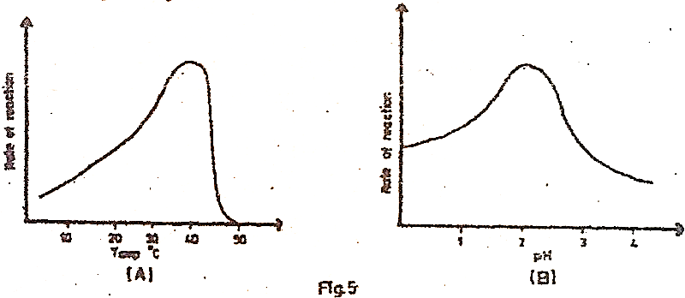

1. At what temperature and pH does the enzyme show optimal activity?

………………………………………………………………………………………………………

………………………………………………………………………………………………………

1. Suggest one reason for the sharp fall in the rate of reaction of the enzyme as shown in graph A.

………………………………………………………………………………………………………

………………………………………………………………………………………………………

1. (i) Suggest the identity and location of this enzyme.

………………………………………………………………………………………………………

………………………………………………………………………………………………………

(ii) Give a reason for your answer to c(i) above.

………………………………………………………………………………………………………

………………………………………………………………………………………………………

1. For the enzyme in e(i) above, suggest the food it acts on and the end products.

Food acted on

………………………………………………………………………………………………………

End products

………………………………………………………………………………………………………

**SECTION C**

*Answer any two questions from this section.*

1. (a) What is growth?

(b) Name the main parts responsible for producing growth in a shoot.

(c) Describe an experiment you would perform to determine the region of most rapid elongation in the root of a bean seedling.

1. (a) What do you understand by the term ‘irritability’ as applied to plants and animals?

(b) Explain how plants respond to light as a factor of irritability.

(c) Name any three other trophic responses in plants.

1. (a) Explain how the action of muscles causes air to pass from the atmosphere into the lungs?

(b) How does oxygen move from the air in the lungs into the cells of the blood?

(c) Give three characteristics of an efficient respiratory organ.

1. (a) What is pollution?

(b) Give an outline of the human activities, in Uganda, which may result in environmental pollution.